Molecular mechanics parameters for the modelling of four-coordinate Zn(II) porphyrins

Helder M. Marques* and Ignacy Cukrowski*

Molecular Sciences Institute, School of Chemistry, University of the Witwatersrand, P.O. Wits, Johannesburg, 2050 South Africa.

E-mail: hmarques@aurum.wits.ac.za
igancy@aurum.wits.ac.za

SUPPLEMENTARY INFORMATION
Supplementary Figures

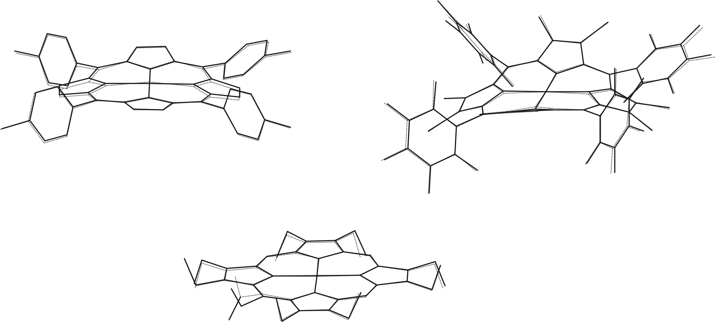
Fig. S1 Overlay of the crystal structure (----) and the MM-energy minimised structure (――) of [Zn(TPClP)] (top left), [Zn(OClTPF₅P)] (top right) and [Zn(5-NO2-OEP)] (bottom) obtained with the parameters k_{s} = 1.59 mdyn Å⁻¹ and l_{o} = 2.007 Å.

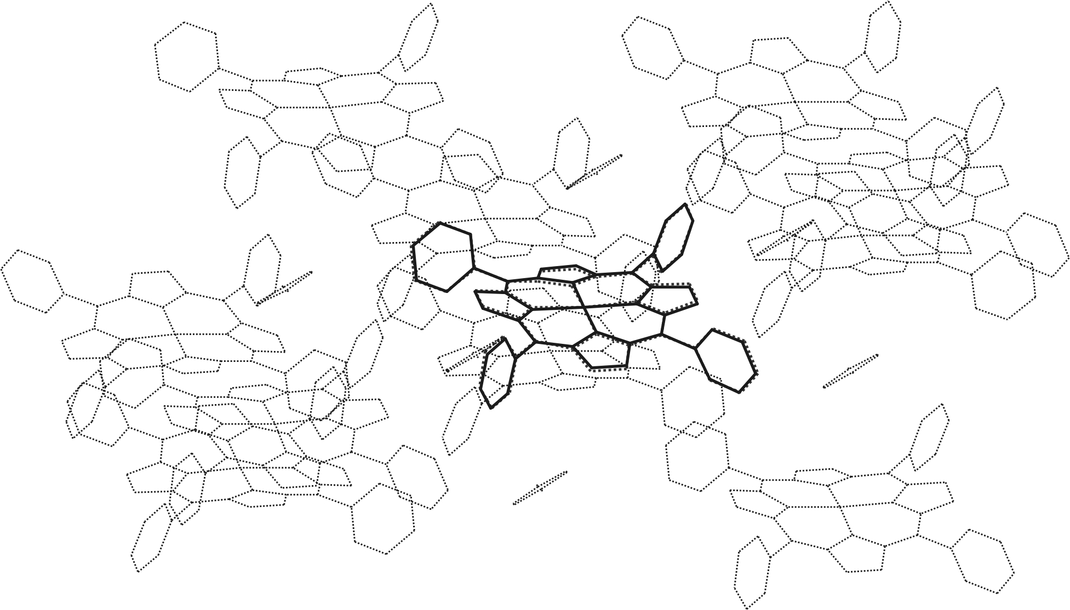
Fig. S2 Energy minimised (──) and (---) crystal structure of a molecule of [Zn[TPP] in the
lattice of [Zn(TPP)] p-xylene clathrate (SEMPAB). The positions of all atoms in the molecules drawn with fine broken lines were kept fixed during the minimisation procedure. Hydrogen atoms are omitted for clarity.

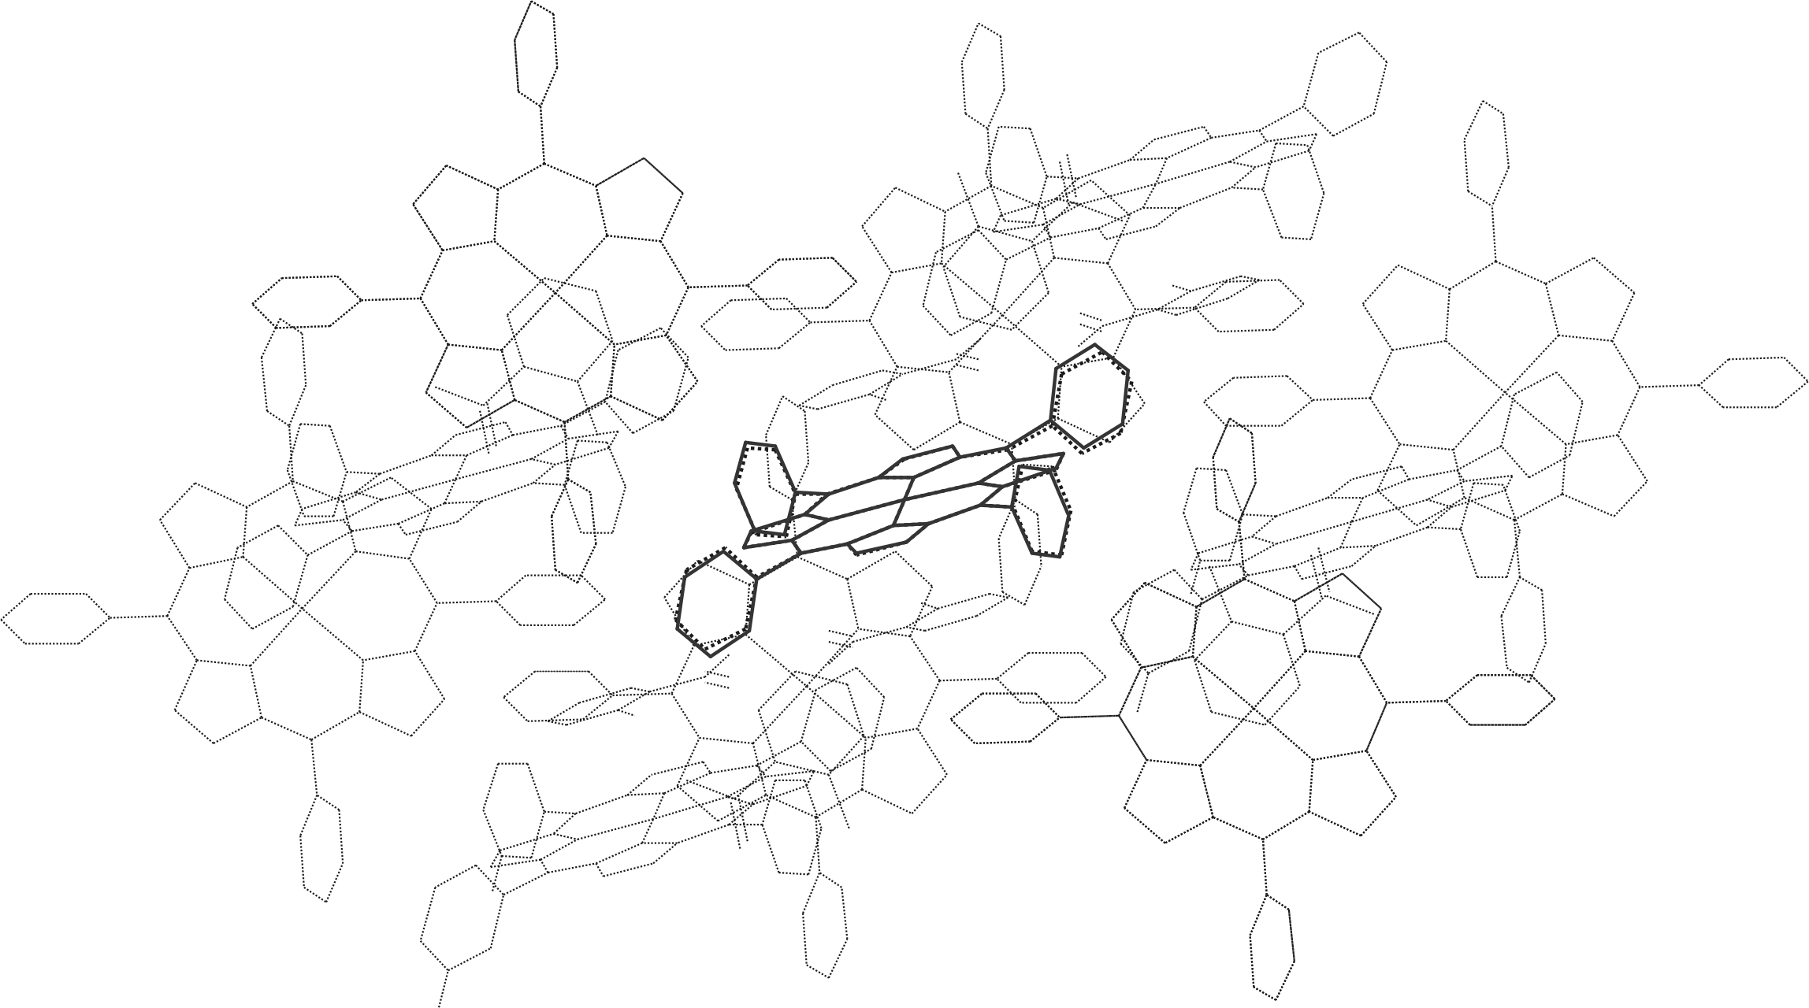
Fig. S3 Structure of sad-distorted [ZnTPP] (from SEMPAB, Fig. S2) (──) energy minimised in the lattice of [Zn(TPP)] bis(o-toluic acid) clathrate (HALVEV, (P2₁/a)) (---). The molecule drawn with bold broken lines is that observed at that lattice position in the HALVEV crystal structure. The positions of all atoms in the molecules drawn with fine broken lines were kept fixed during the minimisation procedure. Hydrogen atoms are omitted for clarity.
Supplementary Material - Comparison of the crystal structures of three four coordinate Zn(II) porphyrins and the MM energy-minimised structures

Three structures not used in the training of the ANNs, (5-(9,10-dimethoxyphenanthren-1-yl)-10,15,20-triphenylporphyrin zinc(II) (LODSEC), 5,10,15,20-tetra-p-tolylporphyrin zinc(II) (TEGVIK), and 5,10,15,20-tetraphenyl-(2,3-b),(2,3-g),(2,3-l),(2,3-q)-tetrakis(bicyclo(2.2.2.) oct-2-ene)porphyrin zinc(II) (CIQXOP) (see text), were subjected to energy minimisation using the Zn-N bond length parameters derived in this work. The starting point for the minimisation was in each case the crystal structure of the molecule. A comparison of the crystal structures and the MM energy-minimised structure is given below.

Table S1 – Comparison of the Zn-N bond lengths in the solid state and the MM energy-minimised structures.

Structure |  | Zn-N (solid state)  /Å | Zn-N (MM structure)  /Å | /Å
LODSEC |  | 2.025 | 2.031
 |  | 2.029 | 2.025
 |  | 2.039 | 2.032
 |  | 2.032 | 2.028
 | Mean, r | 2.031 | 2.029
 | |r_{obs}-r_{calc}| |  |  | 0.002
TEGVIK |  | 2.029 | 2.025
 |  | 2.045 | 2.034
 |  | 2.029 | 2.026
 |  | 2.045 | 2.036
 | Mean, r | 2.037 | 2.030
 | |r_{obs}-r_{calc}| |  |  | 0.007
CIQXOP |  | 2.068 | 2.066
 |  | 2.066 | 2.068
 |  | 2.068 | 2.067
 |  | 2.066 | 2.067
 | Mean, r | 2.067 | 2.067
 | |r_{obs}-r_{calc}| |  |  | 0.000

Table S2 – Comparison of the distortions from planarity in the solid state and the MM energy-minimised structures

Structure |  | D_{oop} | δ_{oop} | sad  B_{2u} | ruf  B_{1u} | dom  A_{2u} | wav(x)  E_{gx} | wav(y)  E_{gy} | pro  A_{1u}
LODSEC | Solid state | 0.993 | 0.013 | 0.950 | 0.220 | 0.140 | -0.121 | -0.026 | 0.019
 | MM | 0.665 | 0.020 | 0.650 | 0.126 | 0.021 | 0.036 | -0.037 | -0.039
TEGVIK | Solid state | 0.078 | 0.015 | 0.000 | 0.000 | 0.000 | -0.075 | -0.021 | 0.000
 | MM | 0.084 | 0.006 | 0.018 | 0.000 | -0.003 | -0.024 | -0.078 | 0.000
CIQXOP | Solid state | 0.377 | 0.012 | 0.000 | 0.000 | 0.000 | 0.213 | -0.310 | 0.000
 | MM | 0.428 | 0.007 | 0.000 | 0.000 | 0.001 | 0.234 | -0.359 | 0.000

