Supplementary Information

1)- R6G dimerization in aqueous solution

a)- Determination of the equilibrium constant

Assuming that in this concentration range R6G aggregation does not exceed dimerization, a 2A  B equilibrium with K_{d} = [B]/[A]² is proposed, then, the proportion of free monomer x = [A]/[A]₀ is given by:

x = [(1+8K_{d}[A₀])^{1/2}-1]/(4K_{d}[A₀]) [1S]

where [A]₀ is the initial monomer concentration. From Beer's law :

Abs/l = ε_{A}[A] + ε_{B}[B] [2S]

where l is the optical path in cm, ε_{A} and ε_{B} being respectively the molar extinction coefficients of monomer A and dimer B. Apparent ε (ε_{app}) can be calculated using the mass balance equation:

[B] = ([A₀] – [A])/2 [3S]

ε_{app} = Abs/ (l *[A₀]) = (ε_{A}[A] + ε_{B}[B])/[A]₀ = xε_{A} + (1-x)ε_{B}/2 [4S]

The visible spectra of various aqueous solutions ranging from [A]₀ = 1.86µM to 0.33mM
were recorded using 0.1cm to 10cm optical path cells. 6 wavelengths were selected from 490 to 560nm. ε_{app} from eq.[1S] and [4S] were fitted using a home-made program. Unknown parameters are the ε_{A} (at 6λ_{obs}), ε_{B} ( at 6λ _{obs}) and K_{d}. Note that ε_{A} was considered as unknown and not assumed from more or less diluted R6G solutions.

Figure 1S: Apparent molar extinction coefficients of aqueous solutions of R6G at selected wavelengths. Data points: experiments; lines: numerical fitting from eqs [1S] and [4S].

λ (nm) | 490 | 500 | 525 | 540 | 550 | 560
ε_{A}  (L.mol⁻¹.cm⁻¹) | 28800 | 39120 | 85040 | 52080 | 20500 | 7230
ε_{B}  (L.mol⁻¹.cm⁻¹) | 113600 | 118600 | 37740 | 28280 | 24830 | 15900

Table IS: Molar extinction coefficients extracted from the fitting (K_{d} = 2680 L.mol⁻¹)

b)- Reconstruction of the monomer and dimer spectra.

Monomer and dimer spectra (ε_{A} and ε_{B}/2 vs λ) were calculated from the dimerization constants and spectra of two solutions of respective concentrations [A₀]₁ and [A₀]₂ .

ε_{B}/2 = (x₁ε₂ - x₂ε₁)/(x₁ - x₂) [5S]

ε_{A} = (ε₁(1- x₂) - ε₂(1 - x₁))/(x₁ - x₂) [6S]

where x₁ and x₂ derive from eq.[1S] for initial concentrations [A₀]₁ and [A₀]₂ respectively. ε₁ and ε₂ are the corresponding apparent molar extinction coefficients of solutions [A₀]₁ and [A₀]₂ at any wavelength. Better results are obtained by taking [A₀]₁ and [A₀]₂ as different as possible.

Figure 2S: Reconstructed dimer and monomer spectra.

c)- Determination of the free monomer content of any solution

This calculation is based on the analysis of the shape of the spectrum defined from the ratio of absorbance at two wavelengths λ and λ'. From eq. [2S], the following formula can be established which works without the prior knowledge of the total dye concentration.

x = (rε'_{B}/2 - ε_{B}/2)/(Δ - rΔ') [7S]

where r = Abs/Abs' is the ratio of the spectrum absorbances measured at λ and λ' ,
Δ = ε_{A}- ε_{B}/2 and Δ' = ε'_{A}- ε'_{B}/2 respectively at λ and λ'.

Better results are obtained by taking λ = 525nm (≈ λ_{max} of the monomer) and λ' = 500nm (≈ λ_{max} of the dimer). From the values listed in Table IS, we have:

x = (59300r -18870)/(66170 + 21180r) [8S]

2)- Poisson distribution

The fraction of micelles containing i solubilizates is given by the Poisson formula:

P_{i} = (<Q>^{i})(exp(-<Q>))/i! [9S]

where <Q> is the global number of dye molecules per micelles.
<Q> = N_{agg}*[R6G]₀/([SDS]₀ , N_{agg} being the mean micellar aggregation number.

P₀ = fraction of empty micelles = exp(-<Q>),
P₁ = fraction of micelles containing one dye = <Q>* exp(-<Q>),
P₂ = fraction of micelles containing two dyes = (<Q>²* exp(-<Q>))/2,
P₃ = fraction of micelles containing three dyes = (<Q>³* exp(-<Q>))/6,

for <Q> < 0.6, higher fractions are negligible.

3)- Ion-pair crystal analysis

a)- Optical microscopy
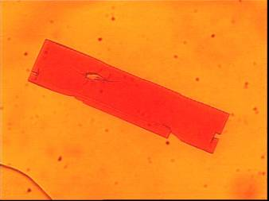

Figure3S: Microphotograph of the biggest ion-pair crystal (OVC) ever obtained after aggregation / precipitation at [SDS] ≈ 2mM. (170 µm length x 35 µm width).

Note the presence of several smaller red dots corresponding to aggregates of radius ≈ 1000nm which are likely to correspond to the smaller colloidal crystals (SC).

b)- X-ray diffraction spectroscopy

Attempts to obtain crystals suitable for X-ray diffraction experiments have not yet been successful, this the reason why the results obtained by the X-ray diffraction studies of the 1:1 R6G:SDS are not very satisfactory. The crystals form very nice plates, but thicker plates are only formed by overlapping of many layers giving a multi-crystal. We were forced to work with a very thin plate producing only very weak diffraction pattern. But the main features of the structure can be discussed. As represented in Figure 4S(a) (after increasing the asymmetric unit) the structure confirms the 1:1 ratio of the ion pair. The cationic part is even good enough to be represented in thermal ellipsoid style. For two half molecules of the cation two half SO₃R anions are present in the asymmetric unit. The high degree of freedom for the positions of the dodecyl groups lead to problems of high disorder. For the moment we are trying to overcome this problem by recrystallization at low temperatures in order to cool the movements of the long chains and to favor certain positions. Furthermore, as represented in Figure 4S(b), the anions and the cations are organized in channels along the b axis. Crystal data: The structure crystallizes in the monoclinic space group P2/m with the cell parameters a = 14.860(8) Å, b = 16.617(9) Å, c = 16.998(9) Å, β = 111.47(1)°.
We tried P2 and Pm in order to see if some disorder problems are only due to pseudo- symmetry, but both space groups show the same problems. For the moment we are blocked at about 0.18 for R1(I>2σ(I)).
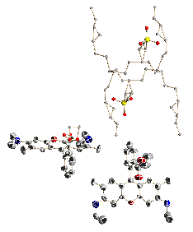
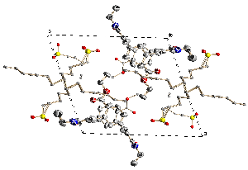

(a) (b)

Figure 4S(a) and (b): Semi-refined X-ray diffraction structure of the 1:1 SDS:R6G ion pair microcrystals.

