Reactivity of cis-dichloro-bis(acetylacetonato)titanium(IV) towards hydroxy (-OH)-containing ligands: Reactivity, and isolation and characterisation of products.#
P. Venkateshwara Raoª, Chebrolu Pulla Rao^{*,a}, Elina C. Wegelus^{b}, Erkki Kolehmainen^{b} and Kari Rissanen^{b}.

Supplementary Figures

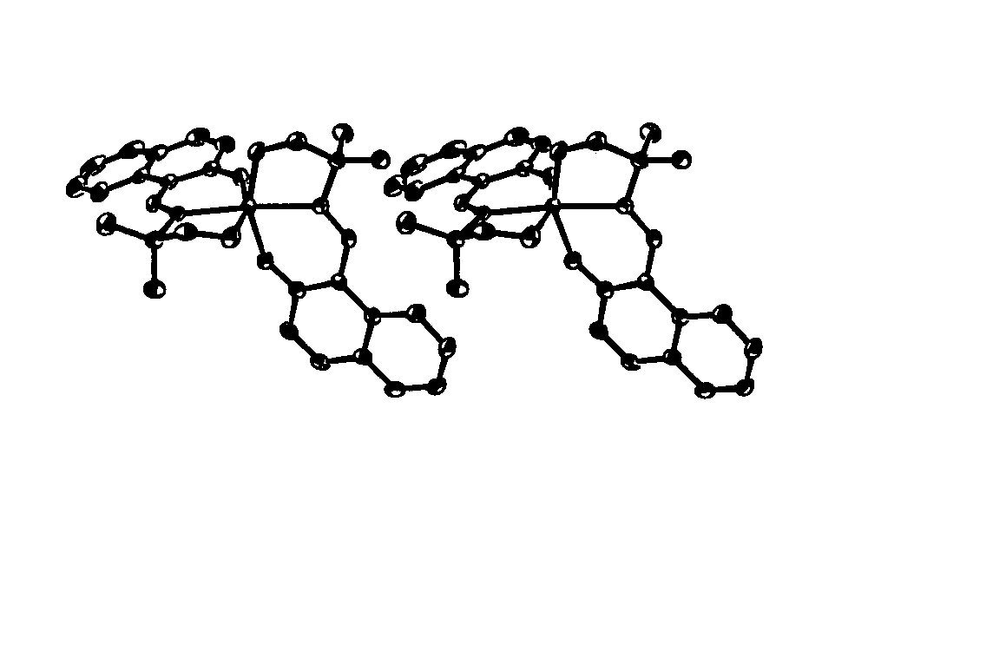
Seteroview of 3b

Seteroview of 4a

