Co-ordination of weak field ligands by N-acetylmicroperoxidase-8 (NAcMP8), a ferric haempeptide from cytochrome c, and the influence of the axial ligand on the reduction potential of complexes of NAcMP8

Helder M. Marques, Ignacy Cukrowski and Preeti R. Vashi

Centre for Molecular Design and Applied Chemistry and Chemical Technology Centre, Department of Chemistry, University of the Witwatersrand, Johannesburg, 2050 South Africa

SUPPLEMENTARY INFORMATION
Table 1. Equilibrium constants for the co-ordination of some ligands by NAcMP8 and related haempeptides

Ligand | pK_{a} ª | Haempeptide | log K | Comments | Ref | Magnetic  moment /_{B} |  | Ref
(a) Ligands that cause Fe(III) to go predominantly low spin
cyanide | 9.04 | NAcMP8 | 6.77 | Aqueous | 1 | 2.83 |  | 14
 |  | NAcMP11 | 6.87 | Aqueous | 2
 |  | MP11 | 7.1 | Aqueous | 3
 |  | MP9 | 7.67 | 20% MeOH | 4
 |  | MP8 | 7.54 | 50% ethylene glycol | 5
 |  | MP8 | 7.58 | 20% MeOH | 6
 |  | MP6 | 6.16 | Aqueous | 7
imidazole | 7.00 | NAcMP8 | 4.08 | Aqueous | 1 | 2.58 |  | 14
 |  | NAcMP11 | 4.11 | Aqueous | 2
 |  | MP11 | 3.98 | Aqueous | 3
 |  | MP9 | 4.34 | 20% MeOH | 4
 |  | MP8 | 4.45 | 20% MeOH | 8
 |  | MP6 | 4.05 | Aqueous | 7
pyridine | 5.19 | NAcMP8 | 2.62 | Aqueous | 1
 |  | MP11 | 2.49 | Aqueous | 9
 |  | MP8 | 2.65 | 20% MeOH | 10
4-cyanopyridine | 1.86 | NAcMP8 | 1.51 | Aqueous | 1
 |  | MP8 | 1.4 | 20% MeOH | 10
4-N,N-dimethyl- aminopyridine | 9.55 | NAcMP8 | 4.61 | Aqueous | 1
 |  | MP8 | 4.58 | 20% MeOH | 10
ethanolamine | 9.52 | NAcMP8 | 3.68 | Aqueous | 1
glycine | 9.57 | NAcMP8 | 3.44 | Aqueous | 1
 |  | MP8 | 3.46 | 20% MeOH | 10
n-propylamine | 10.62 | NAcMP8 | 4.04 | Aqueous | 1
(b) Ligands that produce a S = 5/2, S = 1/2 equilibrium in Fe(III)
hydroxide |  | NAcMP8 | pK_{a} = 9.59 | Aqueous | 11 | 3.2 |  | 15
N₃¯ | 4.38 | NAcMP8 | 1.4  0.1 | Aqueous | This work | 5.10 |  | 14
 |  | MP9 | 1.39 | 20% MeOH | 4
 |  | MP8 | 1.48 | 50% ethylene glycol | 5
 |  | MP6 | 1.23 | Aqueous | 7
(c) Ligands that leave Fe(III) predominantly high spin
SCN¯ |  | NAcMP8 | -0.16 ± 0.01 | Aqueous | This work
 |  | MP8 | -0.052 | 20% MeOH | 12
F¯ |  | MP8 | -0.022 | 50% ethylene glycol | 13 | 5.48 |  | 14
Cl¯ |  | NAcMP8 | -0.35 ± 0.07 | Aqueous | This work
 |  | NAcMP11 | -0.57 | Aqueous | 2
Br¯ |  | NAcMP8 | -0.34 ± 0.04 | Aqueous | This work
I¯ |  | NAcMP8 | -0.45 ± 0.02 | Aqueous | This work
ªValues from Ref. 16

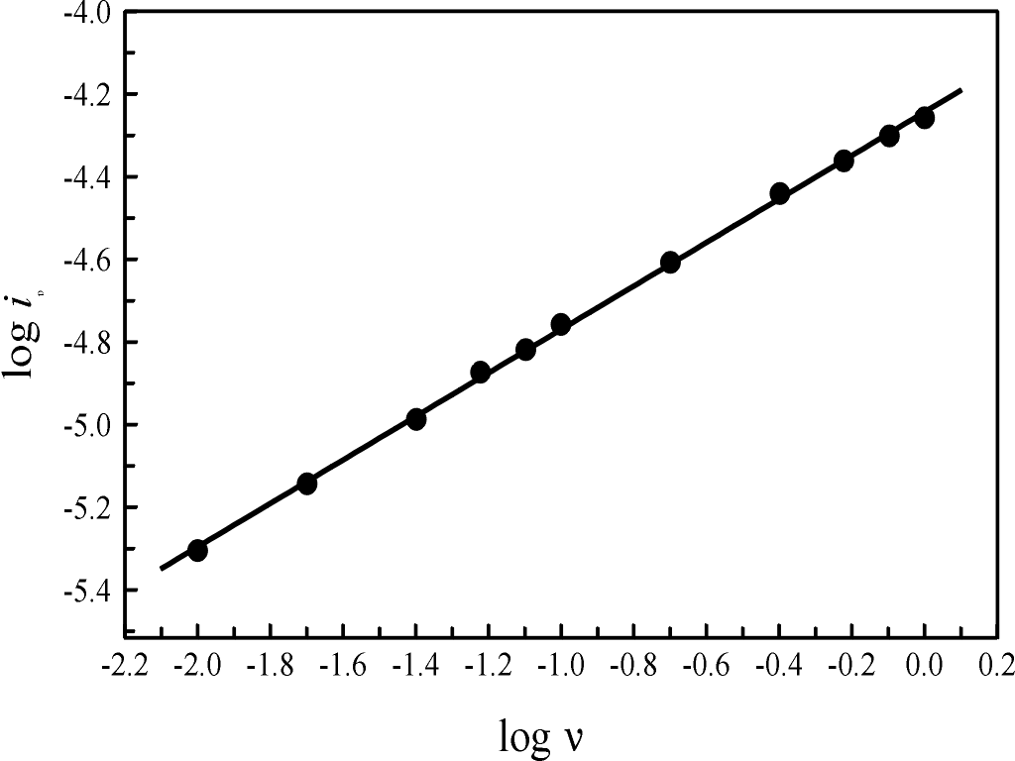

Figure S1. A plot of the log of the peak cathodic current, log i_{c}^{p}, against the log of the scan rate, log , for the imidazole complex of NAcMP8. The slope is 0.526  0.005, which is close to the value of 0.5 expected for an electrochemical reduction under diffusion control.

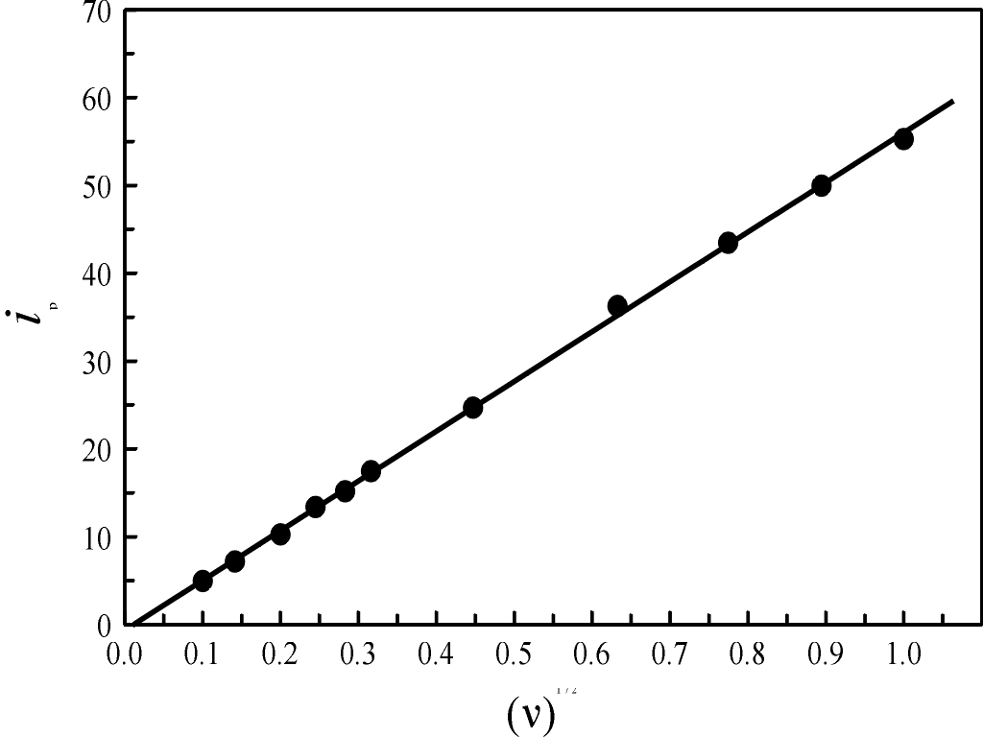

Figure S2. A plot of the peak cathodic current, i_{c}^{p}, against the square root of the scan rate yields a straight line, the slope of which is related to the diffusion coefficient, D_{o}.
References

- H. M. Marques, O. Q. Munro, T. Munro, M. de Wet and P. R. Vashi, Inorg. Chem., 1999, 38, 2312.
- H. M. Marques and C. B. Perry, J. Inorg. Biochem., 1999, 75, 281.
- M. T. Wilson, R. J. Ranson, P. Masiakowski, E. Czarnecka and M. Brunori, Eur. J. Biochem., 1977, 77, 193.
- D. A. Baldwin, M. B. Mabuya and H. M. Marques, S. Afr. J. Chem., 1987, 40, 103.
- D. C. Blumenthal and R. J. Kassner, J. Biol. Chem., 1980, 255, 5859.
- H. M. Marques, D. A. Baldwin and J. M. Pratt, J. Inorg. Biochem., 1987, 29, 77
- M. M. M. Saleem and M. T. Wilson, Inorg. Chim. Acta, 1988, 153, 93
- D. A. Baldwin, H. M. Marques and J. M. Pratt, J. Inorg. Biochem., 1986, 27, 245
- H. A. Harbury and P. A. Loach, J. Biol. Chem., 1960, 235, 3646
- M. S. A. Hamza and J. M. Pratt, J. Chem. Soc., Dalton Trans., 1993, 1647
- O. Q. Munro and H. M. Marques, Inorg. Chem., 1996, 35, 3752.
- H. M. Marques, Ph. D. Thesis, University of the Witwatersrand, Johannesburg, 1986
- Y. Huang and R. J. Kassner, J. Biol. Chem., 1981, 259, 10309
- E. K. Yang and K. Sauer, in H. Chien, ed., Electron Transport and Oxygen Utilization, Elsevier, New York, 1982, p. 89
- O. Q. Munro, M. de Wet, H. Pollak, J. van Wyk and H. M. Marques, J. Chem. Soc., Faraday Trans., 1998, 94, 1743.

