.
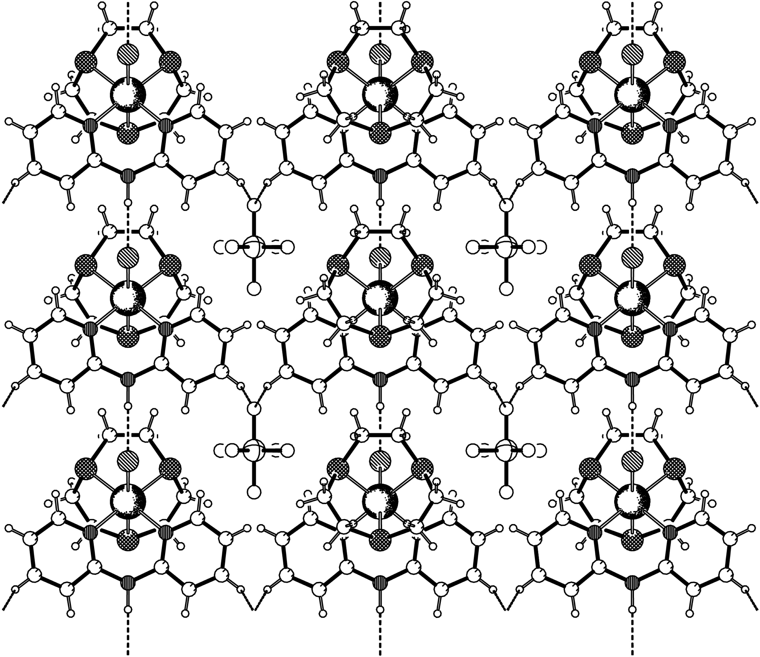
Fig. S3. Crystal packing diagram of [Ru([9]aneS₃)(dipa)Cl]PF₆ 6 showing the larger rings formed by four complex units and two BF₄⁻ anions

