Electronic Supplementary Information

Preparations of M₄As₂W₁₈
K₈Na₂As₂W₁₈Cu₄(H₂O)₂O₆₈·32H₂O, Cu₄As₂W₁₈. Solid CuCl₂·2H₂O (0.26 g, 1.5 mmol) was dissolved in 15 mL of water. To this solution was added with stirring 2.0 g ( 0.75 mmol ) of solid Na₈HAsW₉O₃₄ (1atm, 140 ºC,1-2 h). The solution was stirred at room temperature until all the B-AsW₉ was dissolved. Excess solid KCl (4.5 g) was added to the light green solution, resulting in the precipitation of a pale green solid. This solid was collected on a sintered-glass frit and dried under aspiration. The slightly damp solid was redissolved in about 5-10 mL of hot water and allowed to recrystallize overnight at 5 ºC. A crystalline pale-green solid was collected and dried at 80 ºC under vacuum for 2 h. The yield was 1.54 g (77%) of a pale-green solid. Slow crystallization at room temperature will result in large well-formed pale-green to clear crystals. Anal. Calcd for K₄NaAsW₉Cu₂(H₂O)O₃₄ ·10H₂O: K, 5.62; Na, 0.83; As, 2.70; W, 59.57; Cu, 4.57; H₂O, 7.13. Found: K, 5.75; Na, 0.71; As, 2.63; W, 59.45; Cu, 4.69; H₂O, 7.18.
K_{8.2}Na_{1.8}As₂W₁₈Zn₄(H₂O)₂O₆₈ ·20H₂O, Zn₄As₂W₁₈. Solid ZnCl₂ (0.21 g, 1.5 mmol) was dissolved in 15 mL of water. To this solution was added with stirring 2.0 g ( 0.75 mmol ) of solid Na₈HAsW₉O₃₄ (1atm, 140 ºC,1-2 h). The solution was heated until nearly homogeneous and then filtered hot by gravity filtration through paper. Excess solid KCl (4.5 g) was added to the clear filtrate, resulting in the immediate precipitation of a white solid. After the mixture was cooled to room temperature, this solid was collected on a sintered-glass frit and dried under aspiration. The slightly damp solid was redissolved in about 5-10 mL of hot water and allowed to recrystallize overnight at 5 ºC. A crystalline white solid was collected and dried at 80 ºC under vacuum for 2 h. The yield was 1.60 g (80%) of a white solid. Anal. Calcd for K_{4.1}Na_{0.9}AsW₉Zn₂(H₂O)O₃₄ ·10H₂O: K, 5.75; Na, 0.74; As, 2.69; W, 59.46; Zn, 4.70; H₂O, 7.11. Found: K, 5.69; Na, 0.75; As, 2.71; W, 59.51; Zn, 4.68; H₂O, 7.22 .
K₈Na₂As₂W₁₈Cd₄(H₂O)₂O₆₈ ·20H₂O, Cd₄As₂W₁₈. Solid CdCl₂·2.5 H₂O (0.35 g, 1.5 mmol) was dissolved in 15 mL of water. To this solution was added with stirring 2.0 g ( 0.75 mmol ) of solid Na₈HAsW₉O₃₄ (1atm, 140 ºC,1-2 h). The solution was heated until nearly homogeneous and then filtered hot by gravity filtration through paper. Excess solid KCl (4.5 g) was added to the clear filtrate, resulting in the immediate precipitation of a white solid. After the mixture was cooled to room temperature, this solid was collected on a sintered-glass frit and dried under aspiration. The slightly damp solid was redissolved in about 5-10 mL of hot water and allowed to recrystallize overnight at 5 ºC. A crystalline white solid was collected and dried at 80℃ under vacuum for 2 h. The yield was 1.58 g (79%) of a white solid. Anal. Calcd for K₄NaAsW₉Cd₂(H₂O)O₃₄ ·10H₂O: K, 5.42; Na, 0.80; As, 2.61; W, 57.54; Cd, 7.82; H₂O, 6.89 . Found: K, 5.52 ; Na, 0.75; As, 2.56 ; W, 57.42; Cd, 7.79; H₂O, 6.93 .
K₈Na₂As₂W₁₈Co₄(H₂O)₂O₆₈·18H₂O, Co₄As₂W₁₈. Solid Co(NO₃ )₂· 6H₂O (0.45g, 1.5 mmol) was dissolved in 15 mL of water. To this light pink solution was added with stirring 2.0 g ( 0.75 mmol ) of solid Na₈HAsW₉O₃₄ (1atm, 140 ºC,1-2 h). The solution was heated until a homogeneous purple to burgundy solution resulted. Excess solid KCl (5.0 g) was added , and a blue-purple precipitate formed. After the mixture was cooled to room temperature, this solid was collected on a sintered-glass frit and dried under aspiration. The slightly damp solid was redissolved in about 5-10 mL of hot water and allowed to recrystallize overnight at 5 ºC.A crystalline blue-purple solid was collected and dried at 80 ºC under vacuum for 2 h. The yield was 1.74 g (87%) of a blue-purple solid. Slow crystallization at room temperature will result in large well-formed blue-purple to clear crystals. Anal. Calcd for K₄NaAsW₉Co₂(H₂O)O₃₄ ·9H₂O: K, 5.67; Na, 0.84; As, 2.73; W, 60.16; Co, 4.28; H₂O, 6.54 . Found: K, 5.65; Na, 0.82; As, 2.66; W, 60.25; Co, 4.33; H₂O, 6.62 .
K₁₀As₂W₁₈Ni₄(H₂O)₂O₆₈·20H₂O, Ni₄As₂W₁₈. Solid NiCl₂·6H₂O (0.37 g, 1.5 mmol) was dissolved in 15 mL of water. To this solution was added with stirring 2.0 g ( 0.75 mmol ) of solid Na₈HAsW₉O₃₄ (1atm, 140 ºC,1-2 h). The solution was stirred at room temperature until all the B-AsW₉ was dissolved. Excess solid KCl (4.5 g) was added to the yellow-green solution, resulting in the immediate precipitation of a yellow solid. This solid was collected on a sintered-glass frit and dried under aspiration. The slightly damp solid was redissolved in about 5-10 mL of hot water and allowed to recrystallize overnight at 5 ºC. A crystalline yellow solid was collected and dried at 80 ºC under vacuum for 2 h. The yield was 1.50 g (75%) of a yellow solid. Anal. Calcd for K₅AsW₉Ni₂(H₂O)O₃₄ ·10H₂O: K, 7.00; As, 2.69; W, 59.43; Ni, 4.22; H₂O, 7.11. Found: K, 6.92; As, 2.95; W, 59.55; Ni, 4.18; H₂O,7.28 .
K₁₀As₂W₁₈Mn₄(H₂O)₂O₆₈·18H₂O, Mn₄As₂W₁₈. Solid MnCl₂·4H₂O (0.30 g, 1.5 mmol) was dissolved in 15 mL of water. To this solution was added with stirring 2.0 g ( 0.75 mmol ) of solid Na₈HAsW₉O₃₄ (1atm, 140 ºC,1-2 h). The solution was heated until nearly homogeneous and then filtered hot by gravity filtration through paper. Excess solid KCl (4.5 g) was added to the clear filtrate, resulting in the immediate precipitation of a orange solid. After the mixture was cooled to room temperature, this solid was collected on a sintered-glass frit and dried under aspiration. The slightly damp solid was redissolved in about 5-10 mL of hot water and allowed to recrystallize overnight at 5 ºC. A crystalline orange solid was collected and dried at 80 ºC under vacuum for 2 h. The yield was 1.58 g (79%) of a orange solid. Slow crystallization at room temperature will result in large well-formed orange to clear crystals. Anal. Calcd for K₅AsW₉Mn₂(H₂O)O₃₄·9H₂O: K, 7.07; As, 2.72; W, 59.98; Mn, 3.98; H₂O, 6.52 . Found: K, 6.98; As,2.70; W, 60.15; Mn, 3.89; H₂O, 6.66 .
K₇Na₃As₂W₁₈Fe₄(H₂O)₂O₆₈·18H₂O, Fe₄As₂W₁₈. Solid FeSO₄·7H₂O (0.42 g, 1.5 mmol) was dissolved in 15 mL of water. To this solution was added with stirring 2.0 g ( 0.75 mmol ) of solid Na₈HAsW₉O₃₄ (1atm, 140 ºC,1-2 h). The solution was heated until nearly homogeneous and then filtered hot by gravity filtration through paper. Excess solid KCl (4.5 g) was added to the clear filtrate, resulting in the immediate precipitation of a brown solid. After the mixture was cooled to room temperature, this solid was collected on a sintered-glass frit and dried under aspiration. The slightly damp solid was redissolved in about 5-10 mL of hot water and allowed to recrystallize overnight at 5 ºC. A crystalline brown solid was collected and dried at 80 ºC under vacuum for 2 h. The yield was 1.74 g (87%) of a brown solid. Anal. Calcd for K_{3.5}Na_{1.5}AsW₉Fe₂(H₂O)O₃₄·9 H₂O: K, 5.00; Na, 1.26; As, 2.74; W, 60.47; Fe, 4.08; H₂O, 6.58. Found: K, 5.11; Na, 1.23; As, 2.69; W, 60.42; Fe, 3.98; H₂O, 6.62.
K₁₀ [Zn₄(H₂O)₂(AsW₉O₃₄)₂ ]·23H₂O Prepared after the Method Suggested by Weakley. A boiling solution containing ZnSO₄ ∙7H₂O (5.75 g, 0.021 mol) and 6.4 mol ·dm⁻³ HNO₃ (17.2 cm³ , 0.110 mol) in water (110 cm³ ) was treated slowly with a solution of Na₂WO₄ ·2H₂O (29.7 g, 0.090 mol) and Na₂HAsO₄ ·7H₂O (3.15 g, 0.011 mol ) in water (110 cm³ ). The mixture was refluxed for 3 h and filtered while hot. The crude crystalline product was precipitated by the addition of KNO₃ (40 g) and cooling; it was twice redissolved and reprecipitated with KNO₃ , and was finally recrystallised twice from hot water (Found: As, 2.60; H₂O, 8.05; K, 7.10; W, 58.5; Zn, 4.70. Calc. for H₅₀As₂K₁₀O₉₃W₁₈Zn₄ : As, 2.65; H₂O, 7.95; K, 6.90; W, 58.6; Zn, 4.65% ).
Replacement Reaction of the Water Molecules Coordinated to the M₄As₂W₁₈ Anion in Aqueous Solutions.
K₁₆[Mn₄(L₁)₂(AsW₉O₃₄)₂], Mn₄As₂W₁₈-L₁. The preparation procedure was the same as that for Cu₄As₂W₁₈-L₁ described above except that Mn₄As₂W₁₈ was used and the product was a yellow powder (0.40 g). Elemental analyses gave a ratio K:Mn:Fe:W = 16.0:3.8:2.1:17.8, consistent with the formula. IR (KBr, cm⁻¹): 2109 (v (CN)), 954, 880, 840, 728.
K₁₆[Co₄(L₁)₂(AsW₉O₃₄)₂], Co₄As₂W₁₈-L₁. The preparation procedure was the same as that for Cu₄As₂W₁₈-L₁ described above except that Co₄As₂W₁₈ was used and the product was a brown black powder (0.33 g). Elemental analyses gave a ratio K:Co:Fe:W = 16.0:4.1:1.7:18.4, consistent with the formula. IR (KBr, cm⁻¹): 2116 (v (CN)), 966, 881, 819, 763, 712.
K₁₆[Ni₄(L₁)₂(AsW₉O₃₄)₂], Ni₄As₂W₁₈-L₁. The preparation procedure was the same as that for Cu₄As₂W₁₈-L₁ described above except that Ni₄As₂W₁₈ was used and the product was a yellow-green powder (0.43 g). Elemental analyses gave a ratio K:Ni:Fe:W = 16.0:4.1:1.8:18.3, consistent with the formula. IR (KBr, cm⁻¹): 2112 (v (CN)), 954, 881, 763, 701.
K₁₆[Fe₄(L₁)₂(AsW₉O₃₄)₂], Fe₄As₂W₁₈-L₁. The preparation procedure was the same as that for Cu₄As₂W₁₈-L₁ described above except that Fe₄As₂W₁₈ was used and the product was a dark-green powder (0.43 g). Elemental analyses gave a ratio K:Fe:As:W = 16.0:3.8:2.0:17.7, consistent with the formula. IR (KBr, cm⁻¹): 2114 (v (CN)), 958, 880, 819, 733.
K₁₈[Mn₄(L₂)₂(AsW₉O₃₄)₂], Mn₄As₂W₁₈-L₂. The preparation procedure was the same as that for Cu₄As₂W₁₈-L₂ described above except that Mn₄As₂W₁₈ was used and the product was a pale-yellow powder (0.38 g). Elemental analyses gave a ratio K:Mn:Fe:W = 18.0:4.1:1.7:18.2, consistent with the formula.IR (KBr, cm⁻¹): 2094 (v (CN)), 953, 881, 840, 765, 729.
K₁₈[Co₄(L₂)₂(AsW₉O₃₄)₂], Co₄As₂W₁₈-L₂. The preparation procedure was the same as that for Cu₄As₂W₁₈-L₂ described above except that Co₄As₂W₁₈ was used and the product was a gray-green powder (0.34 g). Elemental analyses gave a ratio K:Co:Fe:W = 18.0:4.0:1.8:18.3, consistent with the formula. IR (KBr, cm⁻¹): 2092 (v (CN)), 954, 881, 819, 759, 712.
K₁₈[Ni₄(L₂)₂(AsW₉O₃₄)₂], Ni₄As₂W₁₈-L₂. The preparation procedure was the same as that for Cu₄As₂W₁₈-L₂ described above except that Ni₄As₂W₁₈ was used and the product was a green powder (0.35 g). Elemental analyses gave a ratio K:Ni:Fe:W = 18.0:4.1:1.9:18.0, consistent with the formula. IR (KBr, cm⁻¹): 2091 (v (CN)), 955, 881 , 763, 701.
K₁₈[Fe₄(L₂)₂(AsW₉O₃₄)₂], Fe₄As₂W₁₈-L₂. The preparation procedure was the same as that for Cu₄As₂W₁₈-L₂ described above except that Fe₄As₂W₁₈ was used and the product was a yellow-green powder (0.58 g). Elemental analyses gave a ratio K:Fe:As:W = 18.0:5.8:1.9:18.1, consistent with the formula. IR (KBr, cm⁻¹): 2092 (v (CN)), 957, 883, 822, 730.
K₁₀[Mn₄(L₃)₂(AsW₉O₃₄)₂], Mn₄As₂W₁₈-L₃. The preparation procedure was the same as that of Cu₄As₂W₁₈-L₃ described above except that Mn₄As₂W₁₈ was used and the product was a white powder (0.32g). Elemental analyses gave a ratio K:Mn:C:N:W = 10.0:4.0:3.6:3.8:18.2, consistent with the formula. IR (KBr, cm⁻¹): 1042 (v(C-N)), 1643 (δ(NH₂)), 948, 882 , 819, 735.
K₁₀[Co₄(L₃)₂(AsW₉O₃₄)₂], Co₄As₂W₁₈-L₃. The preparation procedure was the same as that of Cu₄As₂W₁₈-L₃ described above except that Co₄As₂W₁₈ was used and the product was a pale-pink powder (0.42 g). Elemental analyses gave a ratio K:Co:C:N:W = 10.0:3.9:3.7:4.0:18.2, consistent with the formula. IR (KBr, cm⁻¹): 1057 (v(C-N)), 1651 (δ(NH₂)), 928, 880, 780, 728.
K₁₀[Ni₄(L₃)₂(AsW₉O₃₄)₂], Ni₄As₂W₁₈-L₃. The preparation procedure was the same as that of Cu₄As₂W₁₈-L₃ described above except that Ni₄As₂W₁₈ was used and the product was a flesh-colored powder (0.38 g). Elemental analyses gave a ratio K:Ni:C:N:W = 10.0:4.2:3.9:3.7:17.9, consistent with the formula. IR (KBr, cm⁻¹): 1042 (v(C-N)), 1643 (δ(NH₂)), 938, 872, 822, 725.
K₁₀[Fe₄(L₃)₂(AsW₉O₃₄)₂], Fe₄As₂W₁₈-L₃. The preparation procedure was the same as that of Cu₄As₂W₁₈-L₃ described above except that Fe₄As₂W₁₈ was used and the product was a brown-red powder (0.39 g). Elemental analyses gave a ratio K:Fe:C:N:W = 10.0:4.1:3.7:3.8:18.4, consistent with the formula. IR (KBr, cm⁻¹): 1042 (v(C-N)), 1636 (δ(NH₂)), 958, 881, 819, 745.
K₁₄[Mn₄(L₄)₂(AsW₉O₃₄)₂], Mn₄As₂W₁₈-L₄.The preparation procedure was the same as that of Cu₄As₂W₁₈-L₄ described above except that Mn₄As₂W₁₈ was used and the product was a white powder (0.35 g). Elemental analyses gave a ratio K:Mn:S:W = 14.0:4.1:1.8:17.8, consistent with the formula. IR (KBr, cm⁻¹): 1123 (v(SO₃²⁻)), 945, 881, 819, 729.
K₁₄[Co₄(L₄)₂(AsW₉O₃₄)₂], Co₄As₂W₁₈-L₄. The preparation procedure was the same as that of Cu₄As₂W₁₈-L₄ described above except that Co₄As₂W₁₈ was used and the product was a pink powder (0.39 g). Elemental analyses gave a ratio K:Co:S:W = 14.0:4.1:2.1:18.3, consistent with the formula. IR (KBr, cm⁻¹): 1126 (v(SO₃²⁻)), 943, 884, 820, 735.
K₁₄[Ni₄(L₄)₂(AsW₉O₃₄)₂], Ni₄As₂W₁₈-L₄. The preparation procedure was the same as that of Cu₄As₂W₁₈-L₄ described above except that Ni₄As₂W₁₈ was used and the product was a white powder (0.36 g). Elemental analyses gave a ratio K:Ni:S:W = 14.0:4.1:1.8:18.2, consistent with the formula. IR (KBr, cm⁻¹): 1125 (v(SO₃²⁻)), 953, 881, 818, 735.
K₁₄[Fe₄(L₄)₂(AsW₉O₃₄)₂], Fe₄As₂W₁₈-L₄. The preparation procedure was the same as that of Cu₄As₂W₁₈-L₄ described above except that Fe₄As₂W₁₈ was used and the product was a brown-yellow powder (0.36 g). Elemental analyses gave a ratio K:Fe:S:W = 14.0:3.8:2.0:18.3, consistent with the formula. IR (KBr, cm⁻¹): 1125 (v(SO₃²⁻)), 945, 880, 818, 758.
K₁₂[Mn₄(L₅)₂(AsW₉O₃₄)₂], Mn₄As₂W₁₈-L₅. The preparation procedure was the same as that of Cu₄As₂W₁₈-L₅ described above except that Mn₄As₂W₁₈ was used and the product was a yellow powder (0.42 g). Elemental analyses gave a ratio K:Mn:S:W = 12.0:4.2:2.3:18.1, consistent with the formula. IR (KBr, cm⁻¹): 2071 (v(SCN⁻)), 955, 879, 820, 729.
K₁₂[Co₄(L₅)₂(AsW₉O₃₄)₂], Co₄As₂W₁₈-L₅. The preparation procedure was the same as that of Cu₄As₂W₁₈-L₅ described above except that Co₄As₂W₁₈ was used and the product was a purple powder (0.38 g). Elemental analyses gave a ratio K:Co:S:W = 12.0:4.0:1.8:18.2, consistent with the formula. IR (KBr, cm⁻¹): 2069 (v(SCN⁻)), 959, 878, 818, 762.
K₁₂[Ni₄(L₅)₂(AsW₉O₃₄)₂], Ni₄As₂W₁₈-L₅. The preparation procedure was the same as that of Cu₄As₂W₁₈-L₅ described above except that Ni₄As₂W₁₈ was used and the product was a white powder (0.41 g). Elemental analyses gave a ratio K:Ni:S:W = 12.0:4.1:1.8:17.9, consistent with the formula. IR (KBr, cm⁻¹): 2071 (v(SCN⁻)), 952, 890, 819, 748.
K₁₂[Fe₄(L₅)₂(AsW₉O₃₄)₂], Fe₄As₂W₁₈-L₅. The preparation procedure was the same as that of Cu₄As₂W₁₈-L₅ described above except that Fe₄As₂W₁₈ was used and the product was a yellow powder (0.35 g). Elemental analyses gave a ratio K:Fe:S:W = 12.0:4.2:1.7:18.5, consistent with the formula. IR (KBr, cm⁻¹): 2070 (v(SCN⁻)), 960, 881, 829, 718.

Tables and Figures.

Table 1. CV Data for M₄As₂W₁₈ Compounds (V)ª
heteropoly-  anions | Epa | Epc | ΔEp (mV) | heteropoly-  anions | Epa | Epc | ΔEp (mV)
α-AsW₁₂O₄₀⁴⁻ | 0.0078 | -0.0332 | 41 | Co₄As₂W₁₈ | -0.6522 | -0.7762 | 124
 | -0.1402 | -0.4276 | 286 |  | -0.8344 | -0.9074 | 73
 | -0.3203 | -0.4443 | 124 | Zn₄As₂W₁₈ | -0.6450 | -0.7797 | 135
 | -0.5137 | -0.6595 | 146 |  | -0.7762 | -0.9147 | 139
 | -0.6886 | -0.7943 | 106 | Cd₄As₂W₁₈ | -0.6412 | -0.7822 | 141
B-AsW₉O₃₄⁹⁻ | -0.5464 | -0.7835 | 237 |  | -0.7945 | -0.9475 | 153
Cu₄As₂W₁₈ | 0.1138 | -0.1643 | 278 | Fe₄As₂W₁₈ | 0.1561 | -0.1677 | 324
 | -0.2832 | -0.4269 | 144 |  | -0.5740 | -0.6947 | 121
 | -0.6768 | -0.7742 | 97 |  | -0.7770 | -0.9045 | 127
Mn₄As₂W₁₈ | -0.6776 | -0.7723 | 95
 | -0.7872 | -0.9001 | 113
ª Epa, oxidation potential; Epc, reduction potential; ΔEp, the difference between the pair of redox potentials. Condition: pH 4.0 of a buffer solution of HAc-NaAc; 25℃; glassy carbon working electrode; scan rate 50mV·s⁻¹; potentials recorded vs Ag/AgCl.

Table 2. Colors and States of the Products Isolated from the Replacement Reactions in Aqueous Solutions ª
heteropoly-  anions | ligands
heteropoly-  anions | [Fe(CN)₆]³⁻ | [Fe(CN)₆]⁴⁻ | C₂H₈N₂ | SO₃²⁻ | SCN⁻
Cu₄As₂W₁₈ | yellow↓  (brown-yellow) | dark-red↓  (red-green↓) | violet↓  (blue) | white↓  (yellow↓) | pale-pink↓  (dark↓)
Mn₄As₂W₁₈ | yellow↓  (brown) | pale-yellow↓  (white↓) | white↓  (yellowish↓) | white↓  (no reacn) | yellow↓  (no reacn)
Co₄As₂W₁₈ | brown-black↓  (dark-red) | gray-green↓  (green↓) | pale-pink↓  (brown) | pink↓  (no reacn) | purple↓  (blue)
Ni₄As₂W₁₈ | yellow-green↓  (yellow↓) | green↓  (greenish↓) | flesh↓  (blue) | white↓  (blue↓) | white↓  (no reacn)
Fe₄As₂W₁₈ | dark-green↓  (dark-blue) | yellow-green↓  (blue) | Brown-red↓  (brown-black) | brown-yellow  (khaki) | yellow↓  (orange)
ª The colors and states of the products isolated from aqueous solutions, in which only corresponding simple transition
metal ions and ligands present, are shown in the parentheses

Table 3 . Colors of M₄As₂W₁₈ in Aqueous Solutions and in Benzene Containing 0.1M (tHA)Br.
 | Cu₄As₂W₁₈ | Mn₄As₂W₁₈ | Co₄As₂W₁₈ | Ni₄As₂W₁₈ | Fe₄As₂W₁₈
H₂O | green | orange | blue-purple | yellow | brown
before the loss  of the coordinated water molecules | yellow-green | yellow | blue-purple | yellow | orange
after the loss  of the coordinated water molecules | yellow | yellow | dark-blue | yellow | yellow
pyridine | yellow-green | yellow | purple | yellow | orange
acetone | yellow-green | yellow | purple | yellow | orange
lactic acid | yellow-green | yellow | purple-red | yellow | orange
acetonitrile | yellow-green | yellow | blue-purple | yellow | orange
chloroform | yellow-green | yellow | blue-purple | yellow | orange
pyrrole | orange | orange | purple-black | orange | orange-red

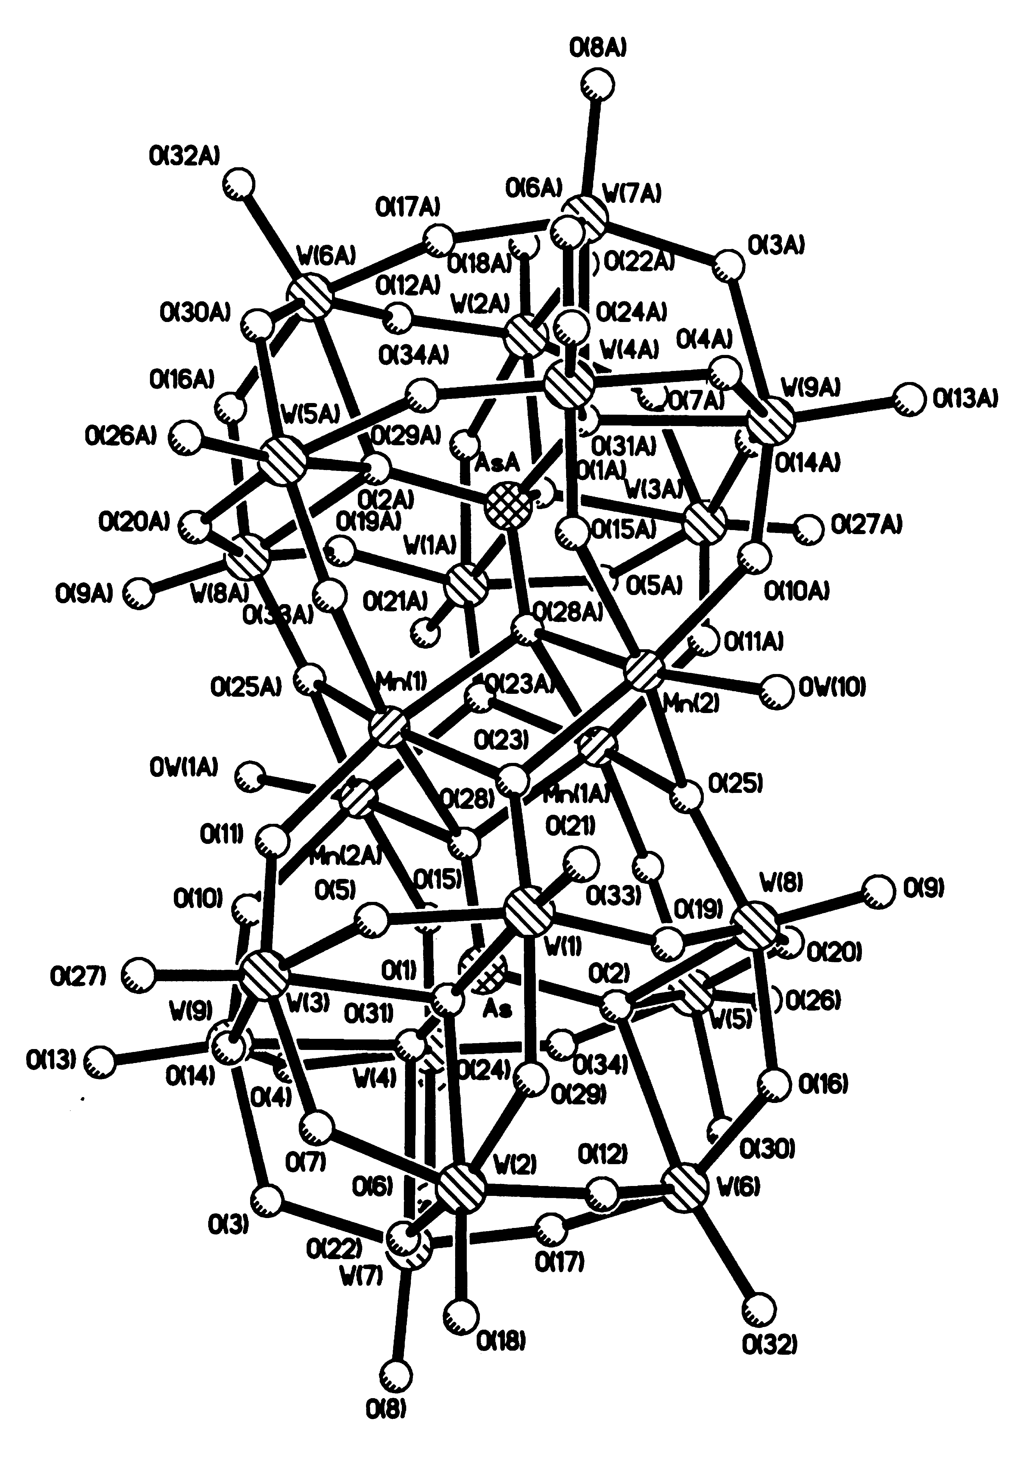
Figure 1. General view of I.

Figure 2. Structure of the central tetrameric unit Cu₄(H₂O)₂O₁₄ in II.

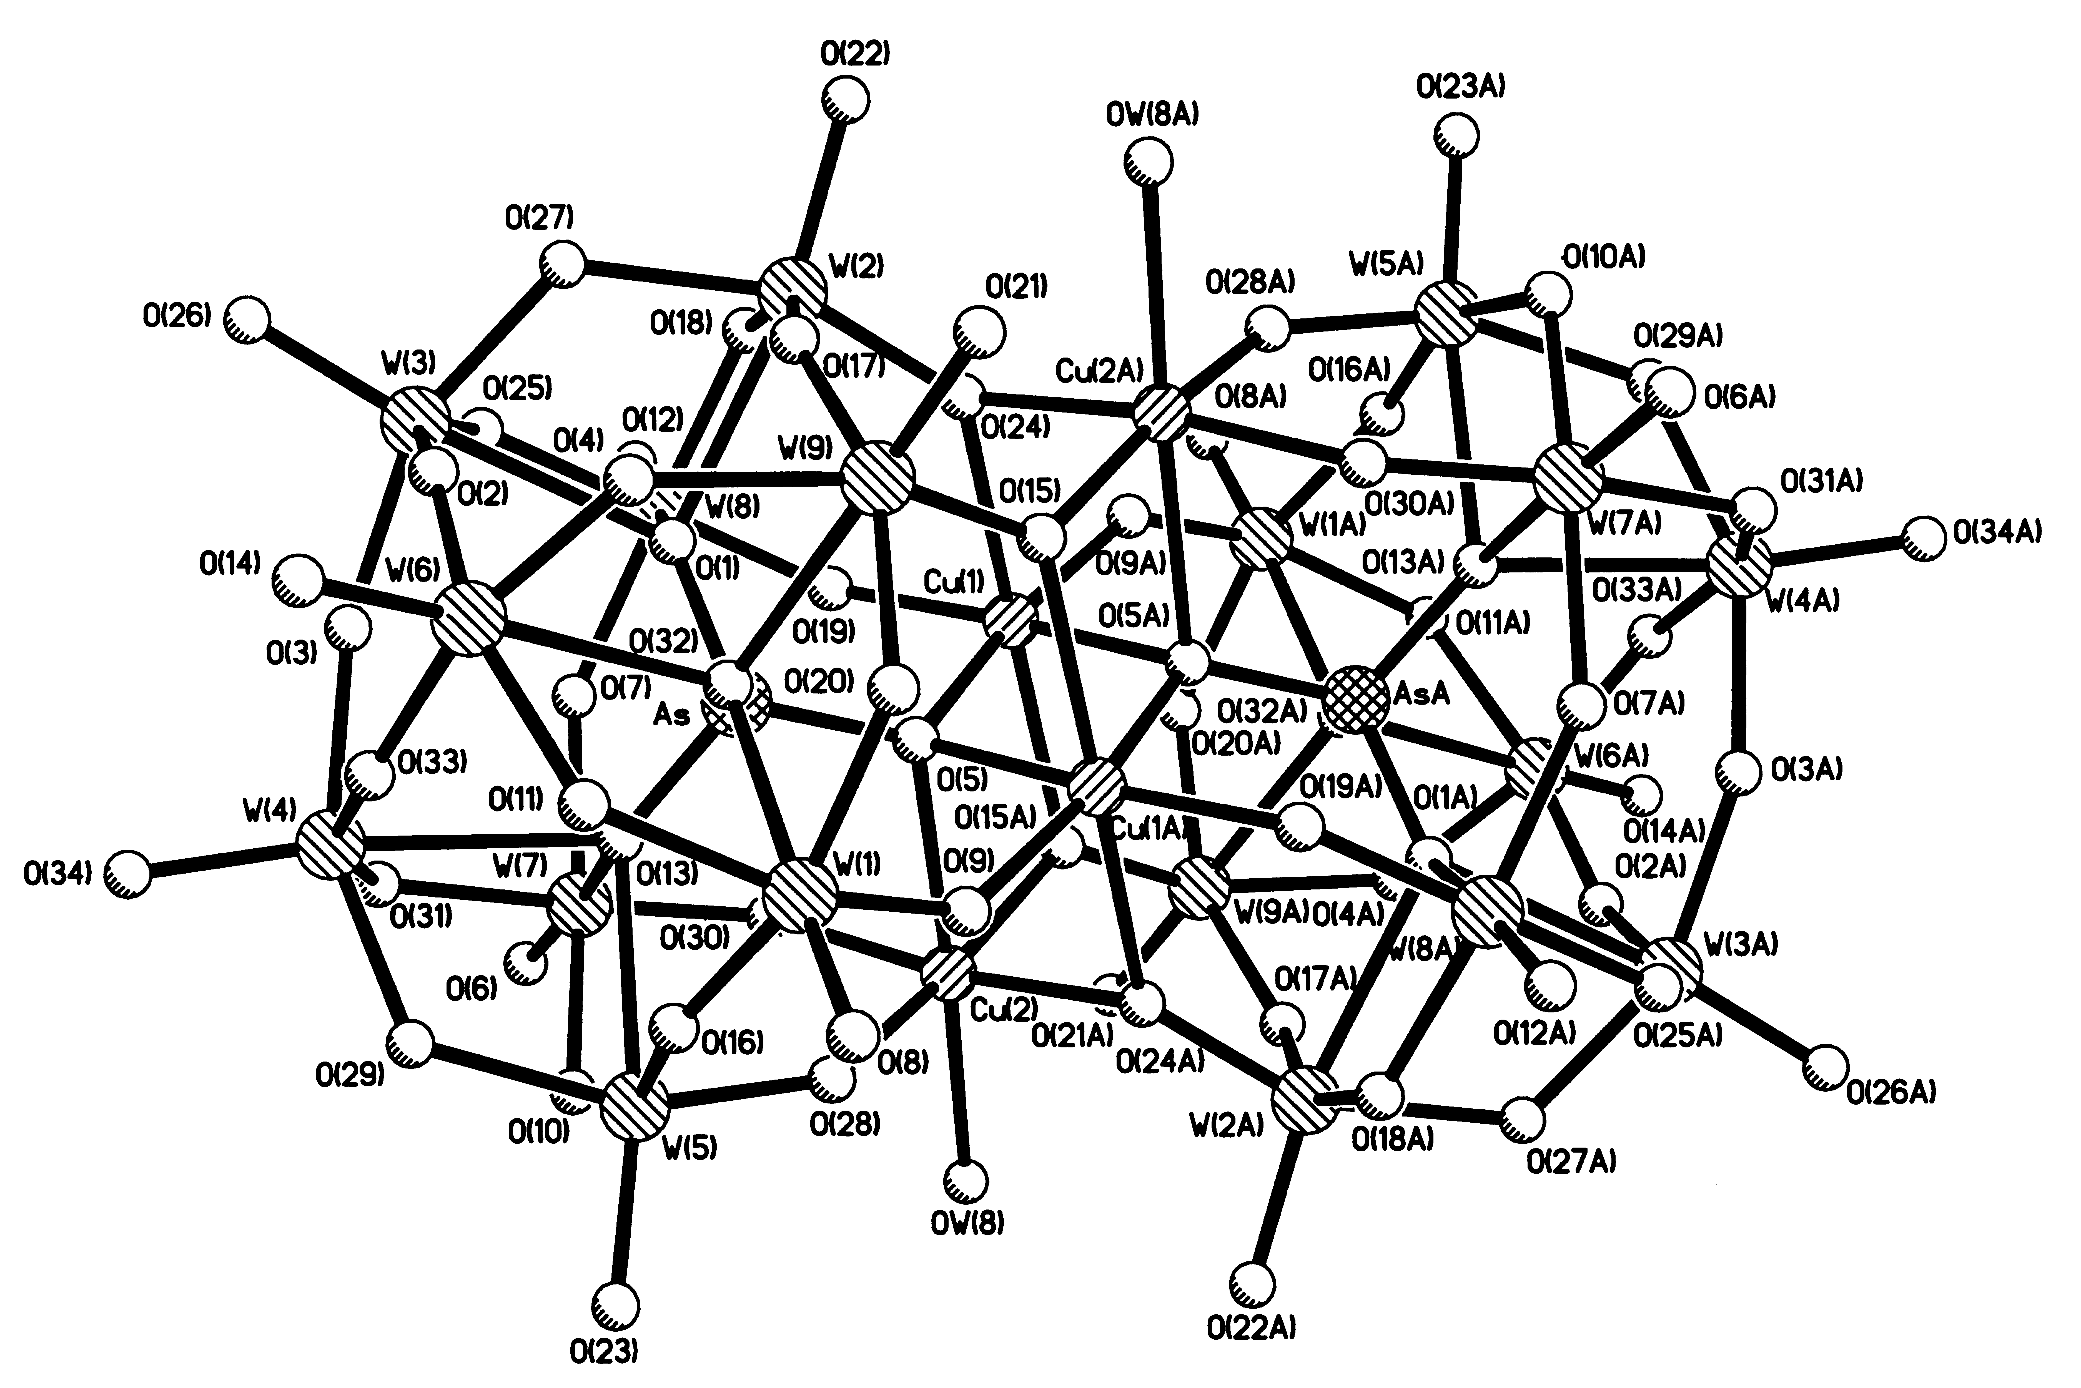
Figure 3. General view of II.
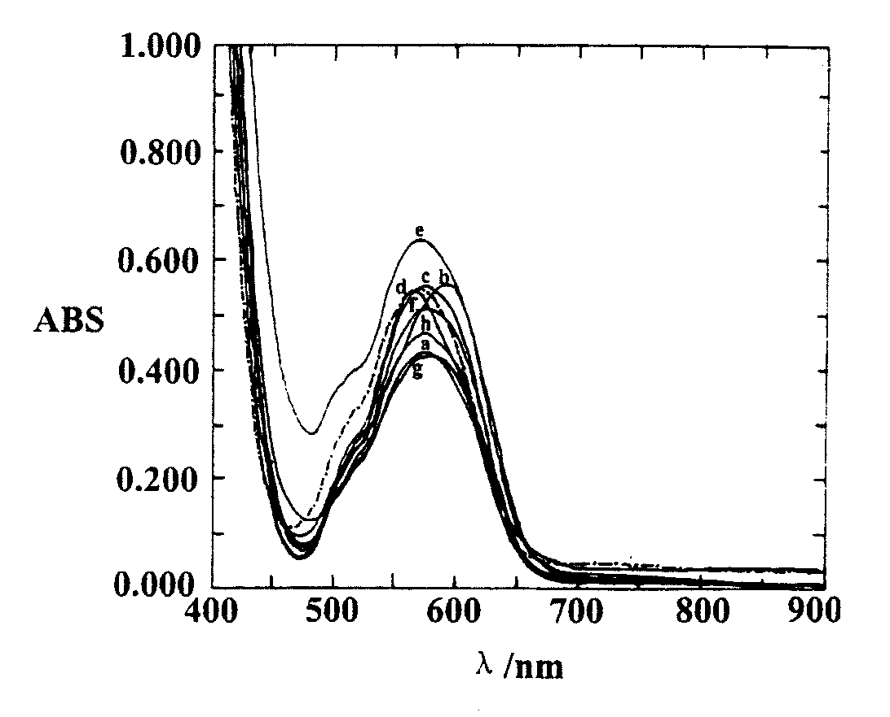

Figure 4. Electronic spectra of Co₄As₂W₁₈ in a aqueous solution (-·-·), in benzene / 0.1M (tHA)Br (a) Co₄As₂W₁₈-H₂O. (b) Co₄As₂W₁₈. (c) Co₄As₂W₁₈-chloroform. (d) Co₄As₂W₁₈-pyridine. (e) Co₄As₂W₁₈-pyrrole. (f) Co₄As₂W₁₈-acetone. (g)Co₄As₂W₁₈-acetonitrile. (h) Co₄As₂W₁₈-lactic acid.

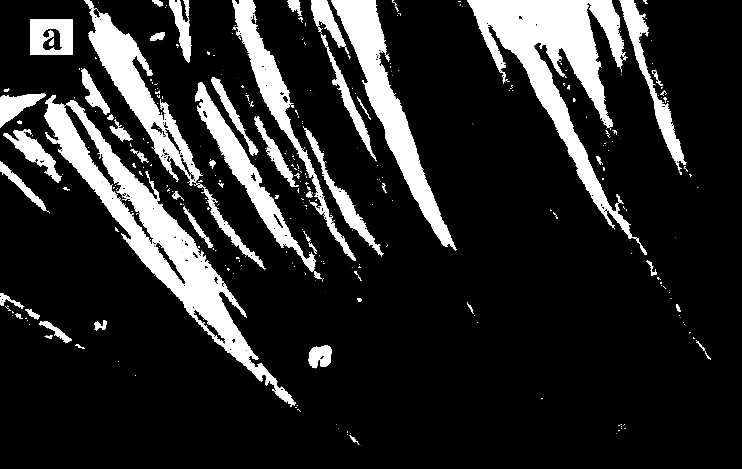
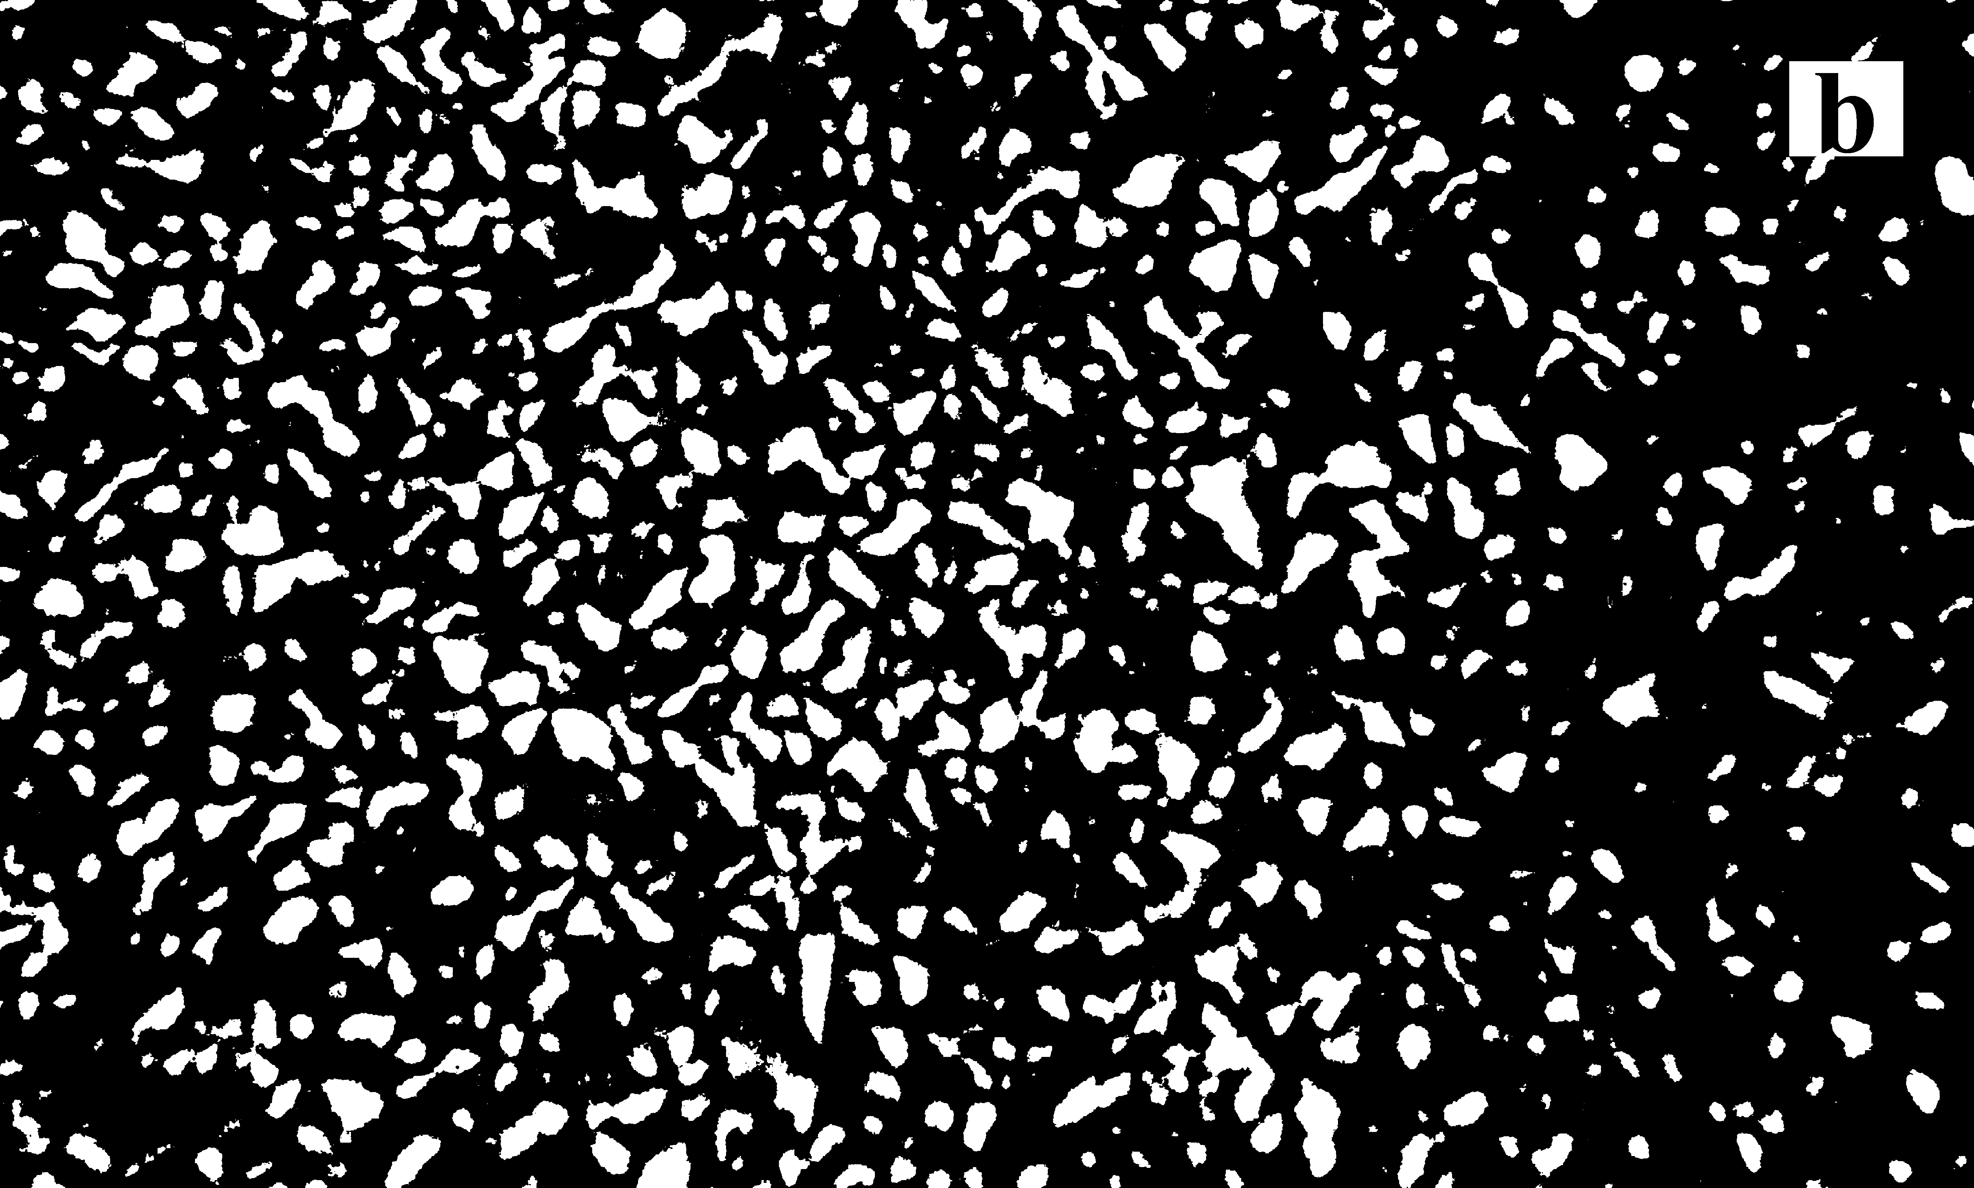
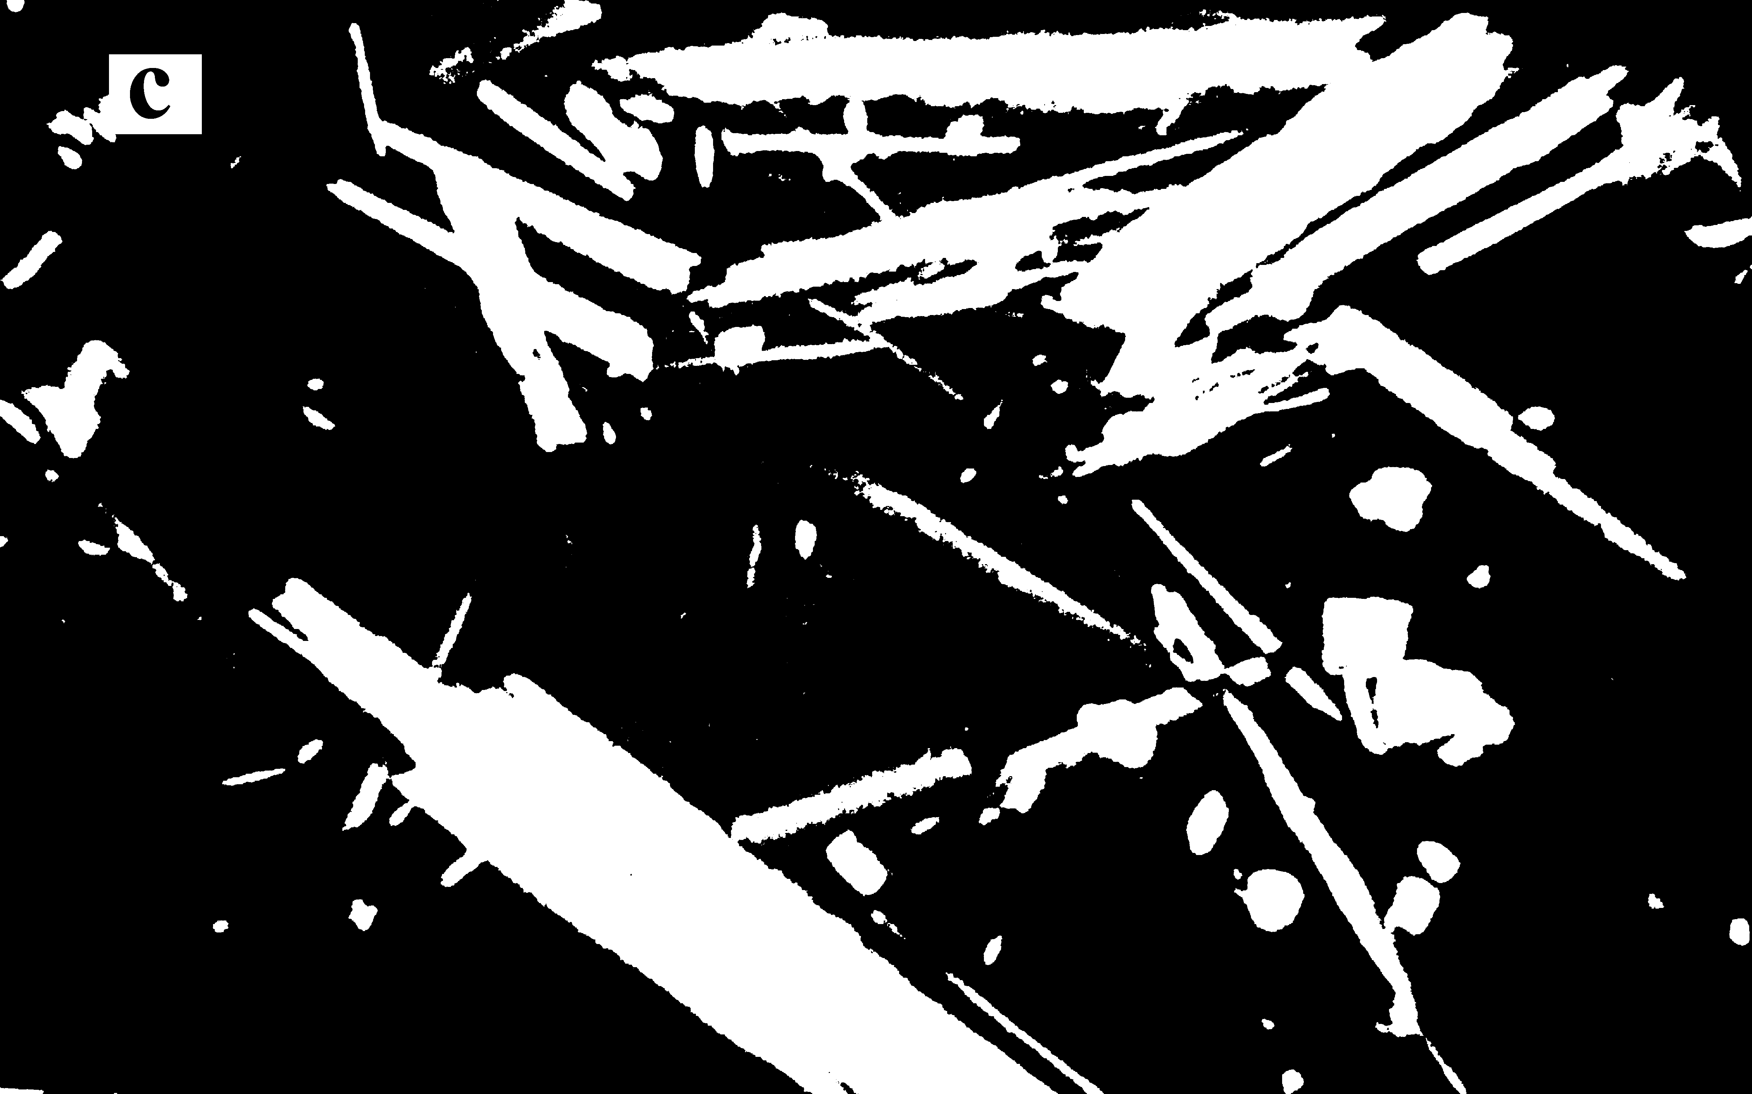
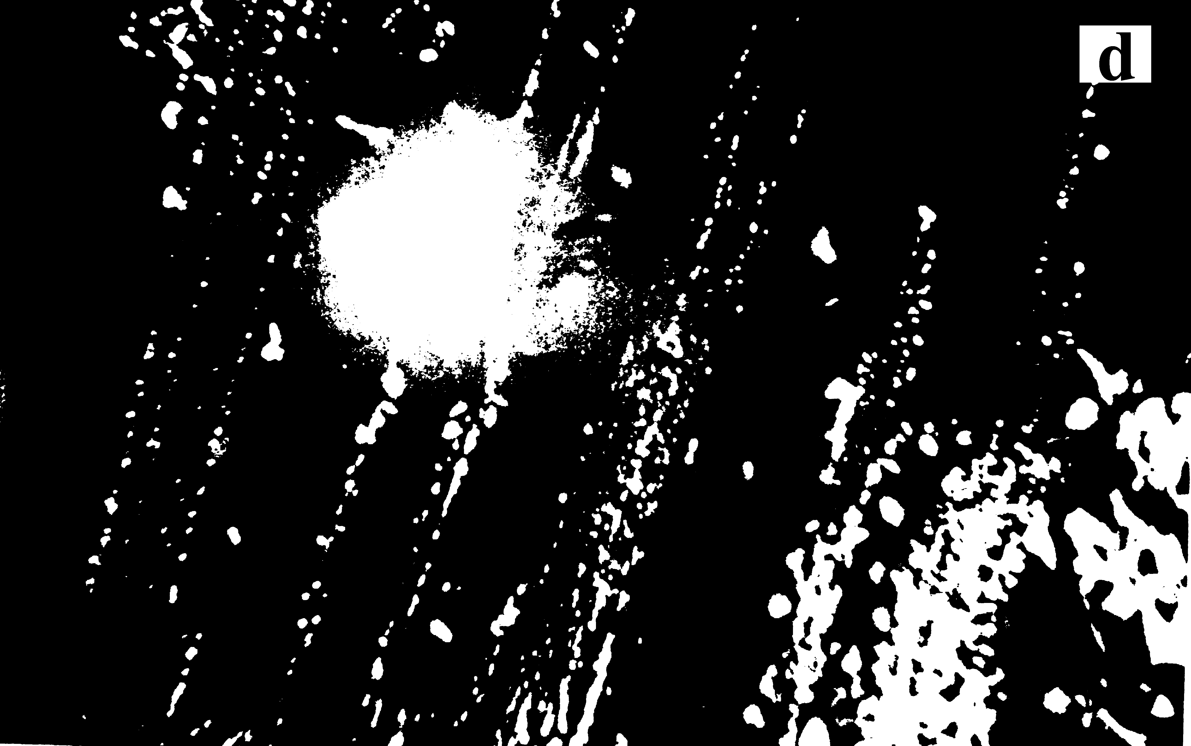
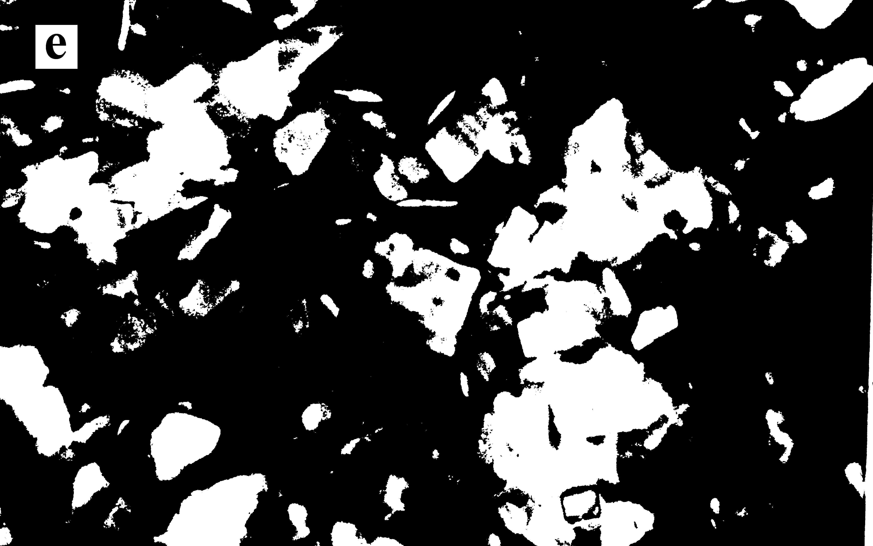
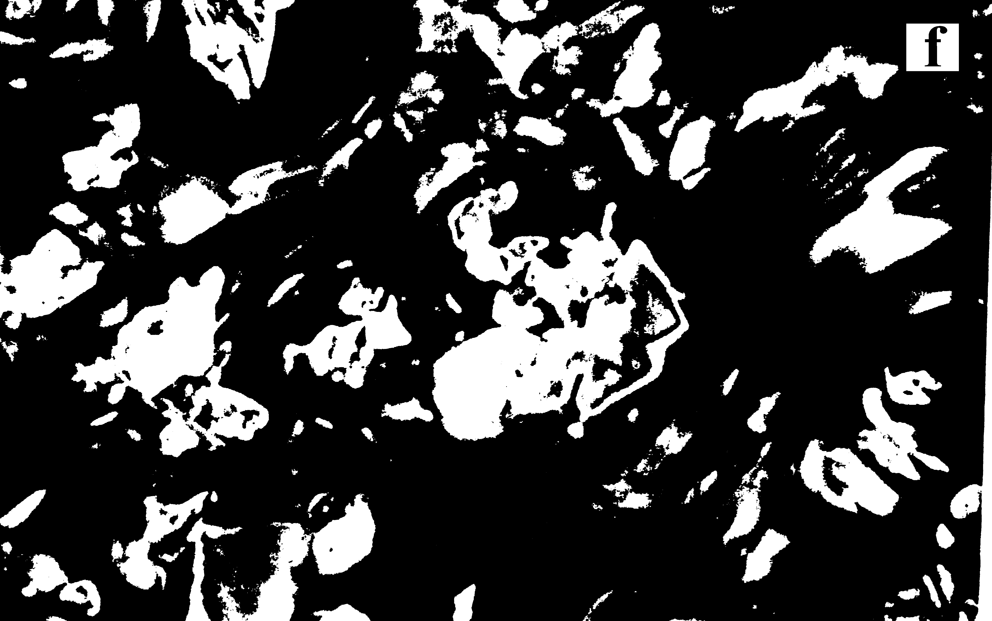
Figure 5. Crystallographic morphologies of Co₄As₂W₁₈ occupied by organic ligands isolated from benzene solutions: Co₄As₂W₁₈ - chloroform (a), Co₄As₂W₁₈ - acetonitrile (b), Co₄As₂W₁₈ - pyridine (c), Co₄As₂W₁₈ -acetone (d), Co₄As₂W₁₈ - pyrrole (e), Co₄As₂W₁₈ - lactic acid (f).

