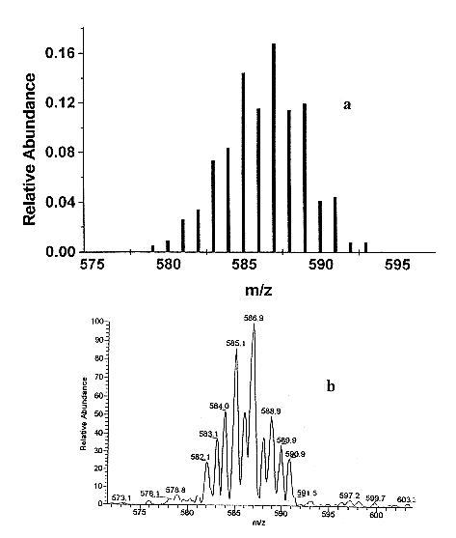
Figure S2. Isotopic distribution of peak 4 [Pt(L-Se-Met)(L-Se-MetH)]⁺ (m/z: 586.9): (a) calculated; (b) experimental.

