Figure S6. 2D [¹H,¹⁵N] HSQC NMR spectrum of the reaction of ¹⁵N-cisplatin with
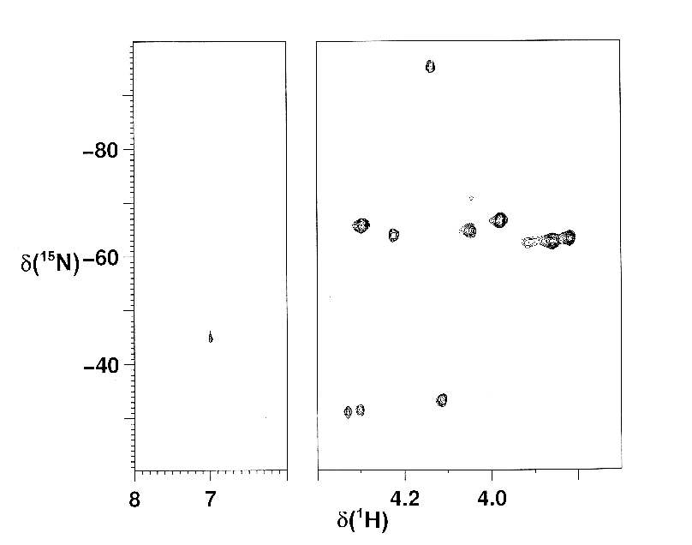
L-Se-MetH at 1:1 molar ratio and at 310 K, recorded after ca 7 h. See text and Figure 5 for the assignment of the cross-peaks.
1a
1a’
1b
3b
3b’
3a
3a’
cisplatin
cis-[Pt(Cl(OH)(NH₃)₂]
?

