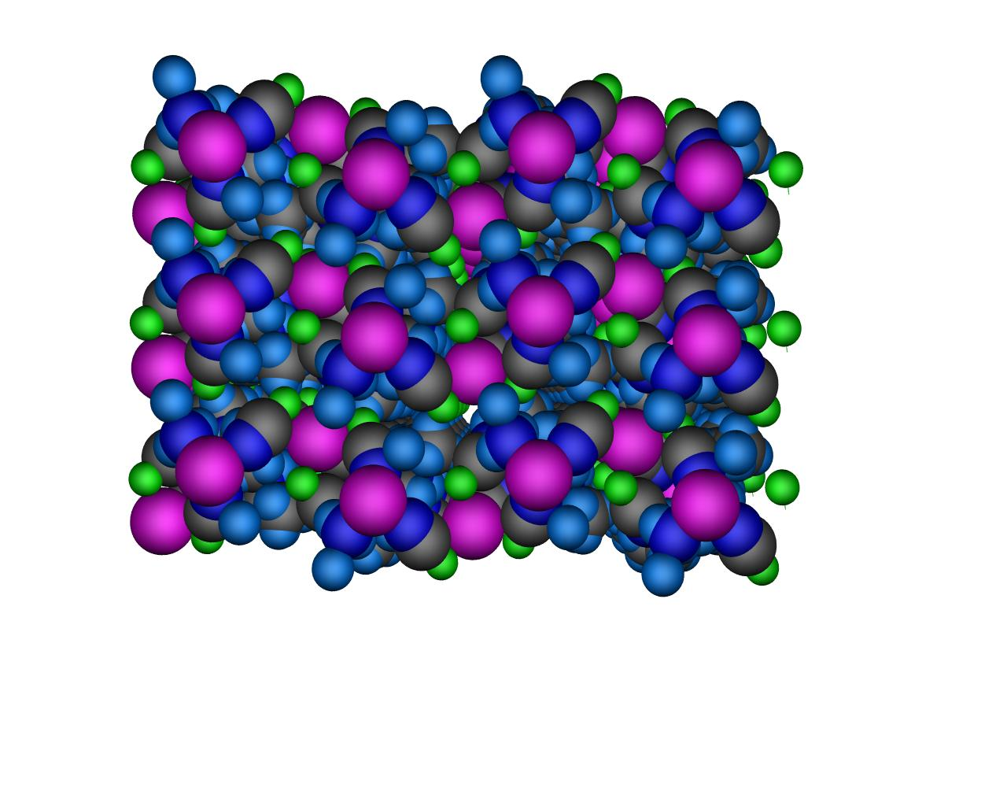
Fig.6 CPK diagram of complex 2 showing no cavities. colour code : Cd - magenta, Se-cyan, C-gray, N-navy blue, H- summer-sky blue

