José A. Montes, Susana Rodríguez, Damián Fernández, M. Inés García-Seijo, Robert O. Gould and M. Esther García-Fernández

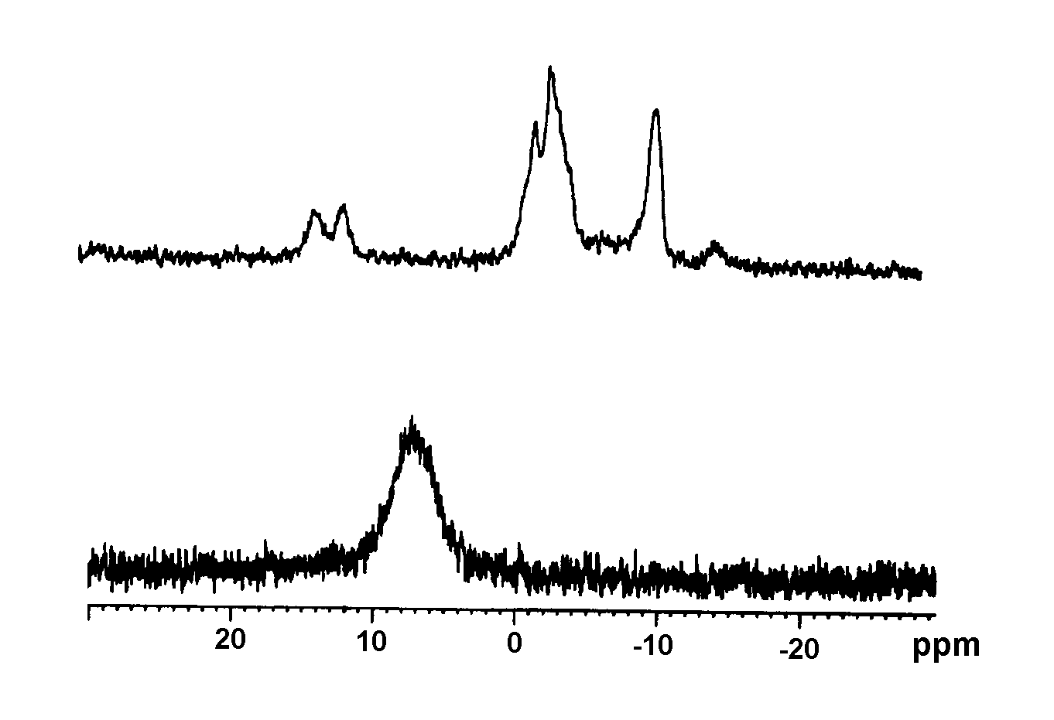
13
13 + 3 equiv PP₃

Figure S1.- ³¹P-{¹H} NMR spectrum for Ag₃(PP₃)(NO₃)₃ (13) in CDCl₃ + DMF and the addition of 3 mol equivalents of PP₃.

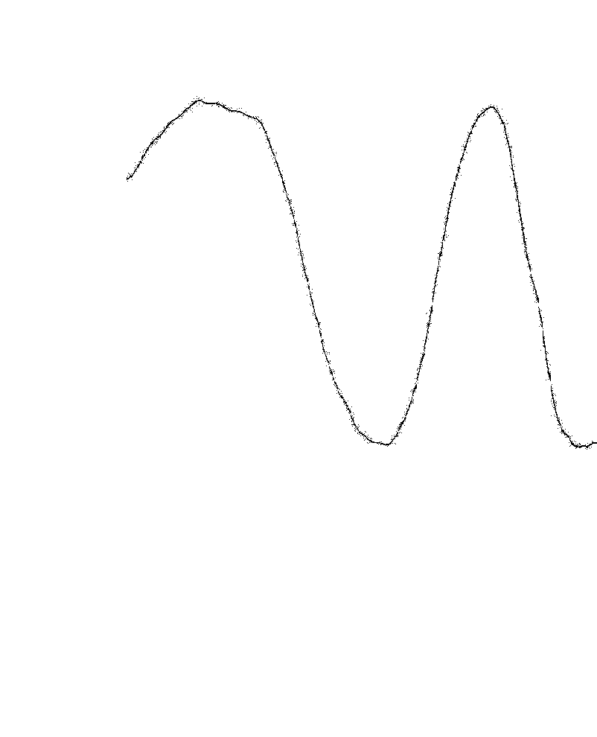
1

Ag — Cl

Ag-Cl
1
Transmitance
204
8
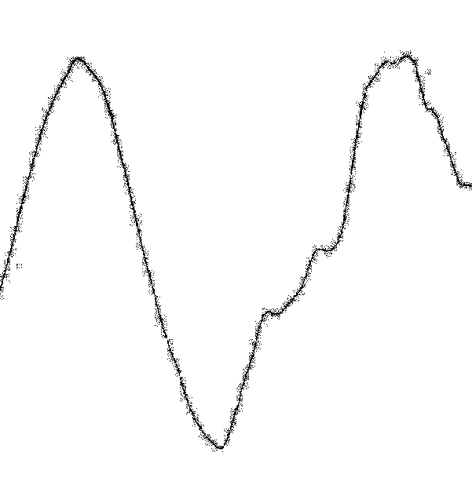
Transmitance

171
8
190
211
Wavenumber / cm⁻¹
211
Figure S2.- Far-IR spectra of 1 and 8. The bands assigned to the ν(Ag-X) modes are labelled with their wavenumbers.

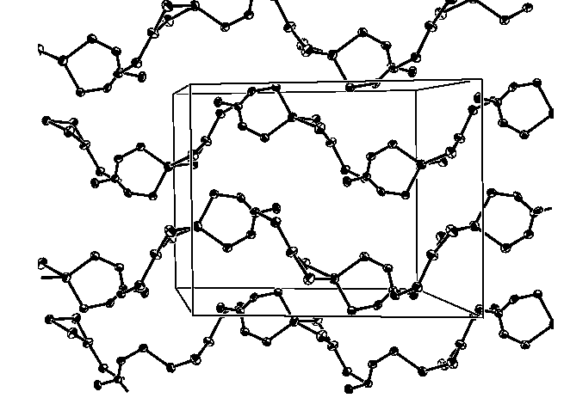

8

Figure S3.- Propagation of the two zigzag chains along the c axis of the unit cell for 8. Phenyl rings are omitted for clarity.

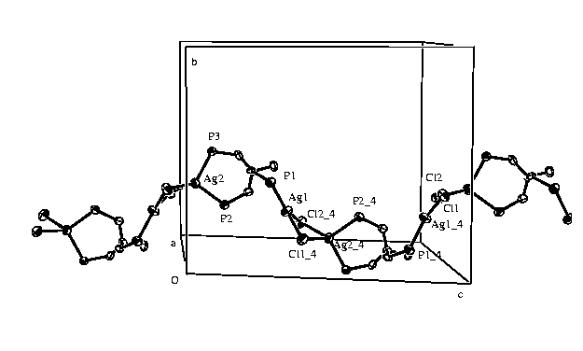
8
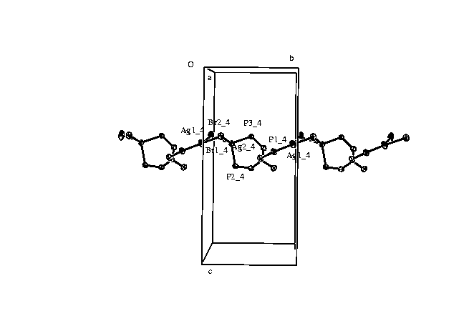
9
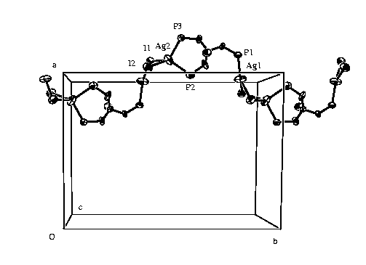10

Figure S4.- Fragment of an infinite chain for 8, 9 and 10 running through the unit cell. Phenyl rings are omitted for clarity.

