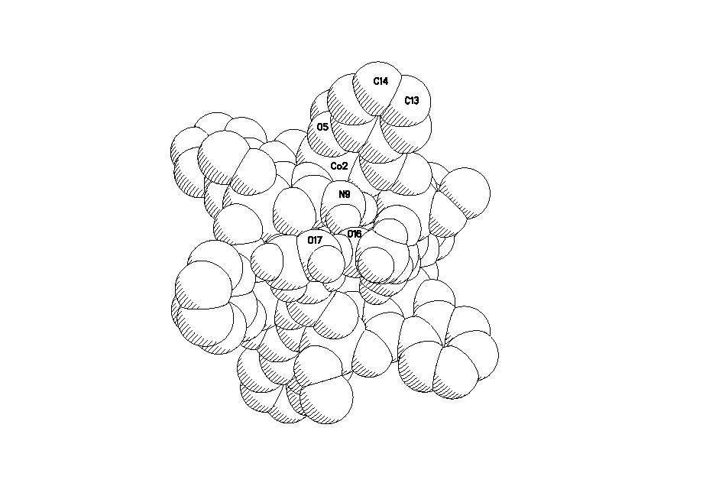

Fig. S1 Space filling of Co₆(amshz)₆(CH₃OH)₆]·10CH₃OH·2H₂O showing that there are two encapsulated solvent methanol molecules in the ‘host’ cavity of the azametallacrown molecule.

