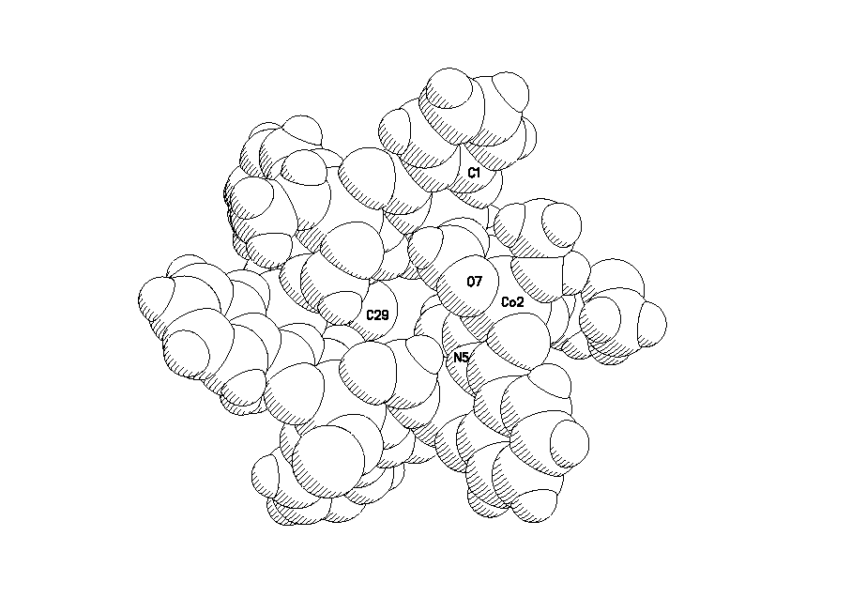

Fig. S2 Space filling of [Co₆(ashz)₆(CH₃OH)₆]·6CH₃OH showing that there are no any guest molecules in the ‘host’ cavity of the azametallacrown molecule.

