Submitted to J. Chem. Soc. Dalton Trans.

Synthesis, Characterization and Properties of Mo₆S₈(4-tert-butylpyridine)₆ and Related M₆S₈L₆ Cluster Complexes (M = Mo, W)

Song Jin, Friedrich Popp, Shannon W. Boettcher,† Min Yuan, Catherine M. Oertel and Francis J. DiSalvo*

Baker Laboratory, Department of Chemistry and Chemical Biology
Cornell University, Ithaca NY 14853, USA

Electronic Supplementary Information

* Author to whom correspondence to be addressed.
† CCMR REU student from Dept. of Chemistry, University of Oregon, Eugene OR.
Email: fjd3@cornell.edu
Telephone number: 607 − 255 − 7238
Fax: 607 − 255 − 4137
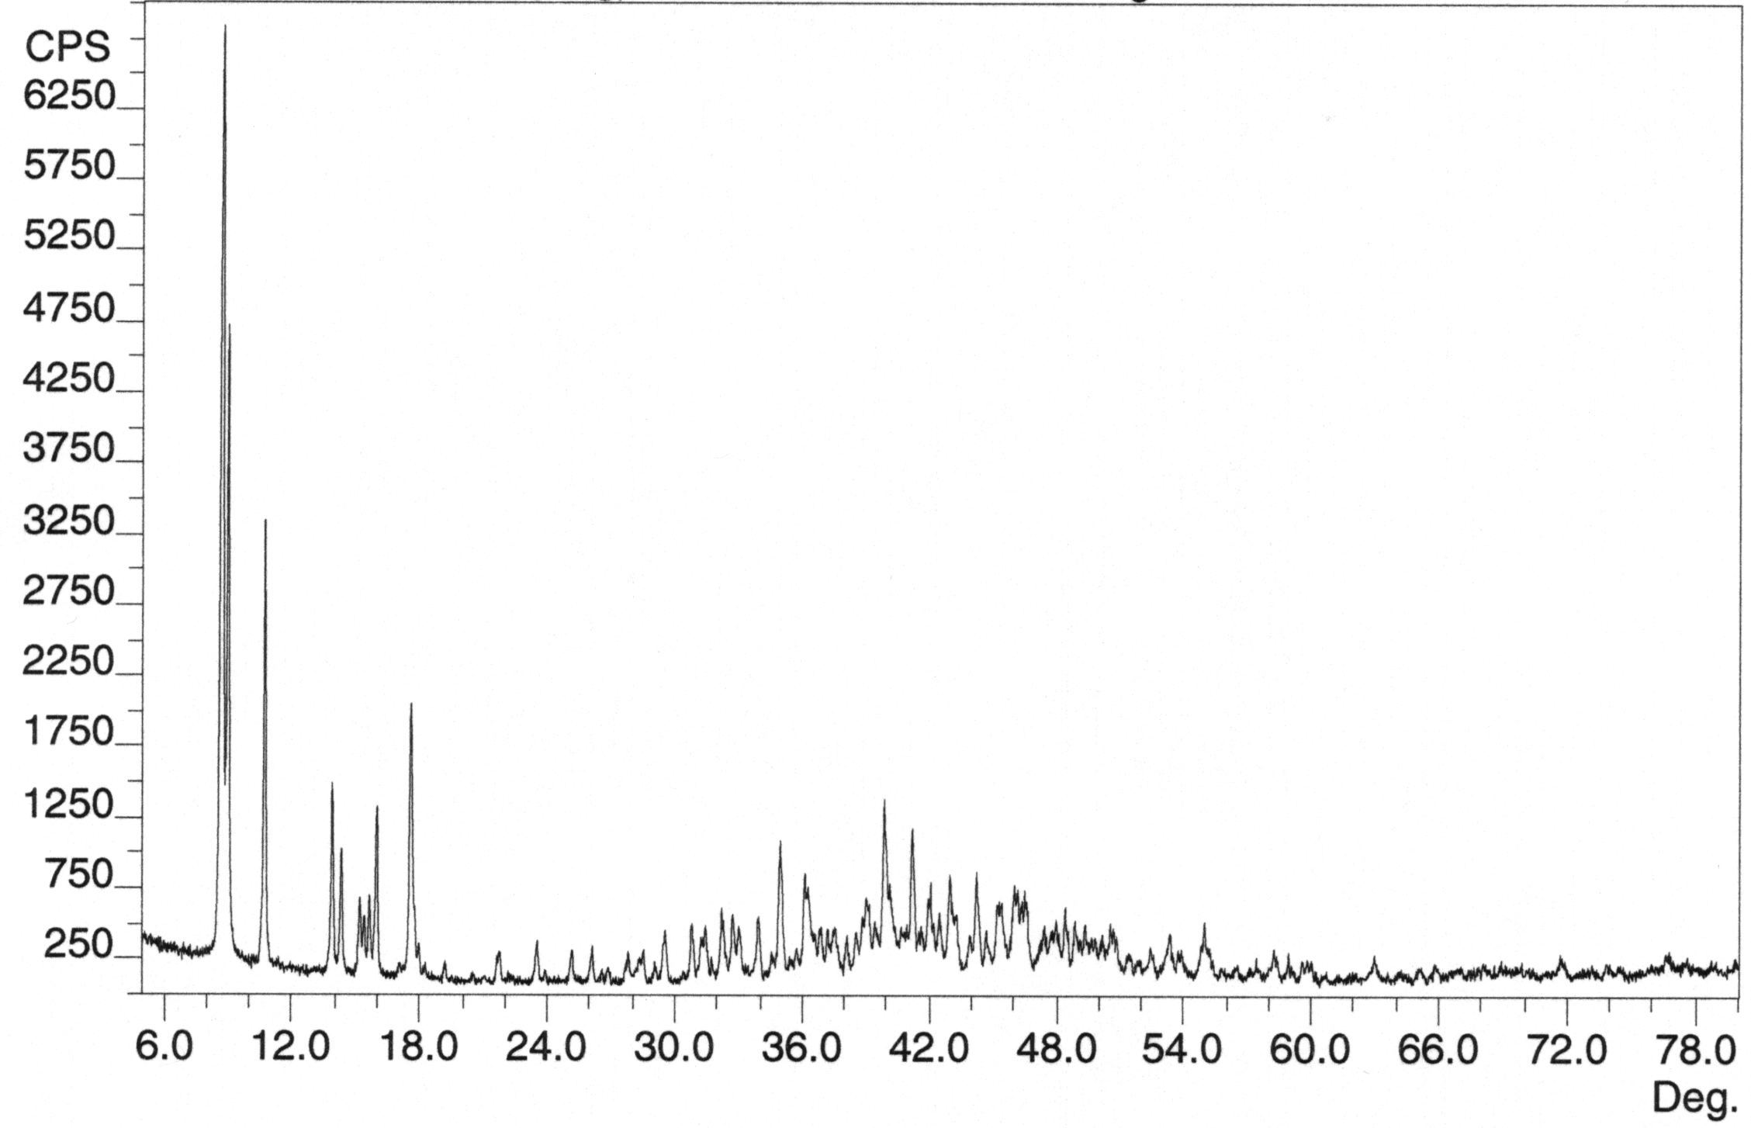
Figure S1. The observed X-ray powder diffraction patterns for compound W₆S₈(morpholine)₆.
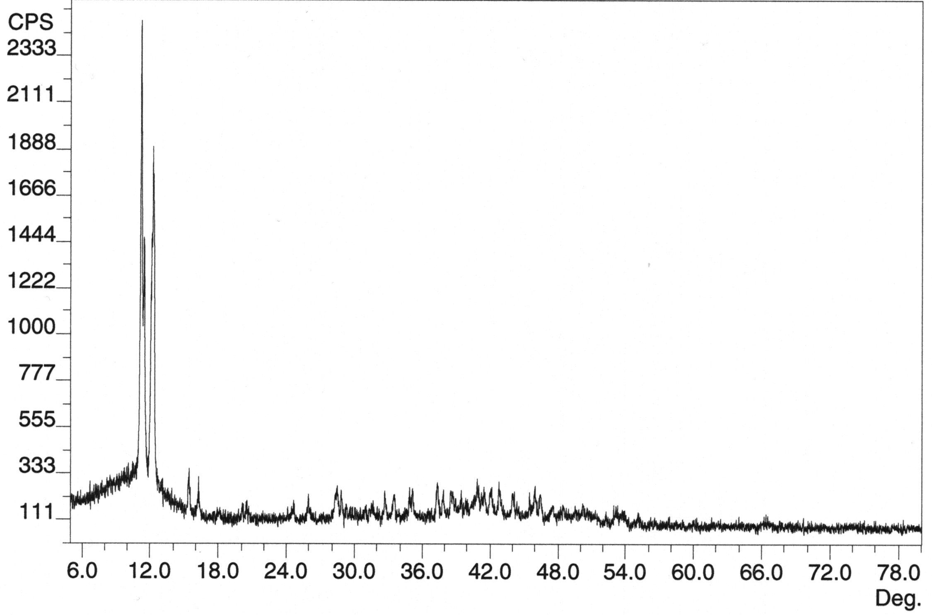
Figure S2. The observed X-ray powder diffraction pattern for compound Mo₆S₈(CH₃NH₂)₆.
Mo₆S₈(CH₃NH₂)₆
Mo₆S₈(bipy)₆
Mo₆S₈(4-tbp)₆
Mo₆S₈(PEt₃)₆
Figure S3. Traces of thermogravimetric analyses of the compounds Mo₆S₈(4-tert-butylpyridine)₆, Mo₆S₈(PEt₃)₆, Mo₆S₈(bipy)₆ and Mo₆S₈(CH₃NH₂)₆. The samples were heated from room temperature to 550°C at the rate of 20°C/min under a flow of dinitrogen (60 mL/min) in a Seiko TG/DTA 220 thermal analyzer.

