Supplementary Information

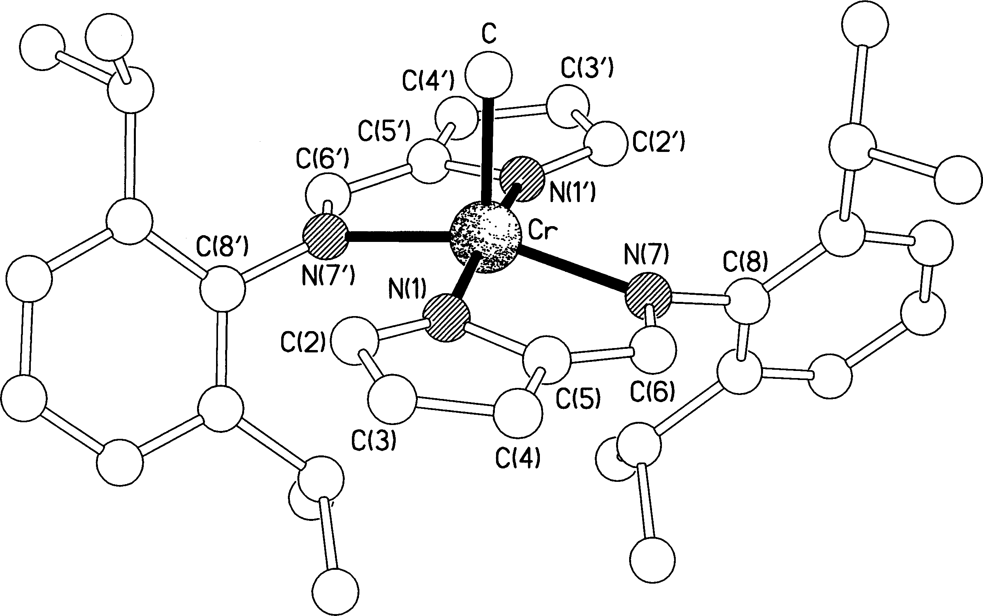

Figure S1 The molecular structure of 3a.

