“Pyridyl donor induced 1,3-silyl migration in metal complexes of the guanidine CyHNC{N(SiMe₃)Py}NCy, Py = 2-(6-MeC₅H₃N)”

by Marcus L. Cole and Peter C. Junk

Supplementary data for compounds 1, 3 and 5

Selected spectroscopic data for 1: ¹H NMR (C₆D₆, 300 K): δ 0.52 (s, 9H, Si(CH₃)₃), 0.86-2.08 (m, 22H, Cy-H), 2.16 (s, 3H, CH₃), 2.09 (br s, 12H, CH₃, pmdien), 2.22 (s, 3H, CH₃, pmdien), 2.34 (br d, 4H, CH₂, pmdien), 2.46 (m, 4H, CH₂, pmdien), 6.24 (d, 1H, Py-H, ²J_{CH} 6.7 Hz), 6.57 (m, 1H, Py-H, ²J_{CH} 7.2 Hz), 7.05 (m, 1H, Py-H). ¹³C NMR (C₆D₆, 300 K): δ 1.3 (s, Si(CH₃)₃), 24.3 (s, CH₃), 25.6, 25.7, 26.7, 26.8, 36.0, 43.5, 46.4, 50.3 (s, Cy-C), 57.4, 57.6, 58.8, 69.5(s, CH₂ and CH₃, pmdien), 105.9, 113.6, 128.5, 138.4, 151.0, 159.3 (s, N₃C and Py-C). IR (Nujol) ν/cm⁻¹: 758m, 843s br, 1037m, 1156m, 1233s br, 1284s br, 1546s, 1570s br, 1598s br, 1651s.

Selected spectroscopic data for 3: ¹H NMR (C₆D₆, 300 K): δ 0.73 (s, 9H, Si(CH₃)₃), 1.16 (t, CH₃, Et₂O, ²J_{CH} 7.0 Hz), 1.26-2.17 (m, 22H, Cy-H), 1.95 (s, 3H, CH₃), 2.04 (br s, 12H, CH₃, pmdien), 2.09 (m, 8H, CH₂, pmdien), 2.29 (s, 3H, CH₃, pmdien), 3.32 (q, CH₂, Et₂O, ²J_{CH} 7.0 Hz), 6.07 (d, 1H, Py-H, ²J_{CH} 6.7 Hz), 6.45 (d, 1H, Py-H, ²J_{CH} 8.5 Hz), 7.16 (dd, 1H, Py-H, ²J_{CH} 6.7 and 8.5 Hz). ¹³C NMR (C₆D₆, 300 K): δ 6.8 (s, Si(CH₃)₃), 15.9, 26.2, 27.2, 27.3, 28.2, 29.3, 35.9, 42.0, 43.1 45.7, 49.1 (s, Cy-C, CH₃ and Et₂O), 55.8, 56.2, 57.7, 66.2 (s, CH₂ and CH₃, pmdien), 104.3, 108.1, 136.5, 155.1, 164.1, 166.9 (s, N₃C and Py-C). IR (Nujol) ν/cm⁻¹: 760m, 774m, 841s br, 942m, 1029m, 1120w, 1161m, 1234s br, 1286s br, 1538m sh, 1571s br, 1635s.

Selected spectroscopic data for 5: ¹H NMR (C₆D₆, 300 K): δ 0.41 (s, 9H, Si(CH₃)₃), 0.78-2.13 (m, 22H, Cy-H), 2.26 (s, 3H, CH₃), 6.28 (m, 1H, Py-H), 6.43 (d, 1H, Py-H, ²J_{CH} 7.1 Hz), 6.81 (d, 1H, Py-H, ²J_{CH} 7.6 Hz). ¹³C NMR (C₆D₆, 300 K): δ 1.3 (s, Si(CH₃)₃), 25.2, 34.2, 43.8, 46.4, 49.7 (s, Cy-C and CH₃), 105.8, 113.5, 118.4, 137.3, 138.4, 154.3 (s, N₃C and Py-C). IR (Nujol) ν/cm⁻¹: 793m, 842m, 871m, 1031s, 1133m, 1148m, 1259m br, 1304m, 1555s sh, 1581s sh, 1621s, 3422s.

Molecular structure of 5 from [{LiCl(pmdien)}₂].2(5). Full details to be published at a later date.

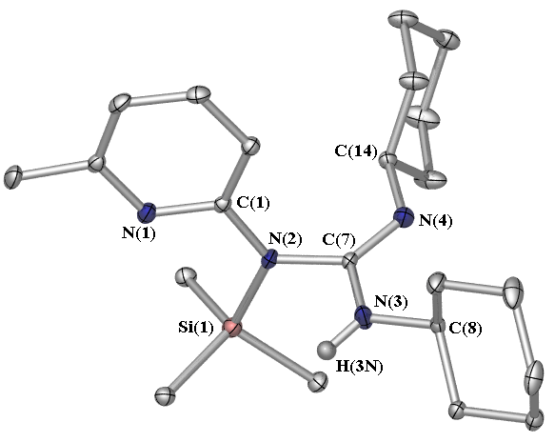

Selected bond lengths (Å) and angles (º): N(2)-C(7) 1.440(2), N(3)-C(7) 1.367(2), N(4)-C(7) 1.277(2), N(1)-C(1)-N(2) 113.7(2), N(2)-C(7)-N(3) 111.8(2), N(2)-C(7)-N(4) 126.6(2), N(3)-C(7)-N(4) 121.6(2), C(7)-N(3)-C(8) 122.4(2), C(7)-N(2)-Si(1) 121.3(1), C(1)-N(2)-Si(1) 121.7(1), C(1)-N(2)-C(7) 116.9(2).

