Synthesis and properties of [M^{II}(L⁶)₂][ClO₄]₂ (M = Fe, Co and Ni): structures of Co and Ni complexes and spin-state transition by Fe complex (L⁶ = 2-[3-(2΄-pyridyl)pyrazol-1-ylmethyl]pyridine)

Shubha Singh, Vibha Mishra, Jhumpa Mukherjee, N. Seethalekshmi and Rabindranath Mukherjee*

Department of Chemistry, Indian Institute of Technology, Kanpur-208 016, India
Fax: +91-512-2597437; E-mail: rnm@iitk.ac.in

-Supplementary Material-

Fig. S1-S3. IR Spectra of compounds 1 – 3.

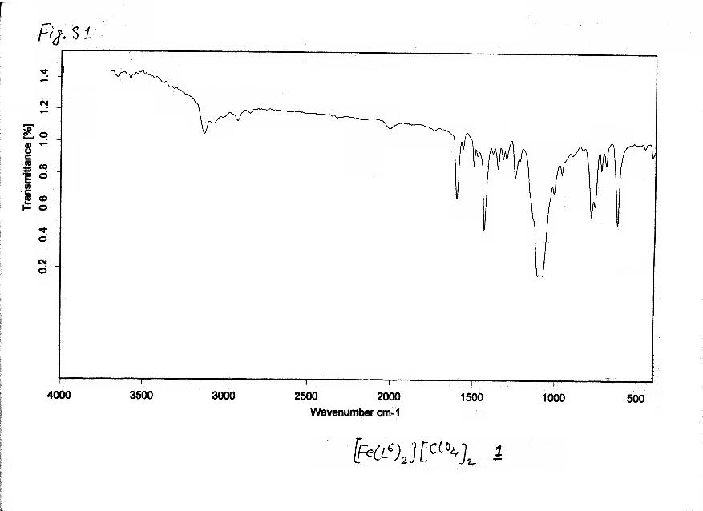

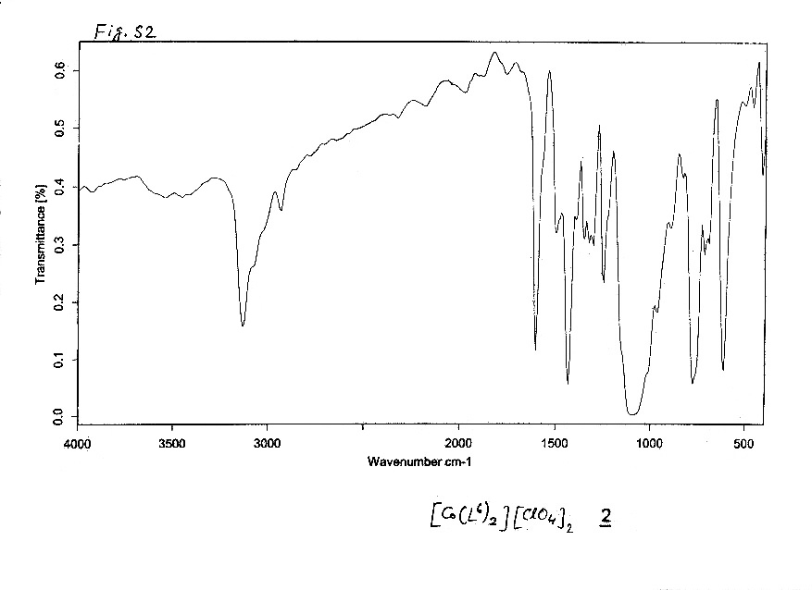
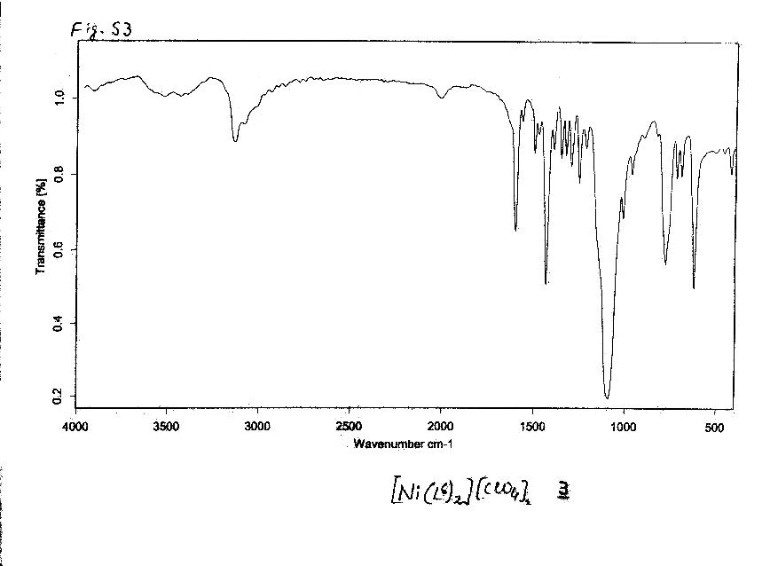

Fig. S4. Absorption spectrum of [Ni(L⁶)₂][ClO₄]₂, (3) in MeCN.

Fig. S5. Plot of reciprocal molar susceptibility vs. temperature for [Co(L⁶)₂][ClO₄]₂, (2).

Fig. S6. Curie-Weiss plot [χ_{M} = C / (T - θ)] for [Ni(L⁶)₂][ClO₄]₂, (3).

