Synthesis, characterization, and reactivity of heterobimetallic complexes (η⁵-C₅R₅)Ru(CO)(μ-dppm)M(CO)₂(η⁵-C₅H₅) (R = H, CH₃; M = Mo, W). Interconversion of hydrogen/carbon dioxide and formic acid by these complexes.
Man Lok Man, Zhongyuan Zhou, and Chak Po Lau*

Department of Applied Biology & Chemical Technology, The Hong Kong Polytechnic University, Hung Hom, Kowloon, Hong Kong, China.
Email: bccplau@polyu.edu.hk Fax: 852-23649932; Tel: 852-27665619

Supporting information
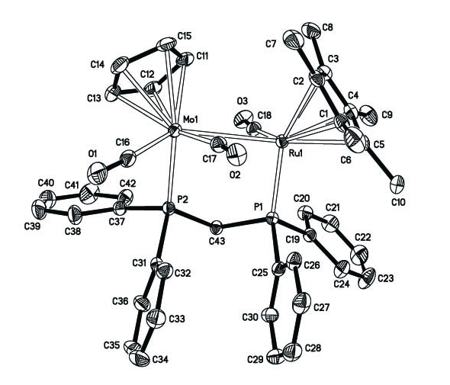

X-ray structure of Cp*Ru(CO)(μ-dppm)Mo(CO)₂Cp (2).
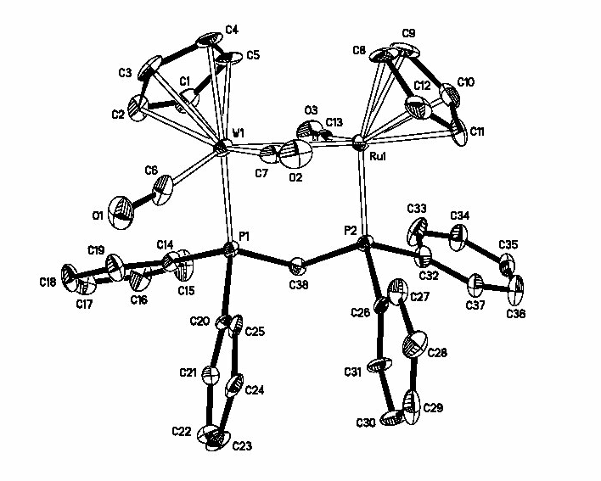

X-ray structure of CpRu(CO)(μ-dppm)W(CO)₂Cp (3).
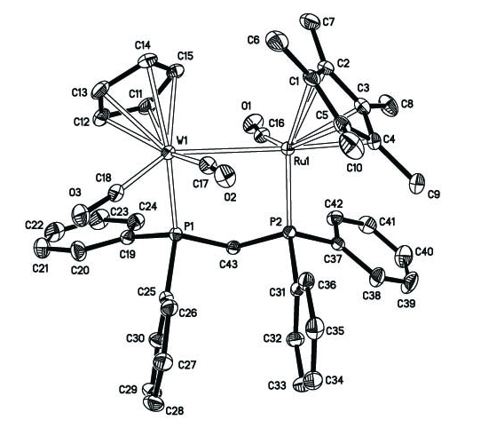

X-ray structure of Cp*Ru(CO)(μ-dppm)W(CO)₂Cp (4).
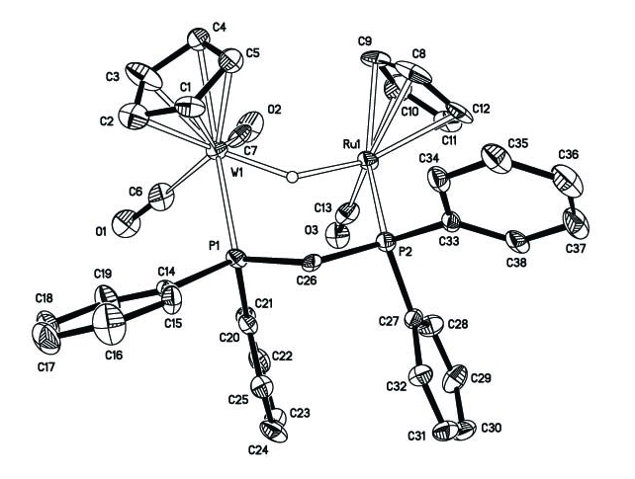

X-ray structure of [CpRu(CO)(μ-dppm)(μ-H)W(CO)₂Cp][Cl] (6·Cl).
Selected bond distance (Å) and angles (deg) for Cp*Ru(CO)(μ-dppm)Mo(CO)₂Cp (2).

Interatomic distance (Å)

Ru (1) – Mo (1) 3.0693(4) Mo (1) – C (16) 1.930(2)
Ru (1) – P (1) 2.2882(6) Mo (1) – C (17) 1.953(2)
Mo (1) – P (2) 2.4022(7) Ru (1) – C (18) 1.818(2)
O (1) – C (16) 1.145(3) O (2) – C (17) 1.172(3)
O (3) – C (18) 1.170(3)

Intramolecular angles (deg)

P (1) – Ru (1) – Mo (1) 92.026(14) O (1) – C (16) – Mo (1) 175.7(2)
P (2) – Mo (1) – Ru (1) 85.467(14) O (2) – C (17) – Mo (1) 164.54(18)
P (2) – C (43) – P (1) 108.18(11) O (3) – C (18) – Ru (1) 169.12(19)
C (19) – P (1) – Ru (1) 114.01(7) C (25) – P (1) – Ru (1) 121.48(7)
C (31) – P (2) – Mo (1) 122.96(7) C (37) – P (2) – Mo (1) 109.25(7)

Selected bond distance (Å) and angles (deg) for CpRu(CO)(μ-dppm)W(CO)₂Cp (3).

Interatomic distance (Å)

W (1) – Ru (1) 3.0246(11) W (1) – C (6) 1.926(6)
Ru (1) – P (2) 2.2565(12) W (1) – C (7) 1.9373(19)
W (1) – P (1) 2.4223(12) Ru (1) – C (13) 1.793(4)
O (1) – C (6) 1.180(7) O (2) – C (7) 1.1887(17)
O (3) – C (13) 1.201(5)

Intramolecular angles (deg)

P (1) – W (1) – Ru (1) 84.83(4) O (1) – C (6) – W (1) 174.1(4)
P (2) – Ru (1) – W (1) 93.18(5) O (2) – C (7) – W (1) 168.4(3)
P (1) – C (38) – P (2) 107.46(16) O (3) – C (13) – Ru (1) 171.2(3)
C (14) – P (1) – W (1) 111.97(12) C (20) – P (1) – W (1) 121.38(11)
C (26) – P (2) – Ru (1) 123.24(11) C (32) – P (2) – Ru (1) 111.06(14)

Selected bond distance (Å) and angles (deg) for Cp*Ru(CO)(μ-dppm)W(CO)₂Cp (4).

Interatomic distance (Å)

W (1) – Ru (1) 3.0695(4) Ru (1) – C (16) 1.815(3)
Ru (1) – P (2) 2.2805(8) W (1) – C (17) 1.942(4)
W (1) – P (1) 2.3970(8) W (1) – C (18) 1.919(3)
O (1) – C (16) 1.163(4) O (2) – C (17) 1.180(4)
O (3) – C (18) 1.167(4)

Intramolecular angles (deg)

P (1) – C (43) – P (2) 107.92(14) O (1) – C (16) – Ru (1) 169.1(2)
P (1) – W (1) – Ru (1) 85.233(16) O (2) – C (17) – W (1) 168.6(2)
P (2) – Ru (1) – W (1) 91.775 (17) O (3) – C (18) – W (1) 175.3(3)
C (19) – P (1) – W (1) 109.29(9) C (25) – P (1) – W (1) 122.71(10)
C(31) – P (2) – Ru (1) 121.48(9) C (37) – P (2) –Ru (1) 113.87(8)
Selected bond distance (Å) and angles (deg) for [CpRu(CO)(μ-dppm)(μ-H)W(CO)₂Cp][Cl] (6·Cl).

Interatomic distance (Å)

Ru (1) – H (1B) 1.85(7) W (1) – H (1B) 1.70 (6)
Ru (1) – P (2) 2.3097(12) W (1) – P (1) 2.4639(11)
W (1) – C (6) 1.859(5) O (1) – C (6) 1.219(6)
W (1) – C (7) 1.973(5) O (2) – C (7) 1.164(5)
Ru (1) – C (13) 1.879(4) O (3) – C (13) 1.145(5)

Intramolecular angles (deg)

P (2) – C (26) – P (1) 113.25(17) C (14) – P (1) – W (1) 112.30(9)
O (1) – C (6) – W (1) 176.8(3) C (20) – P (1) – W (1) 121.35(12)
O (2) – C (7) – W (1) 176.7(3) C (27) – P (2) – Ru (1) 119.60(13)
O (3) – C (13) – Ru (1) 169.0(4) C (33) – P (2) – Ru (1) 112.68(12)
Discussion on the structure of 6·Cl. The ³¹P{¹H} NMR spectrum of 6·Cl, the pattern of which is very similar to that of 5·Cl or 5·BF₄, consists of two doublets at δ 14.3 and 40.5 ppm (J(PP) = 53.5 Hz), corresponding to the two phosphorous atoms of the bridging dppm. In the ¹H NMR spectrum of 6·Cl, the hydride signal is a doublet of doublet of doublet (J(HP) = 27.6 Hz, J(HP) = 19.2 Hz, J(HH) = 5.2 Hz), showing unequal H-P coupling constants; it also couples to one of the methylene hydrogen of dppm. Unlike the molybdenum analogue 5·Cl, which resists single crystal growing, 6·Cl yields good quality single crystals suitable for X-ray diffraction study readily.

The hydride ligand, which is located and refined, bridges slightly asymmetrically the two metal centers, being closer to the tungsten atom (W-H = 1.70 (6) Å) then to the ruthenium atom (Ru-H = 1.85 (7) Å). The large separation between W and Ru excludes metal-metal bonding interaction between the metal centers. Similar to 5⁺, the P-C-P angle of the dppm ligand in 6⁺ opens up to 113.25(17)º, as opposed to 107.46(16)º in the parent complex 3. None of the carbonyl ligands in 6⁺ is bridging or semi-bridging, this is consistent with the IR data, which show no stretch below 1860cm⁻¹ in the carbonyl region. The distance between the two metal centers is 3.250(6)Å, that no metal-metal bond exists.

