Supplementary Material
B309809P (Dalton Transactions)

Title: Direct Gas-Phase Interaction of Aryldiazoacetates and Dirhodium Catalysts
Authors: Marina A. Petrukhina,* Kristian W. Andreini, Abbas M. Walji and Huw M. L. Davies
---------------------------------------------------------------------------------------------------------------------

NMR spectra were obtained using 300 MHz Varian Gemini spectrometer at 300 MHz for ¹H at room temperature. Chemical shifts are reported in ppm relative to CHCl₃ (7.24 ppm) for ¹H.

Compound (1), [Rh₂(O₂CCMe₃)₄(CH₃OC₆H₄C(COCH₃O)N)₂].
¹H NMR (CDCl₃, 22 °C): δ 0.99 (CH₃), 3.71 (CH₃O), 3.99 (CH₃O), 6.91 (Ar), 7.67 (Ar).

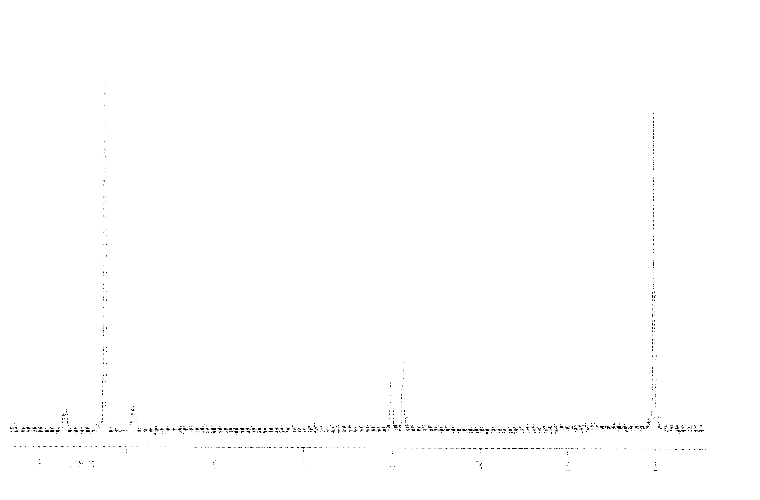

Compound (2), [Rh₂(O₂CCF₃)₄(CH₃OC₆H₄C(COCH₃O))₂]
¹H NMR (CDCl₃, 22 °C): δ 3.79 (CH₃O), 3.85 (CH₃O), 6.94 (Ar), 7.35 (Ar).



