Supporting Information

Kinetics and mechanism of water substitution in the low spin Fe(II) complex

of 4-octasulfophenylpyrazinoporphyrazine

Evgeny V. Kudrik, Rudi van Eldik and Sergei V. Makarov

Figure S1. ¹H NMR spectrum of (Py)₂FePyzPz(PhSO₃⁻)₈ in the presence of Py in D₂O. Experimental conditions: [(Py)₂FePyzPz(PhSO₃⁻)₈] = 1.2 x 10⁻³ M, [Py] = 0.21 M.

Figure S2. Scatchard plots for the reaction of (H₂O)₂FePyzPz(PhSO₃⁻)₈ with Py as a function of temperature. Experimental conditions: pH = 12.4 (NaOH), 25 ⁰C - open circles, 30 ⁰C – open triangles, 35 ⁰C – filled triangles.

Figure S3. Typical kinetic trace for the interaction of (H₂O)₂FePyzPz(PhSO₃⁻)₈ (2 x 10⁻⁵ M) with Py (0.07 M). Experimental conditions: λ = 645 nm, pH = 7 (0.1 M TRIS buffer), 25 ⁰C.

Figure S4. Van ‘t Hoff plots for the reaction of (H₂O)₂FePyzPz(PhSO₃⁻)₈ (2 x 10⁻⁵ M) with Py (triangles) and 4-CNPy (squares) at 25 ⁰C and pH = 7 (0.1 M TRIS buffer).

Figure S5. Plot of lnk_{obs} vs. pressure for the reaction of (H₂O)₂FePyzPz(PhSO₃⁻)₈ (2 x 10⁻⁵ M) with 4-CNPy (0.09 M) at 25 ⁰C and pH = 7 (0.1 M TRIS buffer).

Figure S6. Eyring plot for the reaction of (H₂O)₂FePyzPz(PhSO3-)₈ (2.25× 10⁻⁵ M) with 4-CN Py (k_{b}). Experimental conditions: λ = 641 nm, pH = 6.8.

Figure S7. Eyring plot for the reaction of (H₂O)₂FePyzPz(PhSO₃⁻)₈ (2.25× 10⁻⁵ M) with Pyz (0.07 M) at pH = 5.0 (k_{a}).

Figure S8. Eyring plot for reaction of (H₂O)(Pyz)FePyzPz(PhSO₃-)₈ (2.25× 10⁻⁵ M) with Pyz (0.07 M) at pH = 5.0 (k_{a}’).

Figure S9. lnk_{obs} vs. pressure for the reaction of (H₂O)₂FePyzPz(PhSO3⁻)₈ (2.25× 10⁻⁵ M) with Py (0.084 M) at 25 ⁰C and pH = 7 (0.1M TRIS buffer).

Figure S10. Eyring plot for the reaction of (H₂O)(Py)FePyzPz(PhSO3⁻)₈ (2.25× 10⁻⁵ M) with Py at pH = 7 (0.1M TRIS buffer) (k_{b}’).

Figure S1

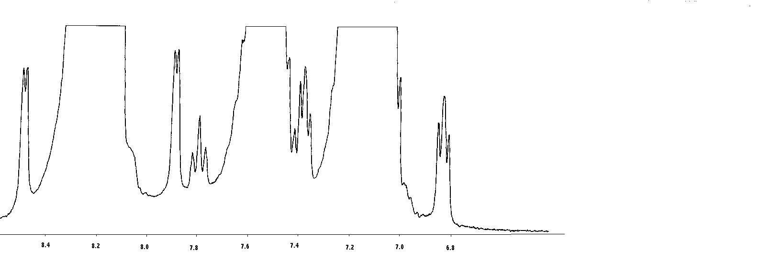

δ/ppm

Figure S2

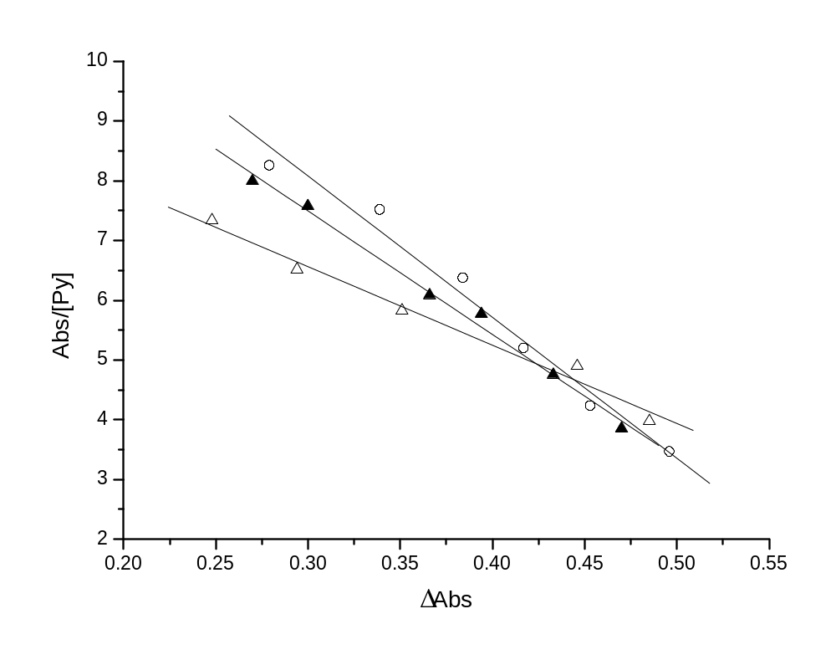

Figure S3

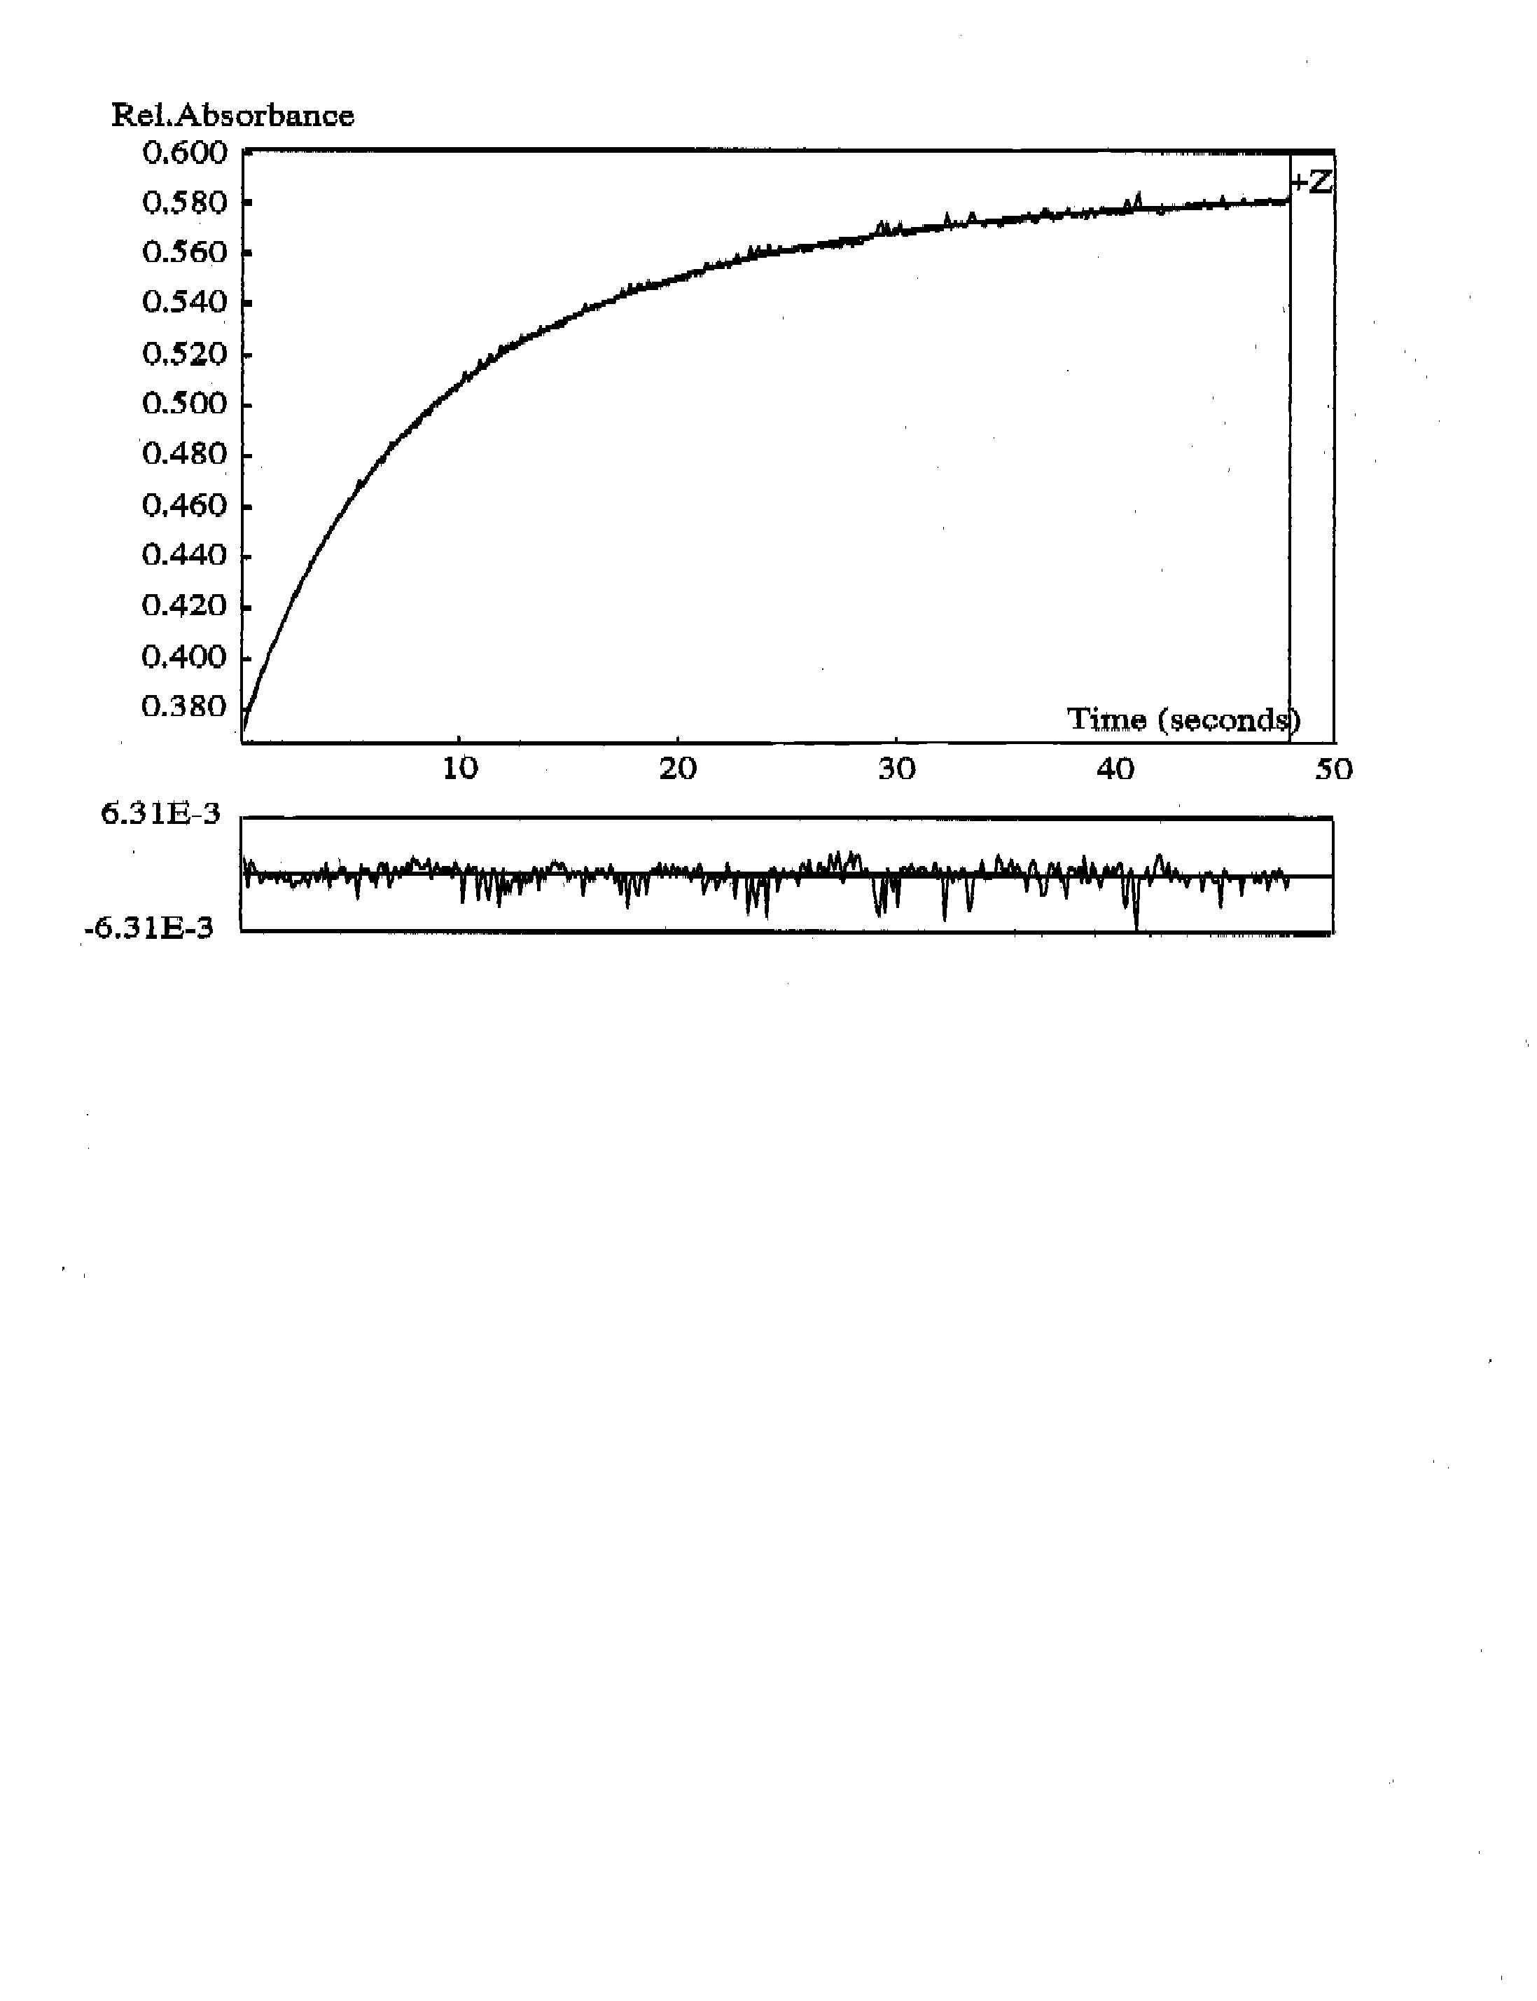

Figure S4

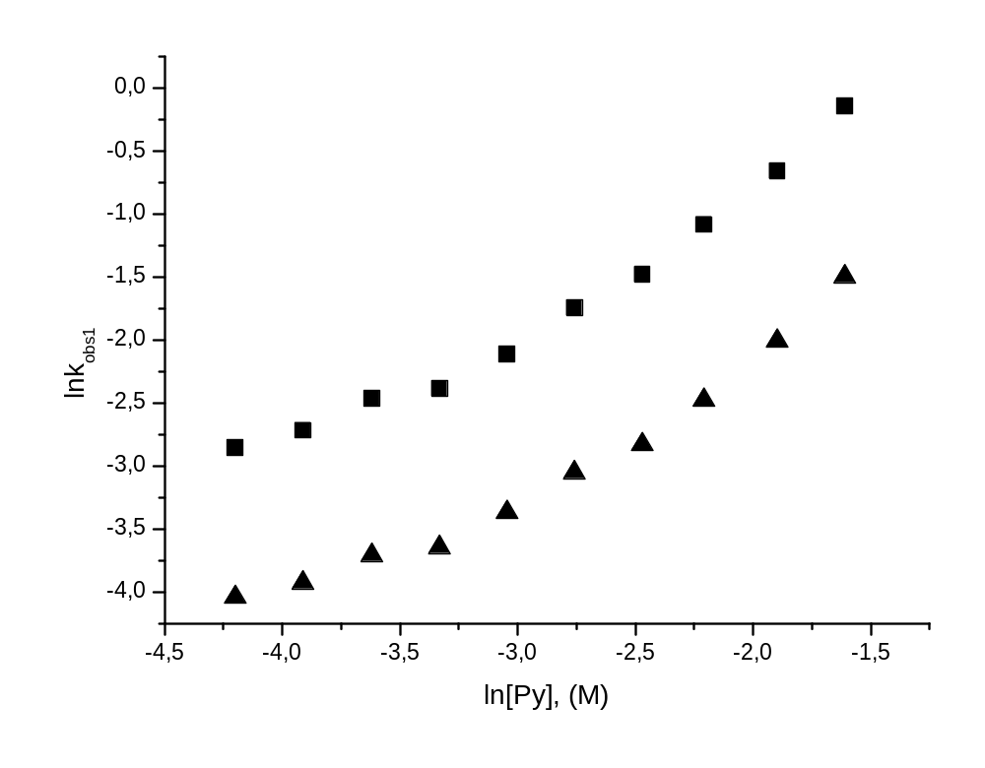

Figure S5
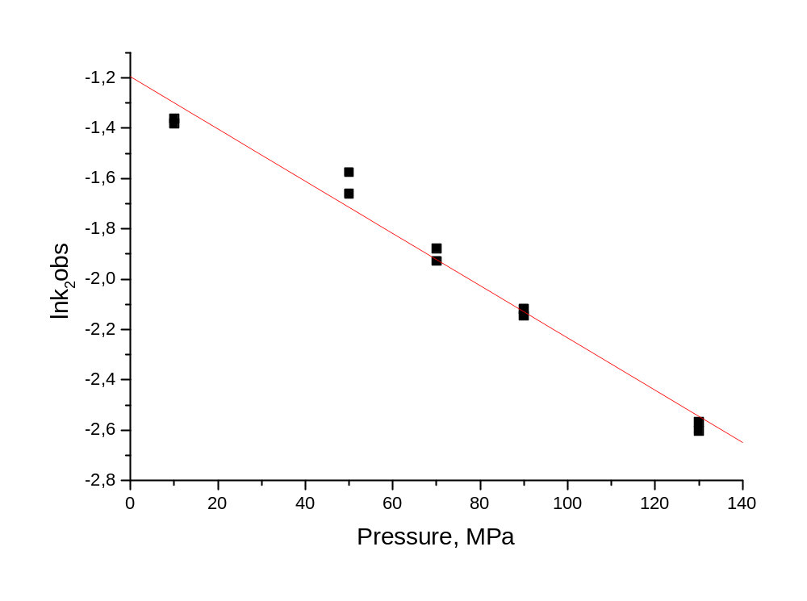
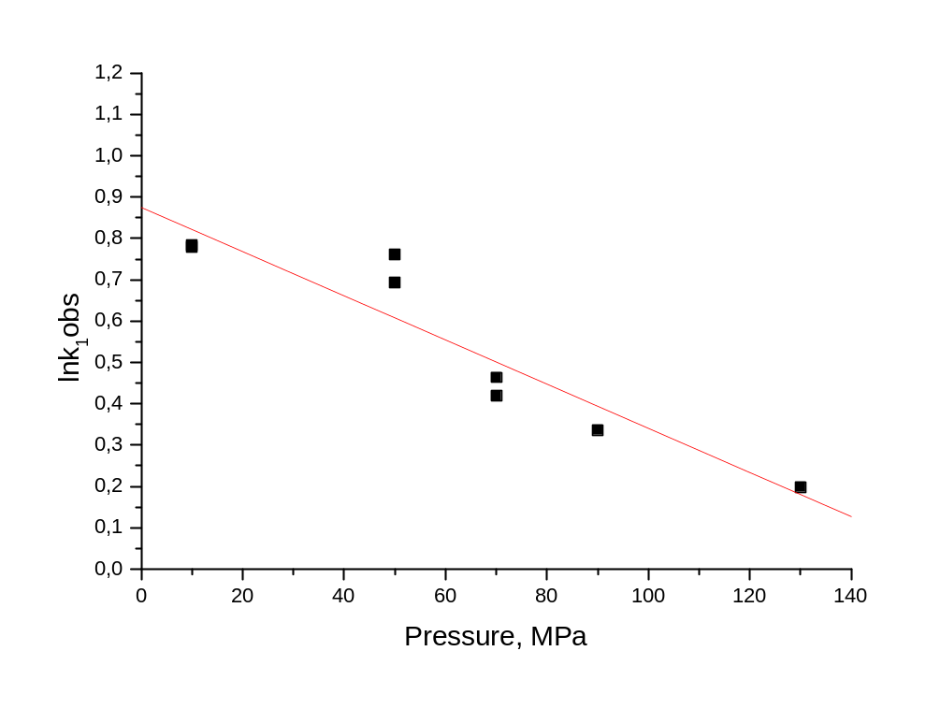

Figure S6

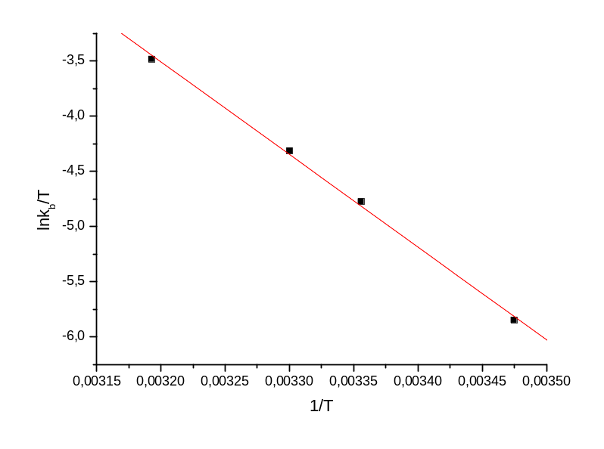

Figure S7

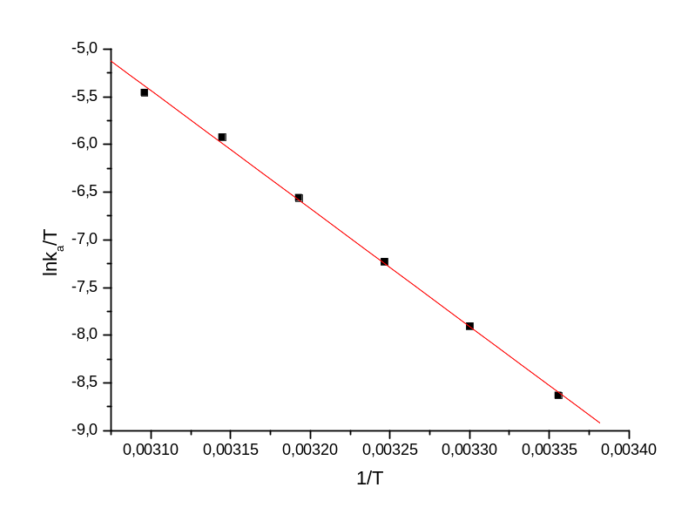

Figure S8

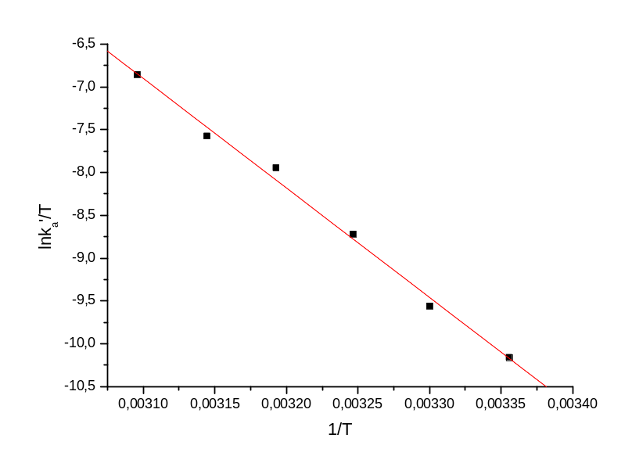

Figure S9

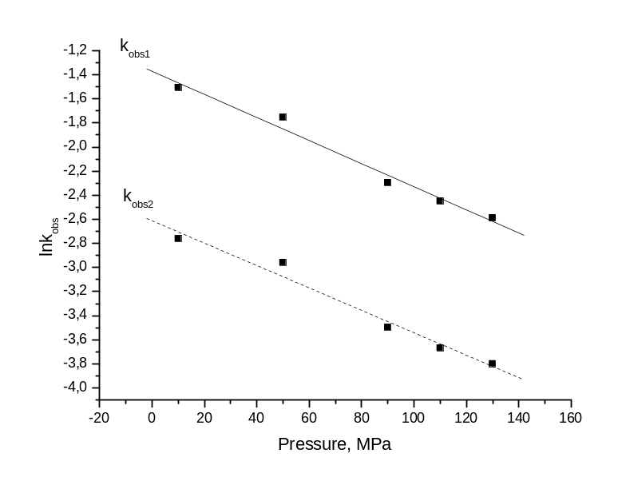

Figure S10



