A severely interrupted germanate zeolite framework synthesised from isolated double four-ring units

Luis A. Villaescusa, Paul S. Wheatley, Russell E. Morris* and Philip Lightfoot

Supplementary Material

Powder X-ray Diffraction was collected on a Stoe STADIP X-ray diffractometer utilising grpahite monochromatised Cu Kα radiation. The diffractometer is equipped with a position sensitive detector covering about 6º in 2θ. Rietveld refinement was accomplished using the GSAS program. Crystal Data for [TEA,F]-D4R [Ge₈O₁₂(OH)₈F](C₈NH₂₀), Orthorhombic space group Pnnm (No. 58) Unit cell (298K) a = 14.154(1) Å, b = 12.908(1) Å, c = 7.7075(5) Å, V = 1408.2(2), Z = 2, 241 reflections ( 10-60º 2θ), CuKα₁ radiation, No of variables = 42 No of restraints = 20, Rwp = 13.5%, Rp = 10.6%. The starting model for refinement was derived from the I-42m for [DCDEMP,F]-D4R. Some soft constraints were necessary on the D4R geometry. In addition, location of the F⁻ anion in the body-centre of the D4R leads to a very high isotropic displacement parameter for F⁻. The fluoride was therefore disordered to a general position and refined with a fixed U_{iso}, leading to a more acceptable shortest Ge-F contact (2.2 Å). The organic cation must once again be disordered, the simplest model in this case being disorder around a site of 2/m point symmetry at (0,1/2,0). However, in this case, all attempts to refine such a model did not lead to improvements in the overall fit. The final model, therefore, did not include the TEA moiety, but does, nevertheless, give a respectable Rietveld fit We note that it is not unusual to be unable to locate template molecules in this type of material, even from single crystal data.
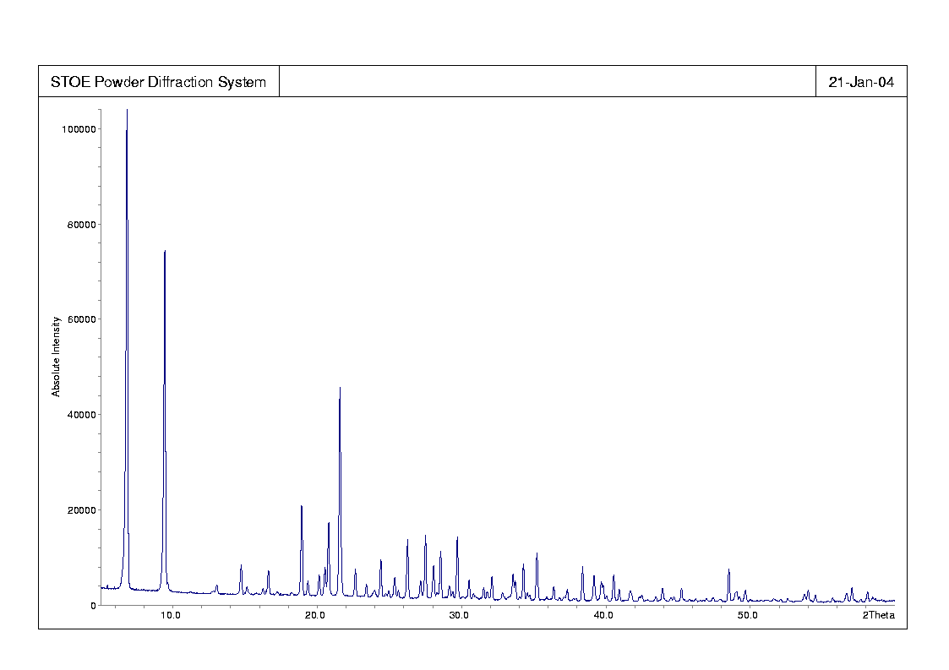
The powder X-ray diffraction (PXD) pattern for the [TEMA,F]-D4R analogue exhibits significant peak broadening, indicating some kind of a structural disorder, but can be indexed based on a similar unit cell to that described above (orthorhombic, with unit cell parameters a = 13.66Å, b = 13.43Å, c = 7.71Å); moreover, ¹⁹F NMR supports the presence of the same type of D4R (see below). Due to the problems with the peak broadening, no further crystallographic analysis of this phase was attempted.

Raw Powder XRD data:

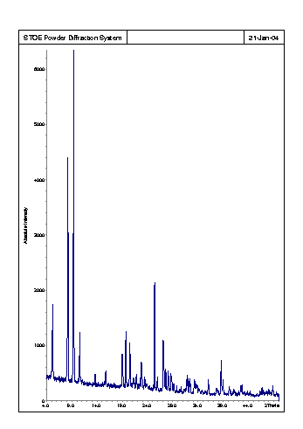
Figure S.1. Raw Powder XRD data for [TEA,F]-BEC

Figure S.2. Raw Powder XRD data for STAG-1

NMR of D4R-GeO₂ cubes

40
20
0
-20
-40
-60
-80
-100
-120
-140
[TEMA,F]-D4R
[TEA,F]-D4R
[DECDMP,F]-D4R
ppm

Figure S.3 ¹⁹F MAS NMR spectra showing the presence of resonances from the fluorine encapsulated in the D4R-GeO₂ units in all three cases. The peaks at –122ppm are due to impurities caused by slight hydrolysis of the frameworks on washing with water.

NMR of [TEA,F]-BEC

50
0
-50
-100
-150
[TEA,F]-D4R
[TEA,F]-BEC
ppm

Figure S.4. Fluorine-19 MAS NMR spectra of [TEA,F]-BEC (top) and [TEA,F]-D4R showing the presence of a resonance in the region of 0 to –20 in both cases, indicating that fluoride is encapsulated inside the D4R units in the BEC framework.

Figure S.5. Carbon-13 MAS NMR spectra of templated, isolated D4R structures, and corresponding framework topologies, demonstrating retention of intact template.

The ¹⁹F MAS NMR experiments of [TEA,F]-D4R and [TEMA,F]-D4R clearly showed similar spectra to that seen for [DECDMP,F]-D4R (Figure 2) with fluoride resonances at around the same chemical shift. This shows that the NMR consistent with the crystallographic description of the materials as isolated D4R units, each containing an encapsulated fluoride ion. In addition, in some (but not all) spectra there is an additional peak at around –122ppm, which has been tentatively assigned as a small amount of impurity containing terminal Ge-F bonds. This is most likely a hydrolysis product of the framework formed on washing/sonicating the product with water as the D4R units are susceptible to hydrolysis, and dissolve fully in hot water after a few hours. The ¹⁹F NMR spectrum of the resulting solution shows only the resonance at –122 ppm. As a result of the PXD and ¹⁹F NMR studies presented here, we report the presence of F⁻ anions inside these D4R-GeO₂ clusters in a similar way to their occurrence in SiO₂ D4R-containing zeolites. Some materials show more than one signal around –12 ppm, indicating different crystallographic sites for F-D4R units. From our work, the characteristic ¹⁹F chemical shifts for these materials ranges from approximately – 9 to –16 ppm, compared to about –40 ppm for D4R-SiO₂, -90 ppm for AlPO₄ and –70 ppm for GaPO₄-D4R units in previously reported cases within zeolites. [] This demonstrates that ¹⁹F NMR is an important tool for the identification of certain building units, which will be helpful in the structure solution of new zeolitic materials, such as that of STAG-1 we report below.

The resonances for the closed and open D4R units consist of two quite well resolved components. However, from the average crystallographic study we would expect only one resonance for each of these two fluorine sites. The splitting of these two sites must then be due to the disorder in the structure, producing different local environments for the fluoride ions. In addition, the resonance at –104 ppm is broad but unresolved, therefore we cannot confirm the presence of two fluoride ions in the ASU-12 type unit, as has been suggested by Yaghi and co-workers.

[?] (a) P. Caullet, J. L. Guth, J. Hazm, J. M. Lamblin and H. Gies, Eur. J. Solid State Inorg. Chem., 1991, 28, 345. (b) Schott-Darie, J. Patarin, P.Y. le Goff, H. Kessler, E. Benazzi. Microporous and mesoporous materials 3 (1994) 123-132 (c) A. Matijasic, P. Reinert, L. Josien, A. Simon and J. Patarin, Stud. Surf. Sci. Catal. 2001, 135, 1610.

