Electronic Supplementary Information (ESI)

Quantifying the relative contribution of hydrogen bonding and hydrophobic environments, and coordinating groups, in the zinc(II)-water acidity by synthetic modelling chemistry

Juan C. Mareque-Rivas,* Ravi Prabaharan and Simon Parsons

School of Chemistry, The University of Edinburgh,
Joseph Black Building, King's Buildings,
West Mains Road, Edinburgh, EH9 3JJ, UK
Tel:44-(0)131-650-4761
Fax:44-(0)131-650-4743

*To whom correspondence should be addressed. Email:juan.mareque@ed.ac.uk.

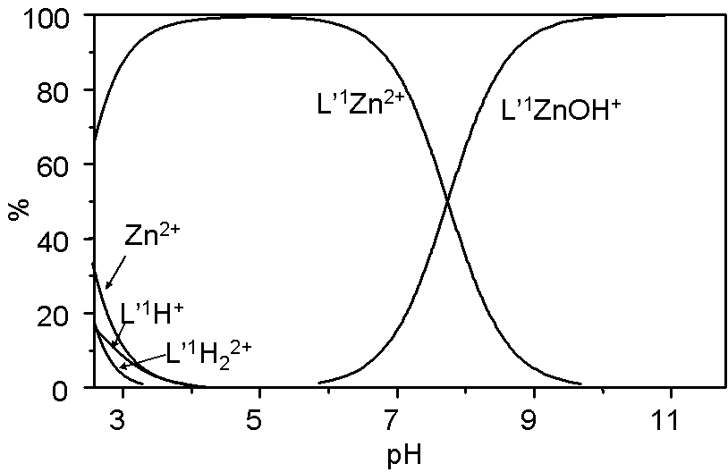

Fig. S1: Speciation diagram for a mixture of 1 mM L’¹ + 1 mM Zn²⁺ as a function of pH at 25 ºC with I = 0.1 (NaNO₃).

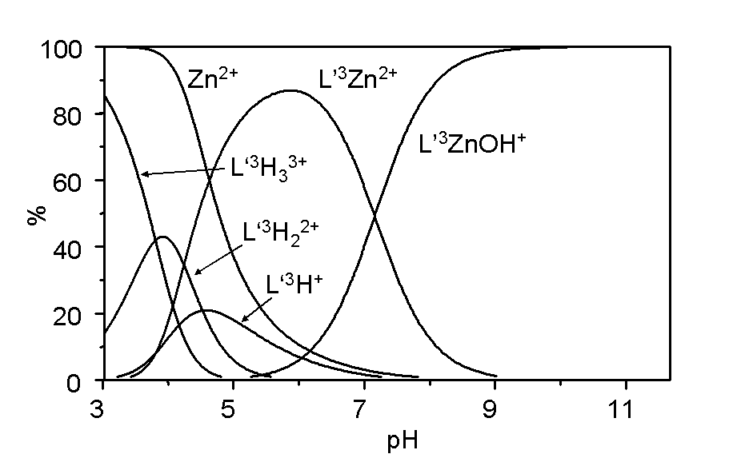
Fig. S2: Speciation diagram for a mixture of 1 mM L’³ + 1 mM Zn²⁺ as a function of pH at 25 ºC with I = 0.1 (NaNO₃).

