Kinetics and mechanisms of the electron transfer reactions of oxo-centred carboxylate bridged clusters, [Fe₃(μ-O)(O₂CR)₆L₃]ClO₄,with verdazyl radicals in acetonitrile solution.

Lynette Keeney and Michael J. Hynes*

Department of Chemistry, National University of Ireland, Galway, Ireland

Electronic Supplementary Information

Fig. S1 Cyclic voltammogram of 5.0 x 10^{–4} mol dm^{–3} [Fe₃(μ₃-O)(O₂CCH₂CN)₆(3-Mepy)₃]^{0/1+} in 0.2 mol dm^{–3} (^{n}C₄H₉)₄NPF₆-acetonitrile, (a) in the absence of free 3-methylpyridine (b) in the presence of 5.0 x 10^{–3} mol dm^{–3} free 3-methylpyridine.
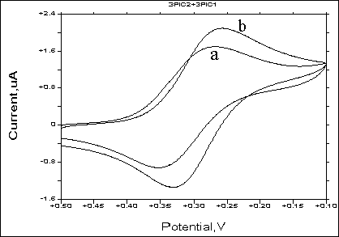

Fig. S2 Plot of E° [Fe₃(μ₃–O)(O₂CCH₂CN)₆(L)₃]^{0/1+} vs. ligand pK_{a} values.
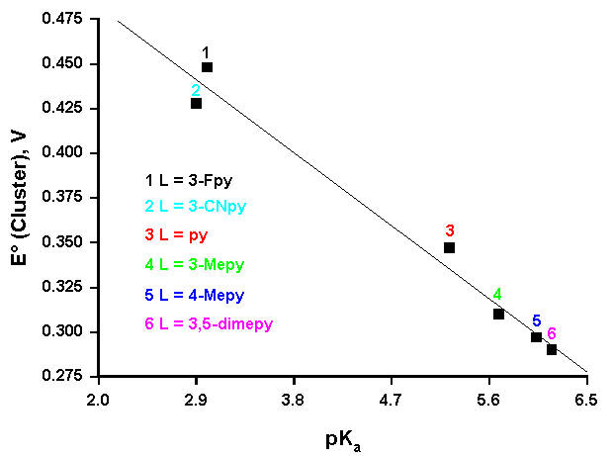

Fig. S3 Marcus plot of (2logk_{AB} – logf_{AB} – 2logW_{AB} – logk_{AA}) against log K_{AB} for reaction of [Fe^{III}₂Fe^{II}(μ₃–O)(O₂CC(CH₃)₃)₆(py)₃] with [Co(N–N)₃]³⁺ in the presence of a 100-fold excess of pyridine at 25ºC and I = 0.05 mol dm^{–3} (^{n}C₄H₉)₄NPF₆.

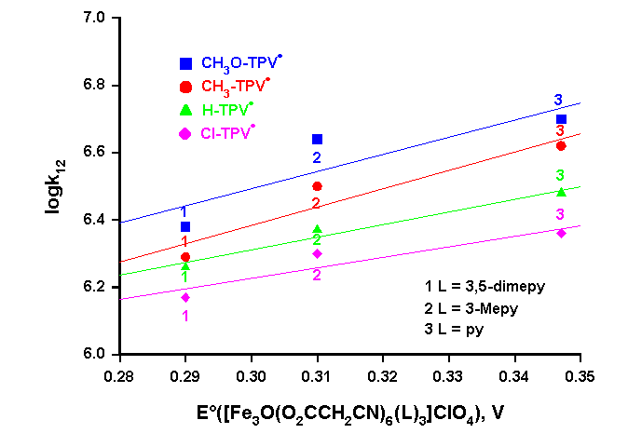
Fig. S4 Plot of the log of the cross-reaction rate constant (log k₁₂) for reaction of X-TPV• with [Fe₃(μ₃–O)(O₂CCH₂CN)₆(L)₃]⁺ as a function of the reduction potential (E°) of [Fe₃(μ₃-O)(O₂CCH₂CN)₆(L)₃]⁺ in the presence of a 10-fold excess of L in acetonitrile at 25ºC.

Fig. S5 Plot of the log of the cross-reaction rate constant (log k₁₂) for reaction of X-TPV• with [Fe₃(μ₃–O)(O₂CCH₂CN)₆(L)₃]⁺ as a function of the reduction potential (E°) of X-TPV• in the presence of a 10-fold excess of L in acetonitrile at 25ºC
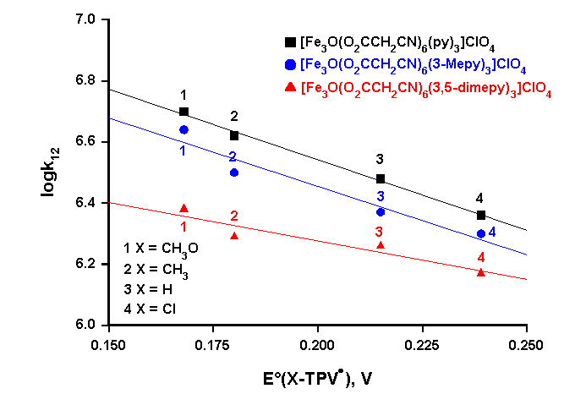

Fig. S6 Plot of the log of the cross-reaction rate constant (log k₁₂) for reaction of X-TPV• with [Fe₃(μ₃–O)(O₂CCH₂R)₆(py)₃]⁺ as a function of the reduction potential (E°) of [Fe₃(μ₃-O)(O₂CCH₂R)₆(py)₃]⁺ in the presence of a 10-fold excess of pyridine in acetonitrile at 25ºC

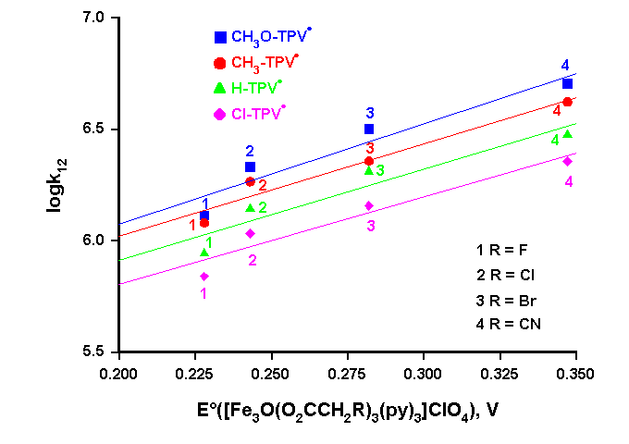
Fig. S7 Plot of the log of the cross-reaction rate constant (log k₁₂) for reaction of X-TPV• with [Fe₃(μ₃–O)(O₂CCH₂R)₆(py)₃]⁺ as a function of the reduction potential (E°) of X-TPV• in the presence of a 10-fold excess of pyridine in acetonitrile at 25ºC

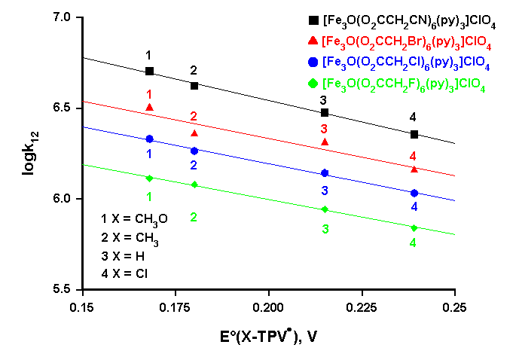

Fig. S8 The effect of varying the terminal ligand of the tri-iron cluster: Marcus plot of log k₁₂ against log K₁₂ for reaction of X-TPV• and [Fe₃(μ₃-O)(O₂CCH₂CN)₆(L)₃]⁺ in the presence of ten-fold excess L in acetonitrile at 25°C.
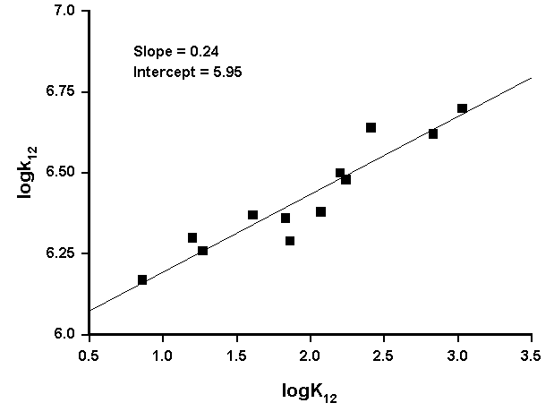
Figure S9 The effect of varying the carboxylate bridge of the tri-iron cluster: Marcus plot of log k₁₂ against log K₁₂ for reaction of X-TPV• and [Fe₃(μ₃-O)(O₂CR)₆(py)₃]⁺ in the presence of ten-fold excess pyridine in acetonitrile at 25°C.
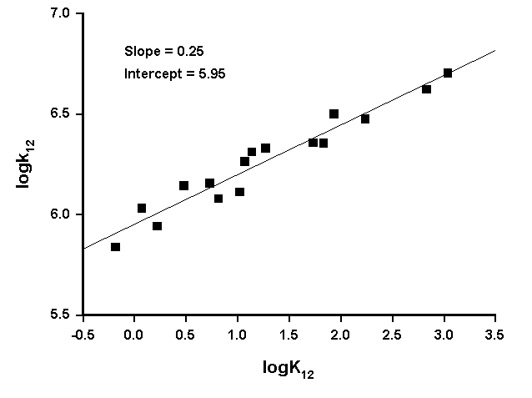

Table S1 pK_{a} values of pyridines at 25°C in H₂O and zero ionic strength.
Ligand | pK_{a}
Pyridine | 5.23 ¹
2-Methylpyridine | 5.95 ¹
3-Methylpyridine | 5.68 ¹
4-Methylpyridine | 6.03 ¹
3,5-Dimethylpyridine | 6.17 ¹
3-Cyanopyridine | 2.90 ¹
3-Fluoropyridine | 3.00 ²

References

1. R. M. Smith and A. E. Martell, 'Critical Stability Constants', Plenum Press, New York, 1975.
2. H. M. Mertel, 'Pyridine and its Derivatives Part 2', ed. E. Klingsberg, Interscience Publishers, New York, 1961.

