Supplementary information

Fig. S1
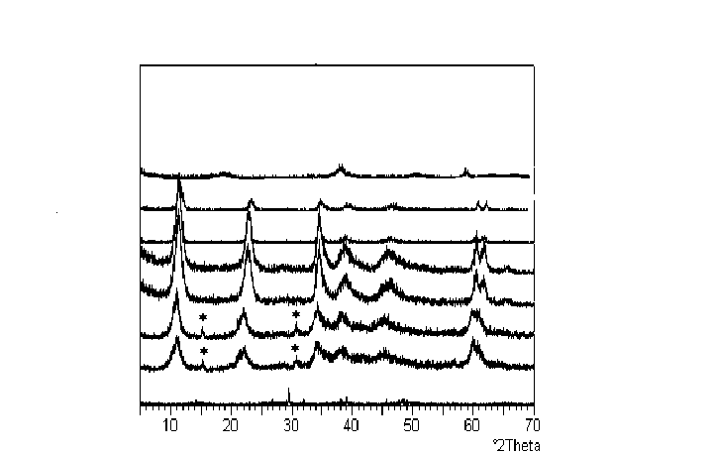
Intensity, a.u.

PXRD of (a) Mg(OH)₂ (b) MgAl-2HT (c) MgAl-3HT (d) MgAl-4HT (e) MgAl-6HT
(f) MgAl-8HT (g) MgAl-10HT (h) Al(OH)₃ (a is top and h is bottom)
(* - Impurity phase, Magnesium carbonate- 5MgO, 4CO₂.5H₂O; JCPDS 01-0168)

Fig. S2
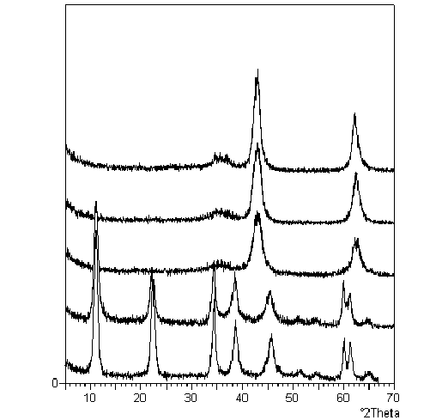
Intensity, a.u.

•
•
•
∗
∗
∗
∗
∗
∗
PXRD of (a) MgAl-4HT fresh (b) MgAl-4HT calcined at 200ºC (c) MgAl-4HT calcined at 400ºC (d) MgAl-4HT calcined at 600ºC (e) MgAl-4HT calcined at 800ºC (a is bottom and e is top) (* - Hydrotalcite ; • - MgO)

