Supplementary information to:

Identification of selenocompounds in yeast by electrospray quadrupole - time- of-flight mass spectrometry

Shona McSheehy, Joanna Szpunar*
Group of Bio-inorganic Analytical Chemistry, CNRS UMR 5034, 2, av. Pr. Angot, F-64053 Pau, FRANCE
Violette Haldys, Jeanine Tortajada
Université d’Evry Val d’Essonne, Institut des Sciences, LAE CNRS UMR 8587, Blv. François Mitterand, F-91025 Evry, FRANCE

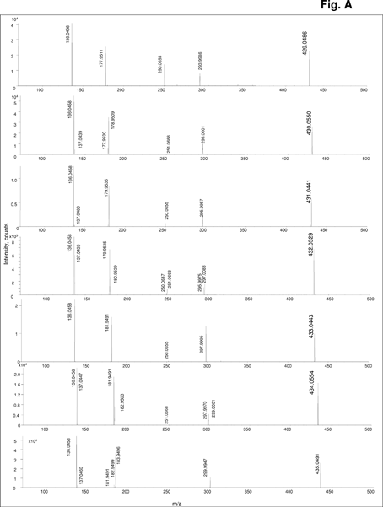
Fig. A Electrospray TOF MS of the fraction III collected after preparative anion-exchange chromatography (cf. Fig.2): mass spectra of the protonated molecular ions of the species shown (m/z 429-435).

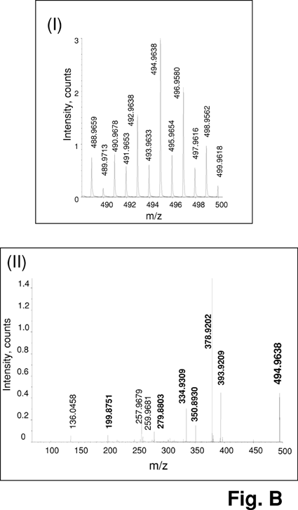
Fig. B Electrospray TOF MS of the fraction III collected after preparative anion-exchange chromatography (cf. Fig.2): (I) zoom of the m/z 495 Se-containing species compared with a theoretical pattern, (II) CID mass spectrum of the most abundant protonated molecular ion of the m/z 495 Se-containing species.

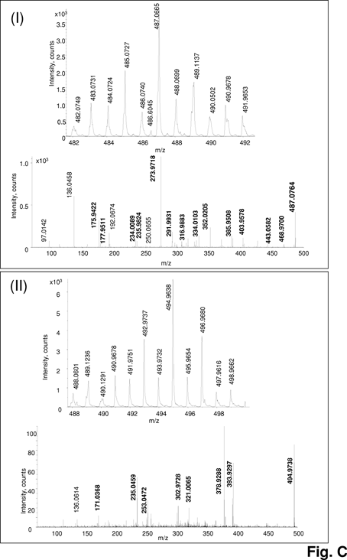
Fig. C Electrospray TOF MS of the fraction I collected after preparative anion-exchange chromatography (cf. Fig.2): (I) zoom of the m/z 487 Se-containing species and CID mass spectrum of the most abundant protonated molecular ion, (II) zoom of the m/z 495 Se- containing species and CID mass spectrum of the most abundant protonated molecular ion.

