This journal © The Royal Society of Chemistry 2006

Electronic Supplementary Information

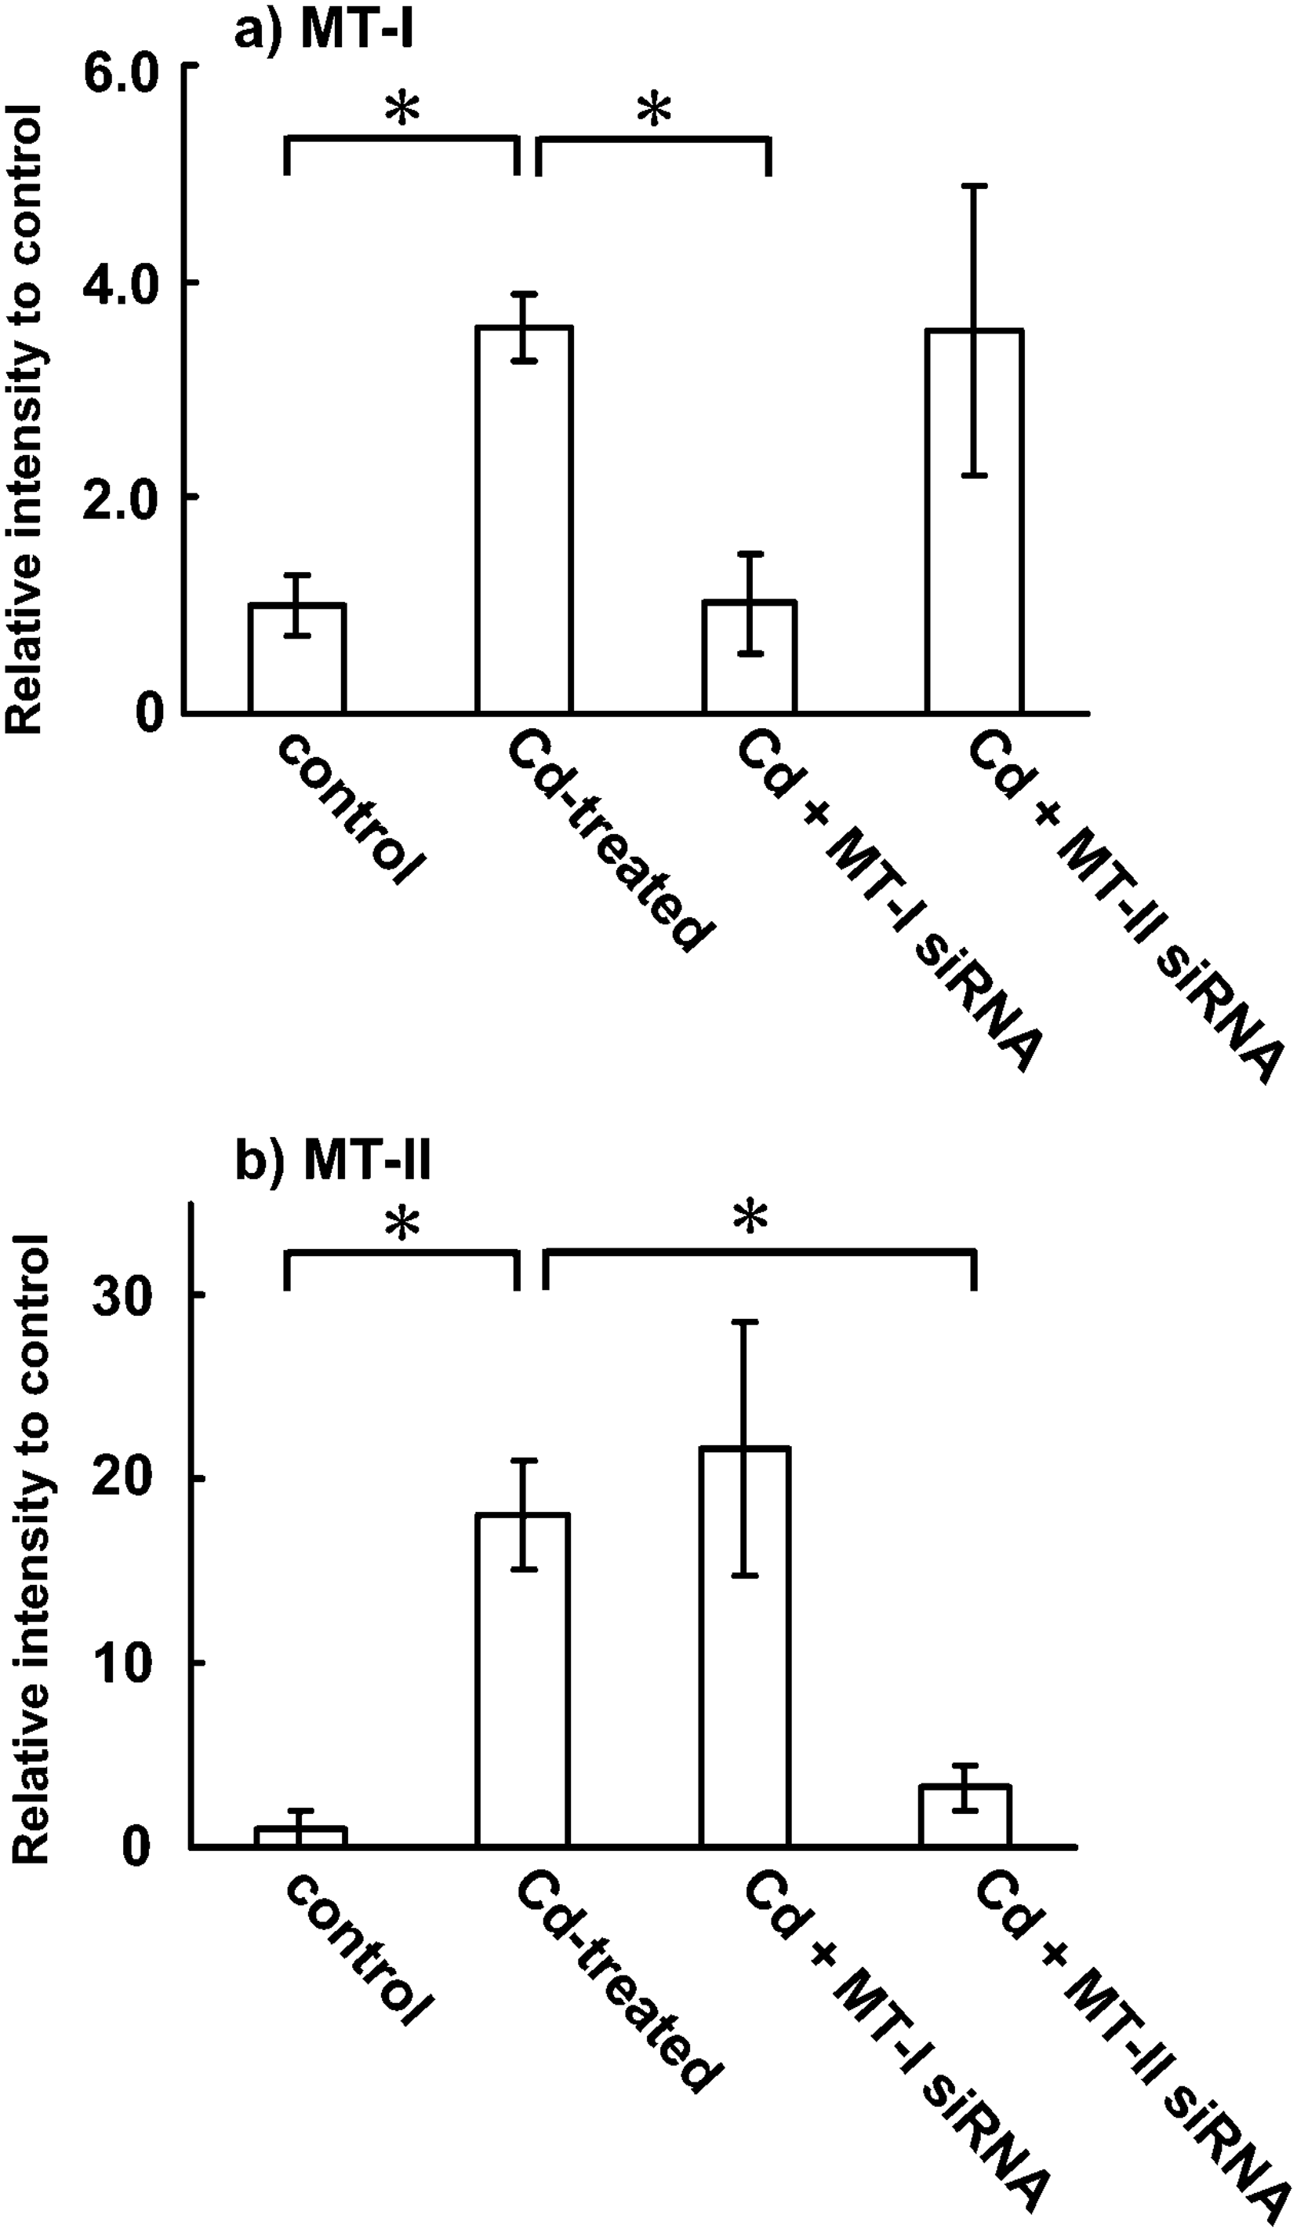

Fig. S1 Effect of RNAi-mediated isoform-specific silencing on the mRNA expression of MT-I and MT-II. The data are expressed as means ± standard deviation of three independent experiments. The significant difference was calculated by the Student’s t-test. The level of significance was set at p <0.05.

