This journal © The Royal Society of Chemistry 2007

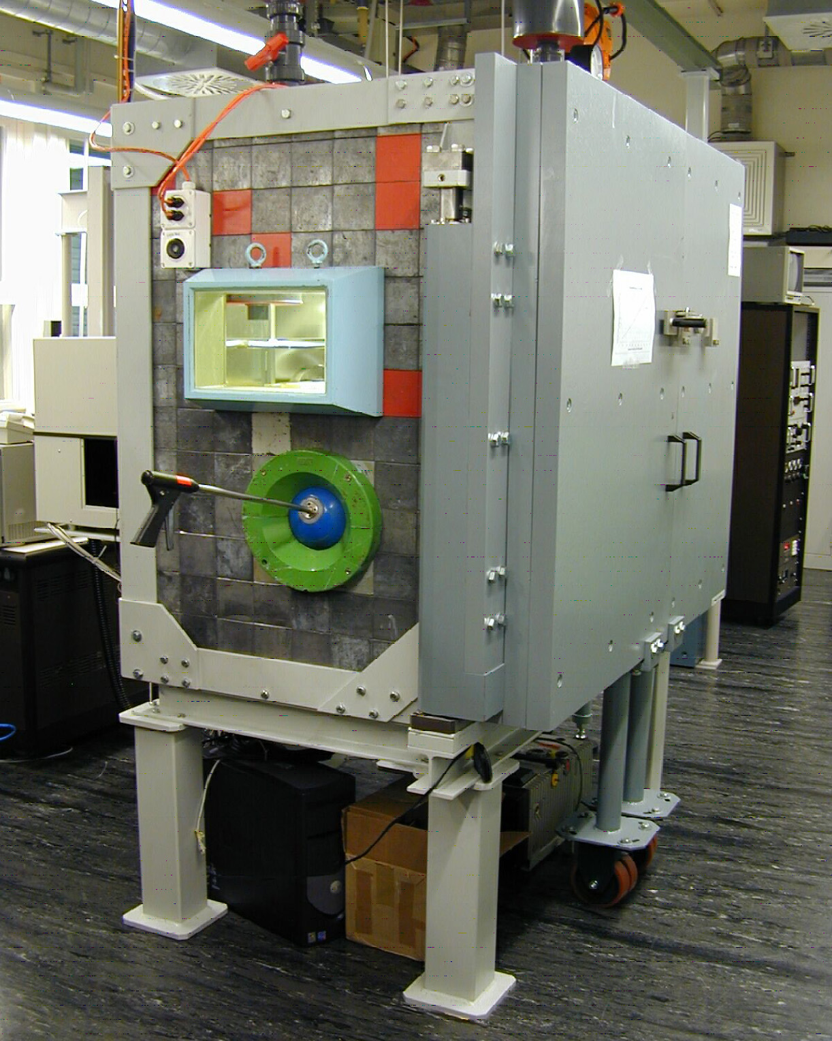

Fig. S1 Photograph of the installed laser ablation system at PSI. From the construction, the lead window, the stick manipulator, the shielding and the steel doors are visible.

Fig. S2 Linear correlation of the ICP-MS signal intensity to the crater area (top) and the laser energy density (bottom).Error bars represent 1s.

