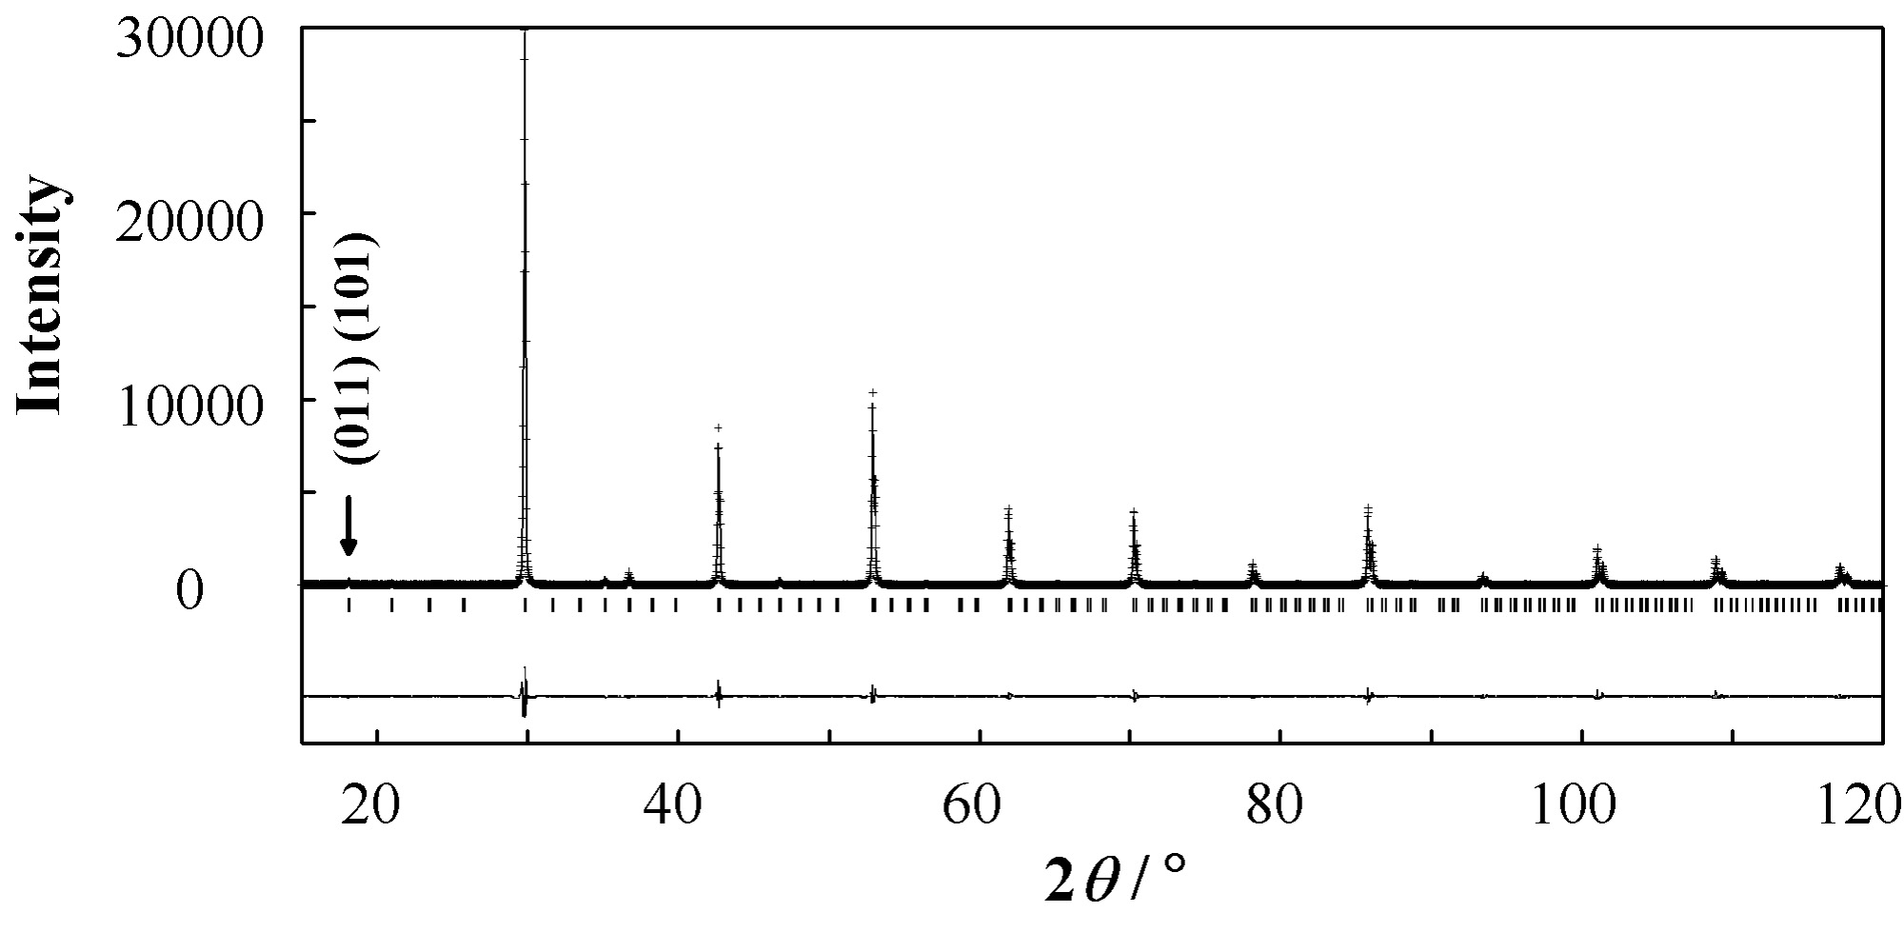

Figure S1 Powder X-ray diffraction profiles for Ba₂NdRuO₆. The calculated and observed profiles are shown on the top solid line and cross markers, respectively. The vertical marks in the middle show positions calculated for Bragg reflections. The lower trace is a plot of the difference between calculated and observed intensities. The superlattice reflections are shown as an arrow.

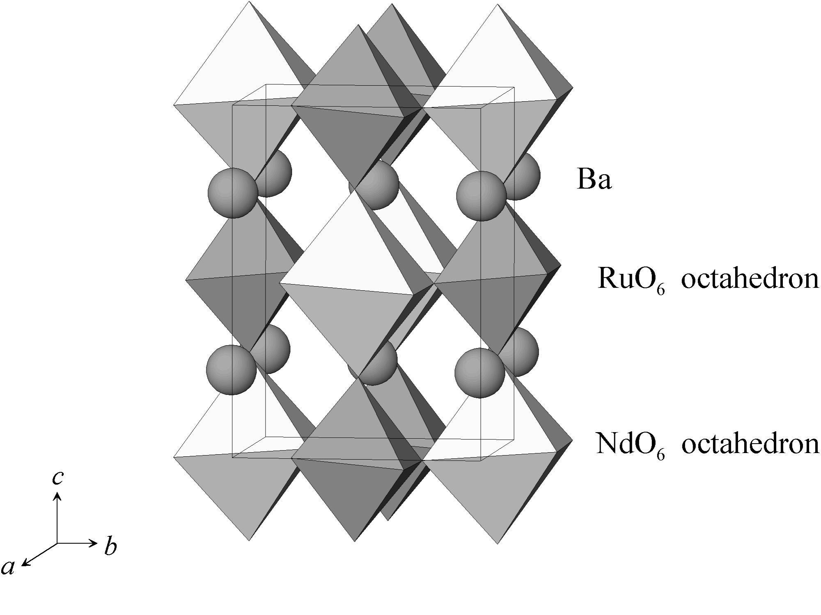

Figure S2 The crystal structure of Ba₂NdRuO₆. Spheres are Ba atoms, bright octahedra are NdO₆ units and dark octahedra are RuO₆ units.
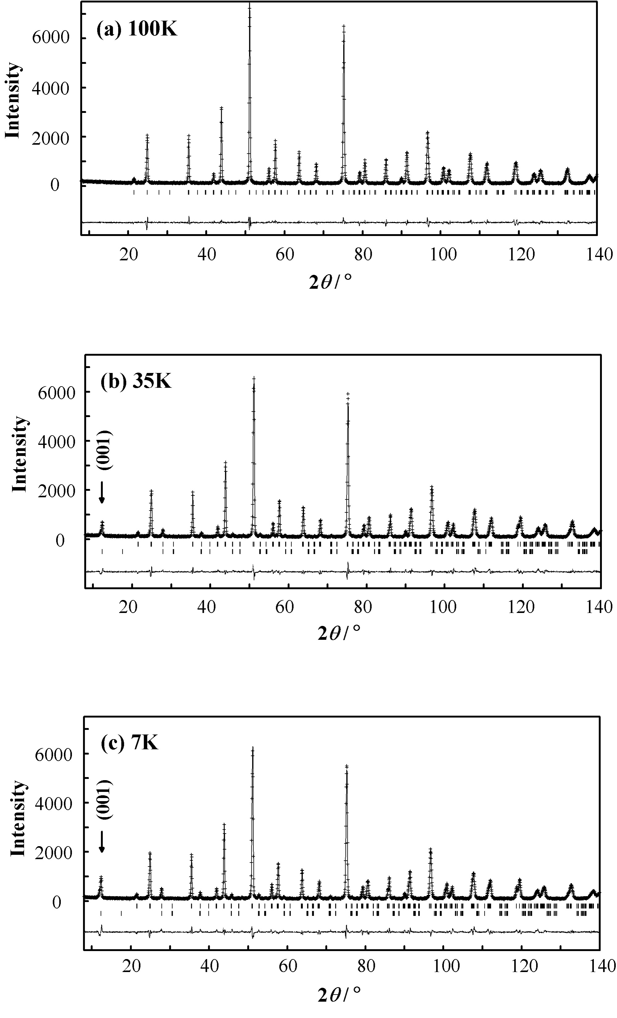
Figure S3 Powder neutron diffraction profiles for Ba₂NdRuO₆ at 100K (a), 35K (b) and 7K (c). The calculated and observed profiles are shown on the top solid line and cross markers, respectively. The vertical marks in the middle show positions calculated for Bragg reflections. In (b) and (c), the nuclear reflection positions are shown as upper vertical marks and magnetic ones are shown as lower ones. The lower trace is a plot of the difference between calculated and observed intensities.

