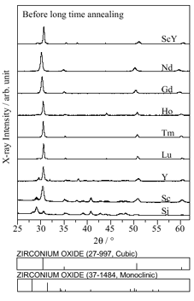

Fig. S1 XRD patterns of (ZrO₂)_{0.92}(RE₂O₃)_{0.08} (RE=Sc, Y, Nd, Gd, Ho, Tm, Lu) and (ZrO₂)_{0.92}(Sc₂O₃)_{0.04}(Y₂O₃)_{0.04} thin films before long time annealing.

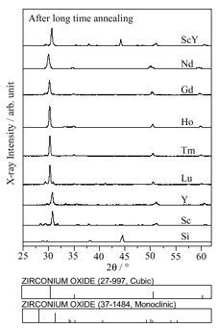

Fig. S2 XRD patterns of (ZrO₂)_{0.92}(RE₂O₃)_{0.08} (RE=Sc, Y, Nd, Gd, Ho, Tm, Lu) and (ZrO₂)_{0.92}(Sc₂O₃)_{0.04}(Y₂O₃)_{0.04} thin films after long time annealing.

