XRD patterns of unknown phase and NKX-1

XRD patterns of the heated NKX-1 and NKX-4
- NKX-1 calcined in air at 550⁰C for 2 hours
- NKX-4 calcined in air at 550⁰C for 2 hours
- NKX-4 calcined in air at 200⁰C for 2 hours

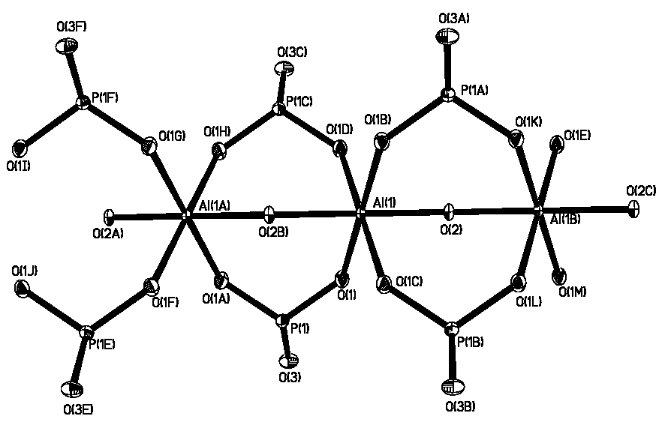

The bonding environment of the Al and P atom in NKX-4

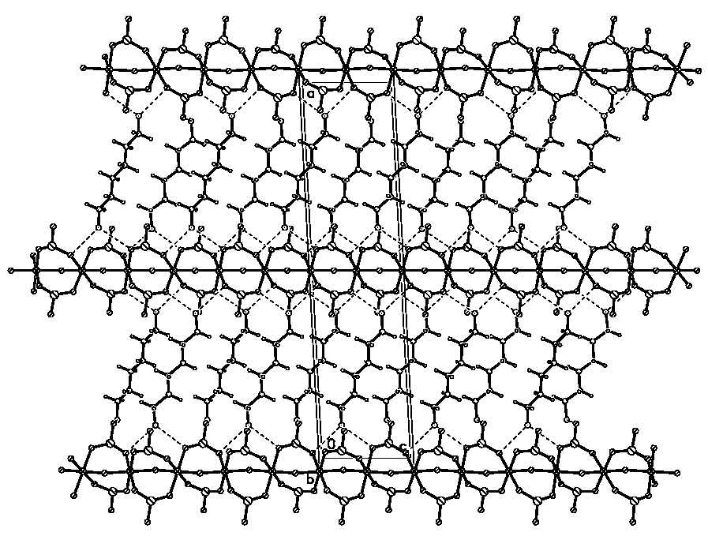

View of NKX-1 along [100]

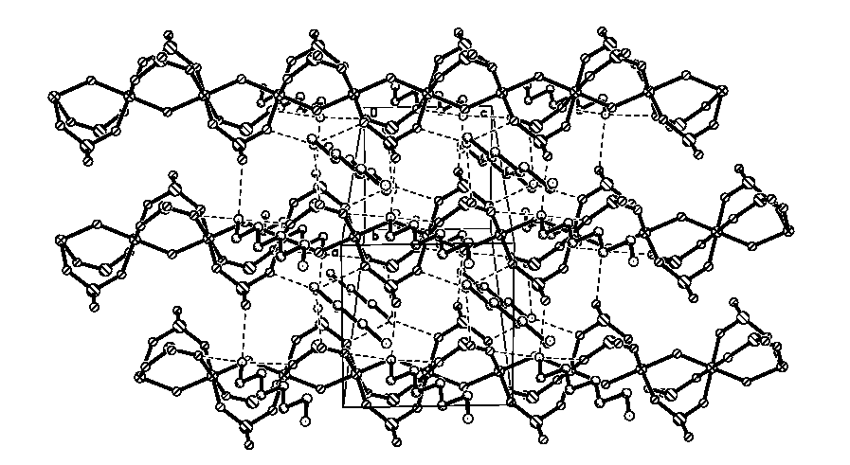

View of NKX-1 along [001]

