ESI information on the paper’ Synthesis of well-dispersed nanoparticles within porous solid structures using surface tethered surfactants in supercritical CO₂‘
Fig. S1 TGA/DTA signals as a function of temperature for UHPV-Cl.

Typical TGA and DTA curves of modified silicas are shown in Figures S 1-3. These results clearly show that all the modifications had successfully occurred. For pure UHPV silica, an endothermic weight loss (5%) at around 100ºC and a gradual weight loss (further 2.3%) from 100ºC to 800ºC attributed to the removal of physisorbed water and surface dehydroxylation respectively (not shown). In the case of all the organic modified silicas (Figures S 1-3) two extra exothermic events were observed with associated greater weight loss from 100ºC to 800ºC. These were assigned to the combustion of surface organic groups when the sample was heated in air. However, no further analysis was attempted to differentiate the two exothermic peaks. Figure 1 shows about 5% weight loss from the TG analysis of the UHPV-Cl sample, associated with the combustion of silica anchored organic groups while UHPV-NH₂ gave about 3% (not shown) in the temperature range from 100ºC to 800ºC. There were 8% and > 30% weight loses in the surfactant attached silica, UHPV-30 (Figure S2) and fluorous surfactant attached silica (UHPV-F as Figure S3), respectively. These values are substantially higher than their precursors with the only linker molecules attached suggesting that the subsequent attachments had been achieved. Our estimation suggests that most of the surface Si-OH groups (~1x 10¹⁹/m²) were covered with these surfactant molecules. The highest weight loss in the case of UHPV-F was attributed to the bulkier group with the fluorine

Fig. S3 TGA/DTA signals as a function of temperature for UHPV-F-SC
Fig. S2 TGA/DTA signals as a function of temperature for UHPV-76.

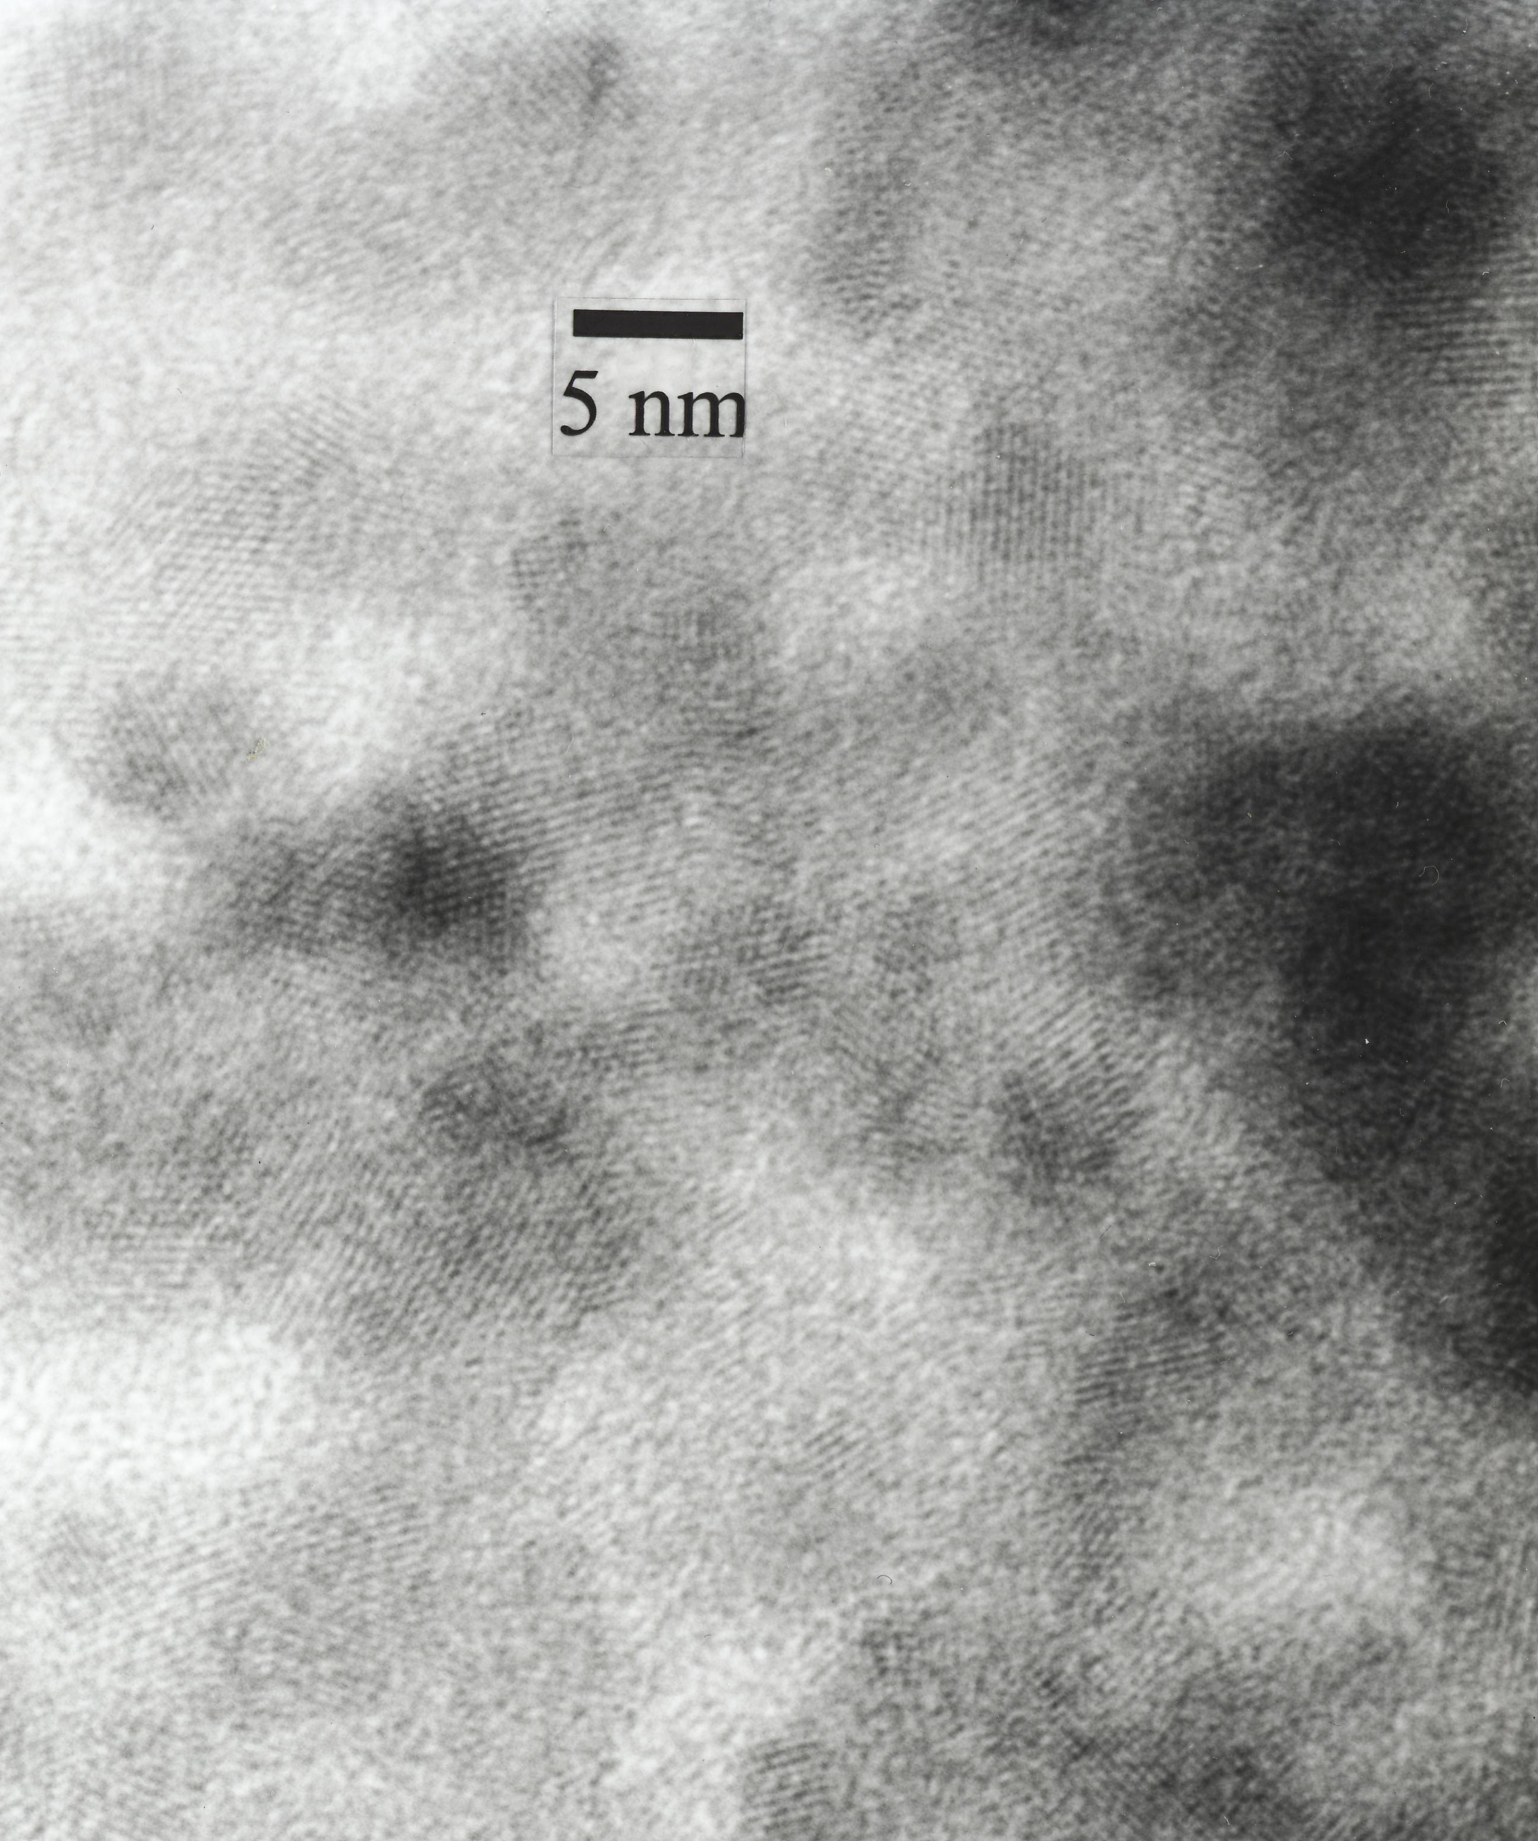
Fig. S4 A HRTEM image from Pd@UHPV-30-SC

