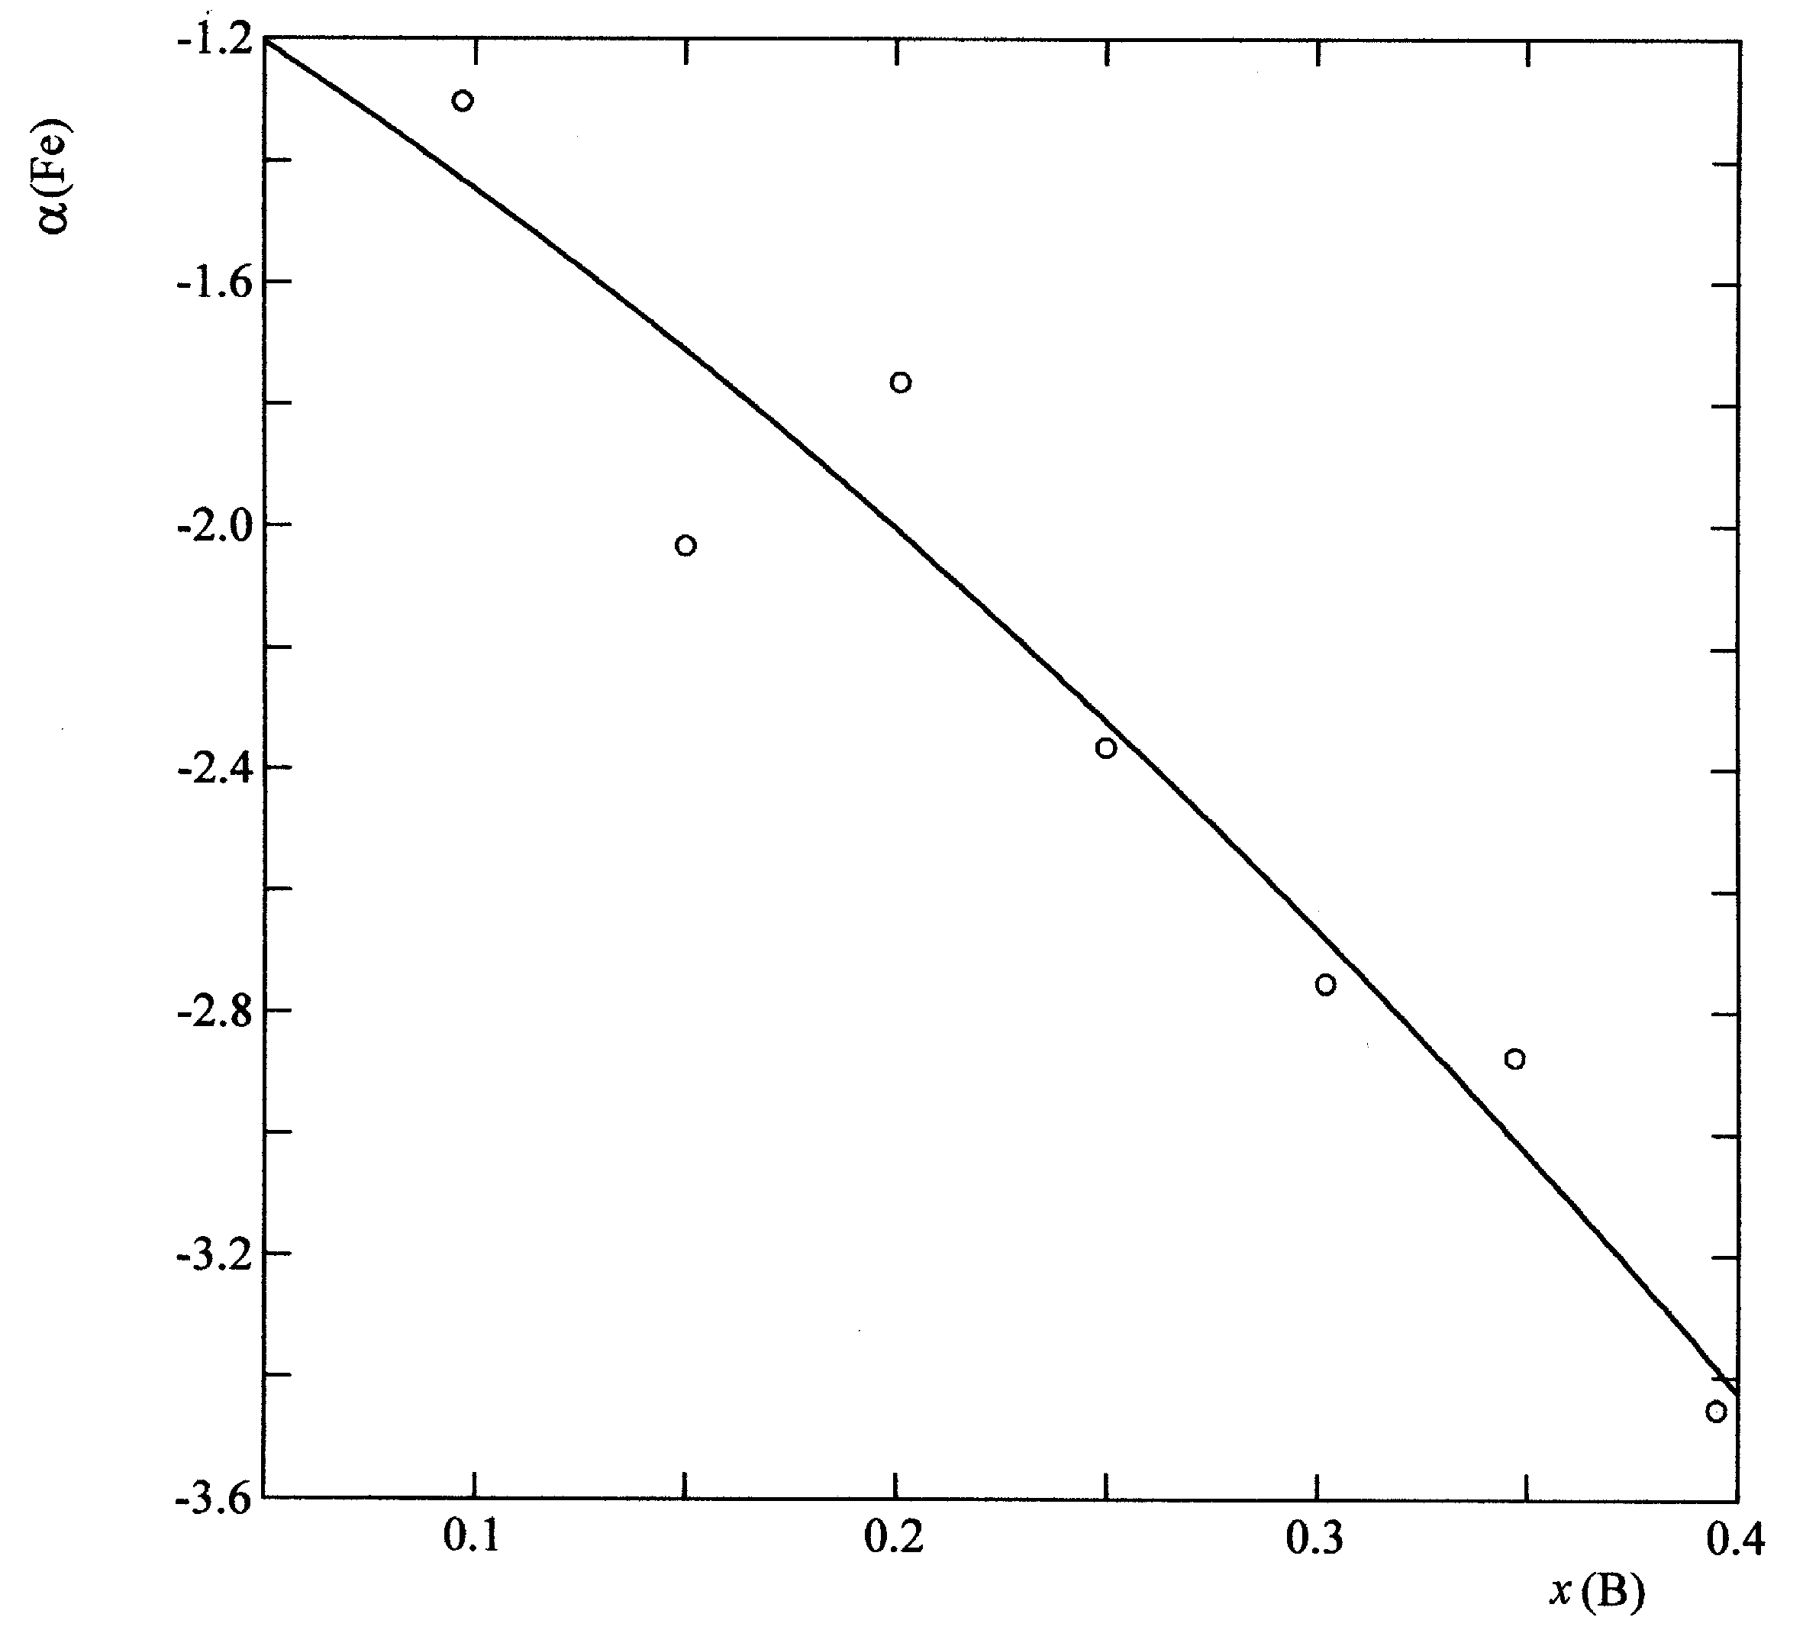

Fig. S1. Concentration dependence of iron α−function for T = 1823 К.
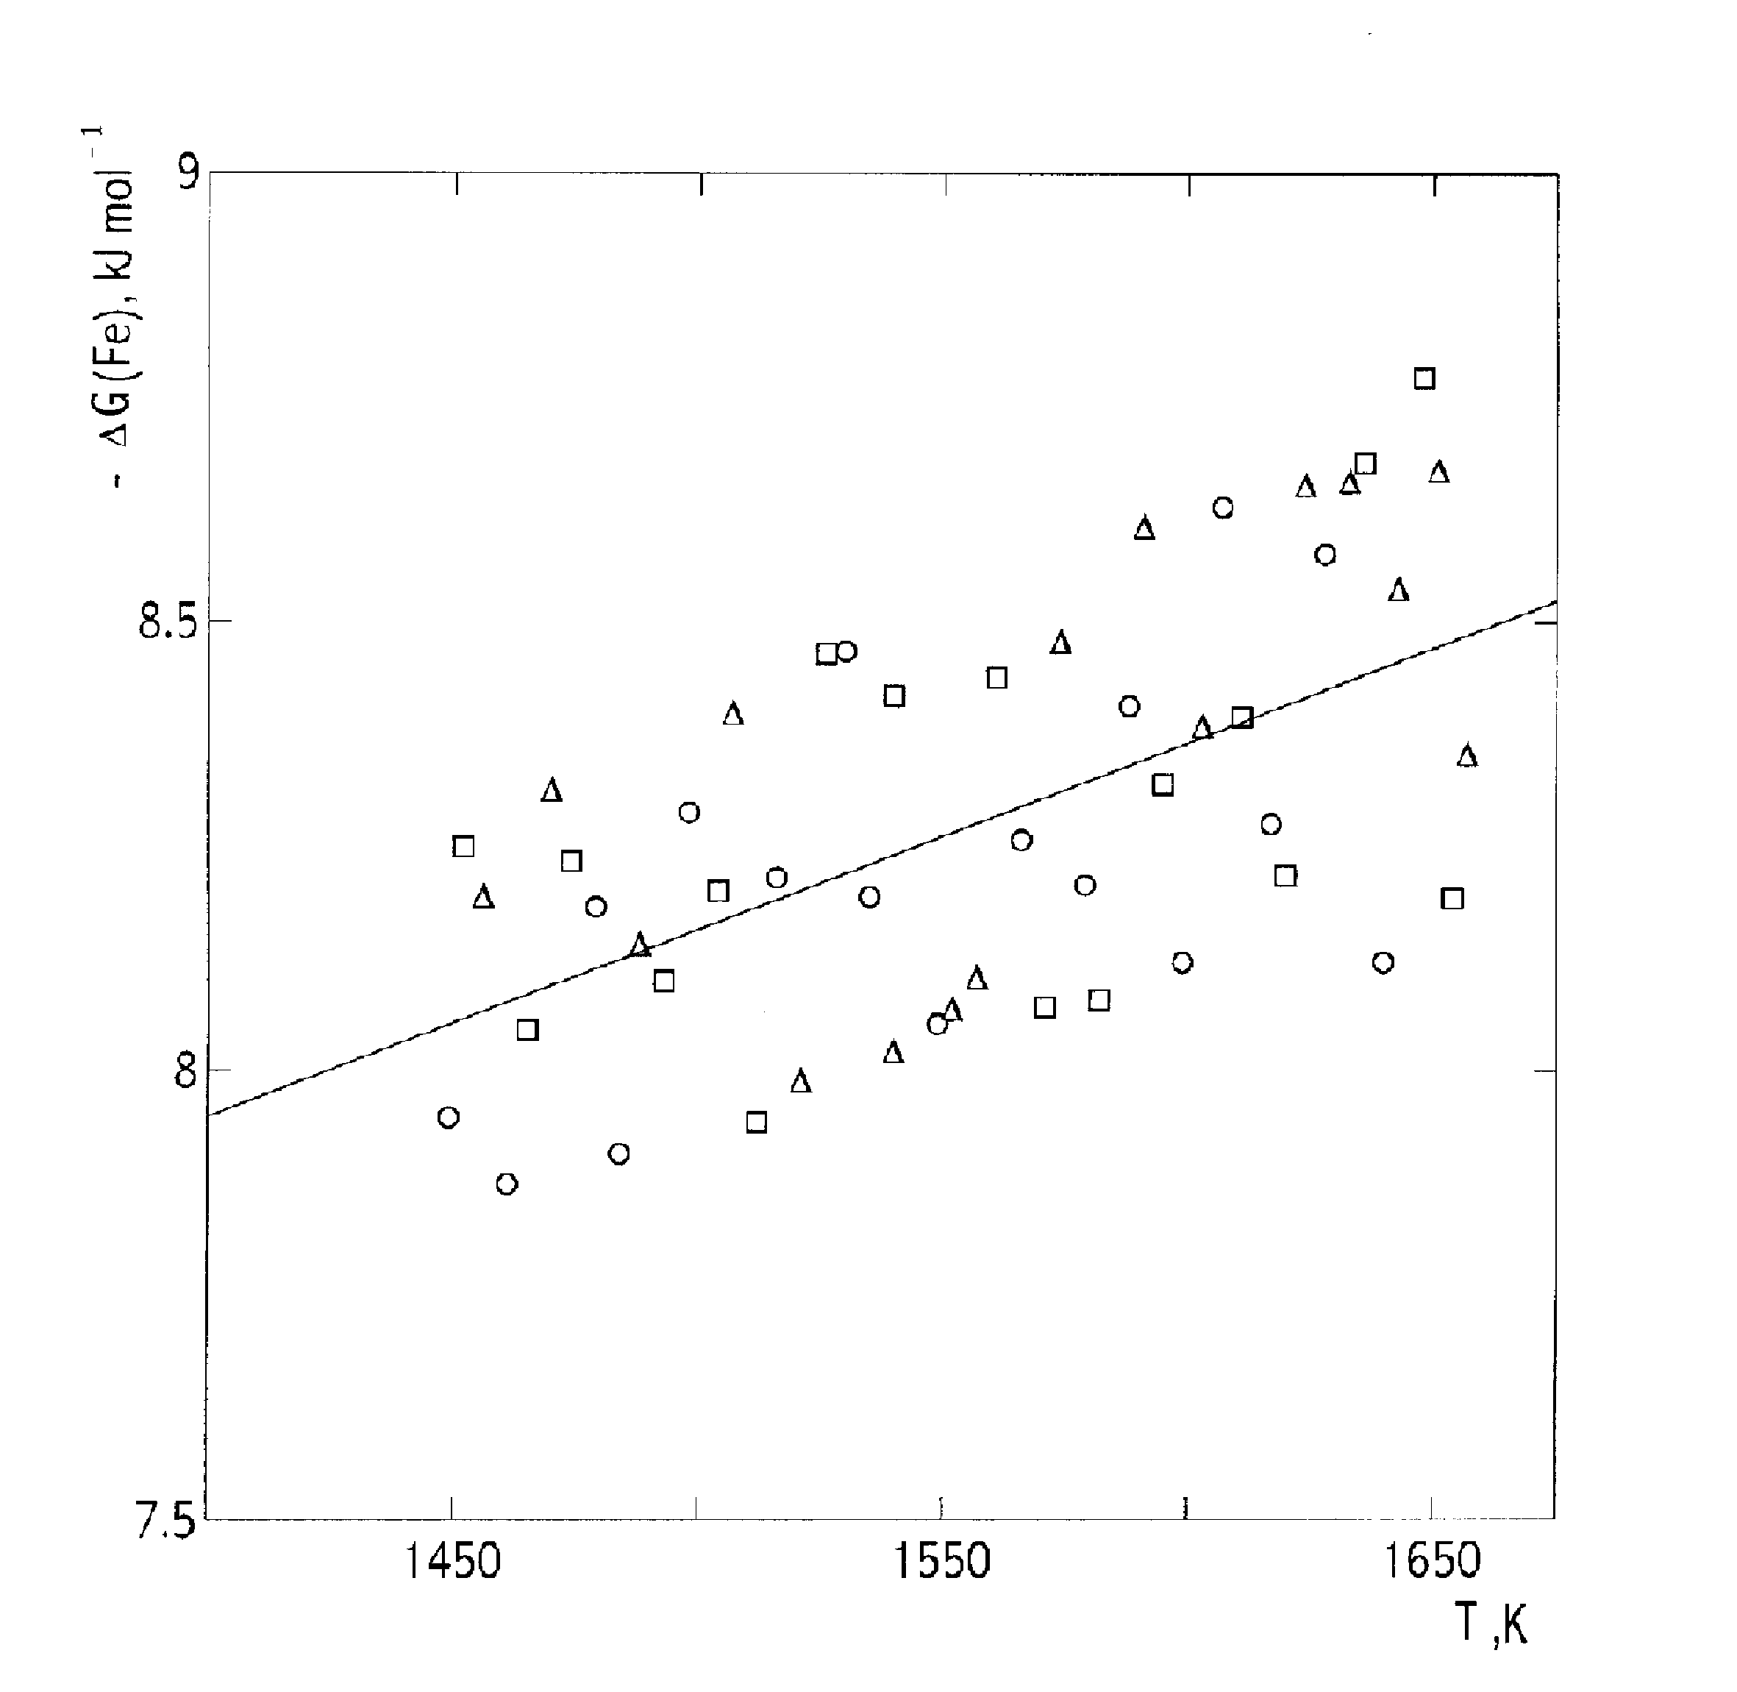

Fig. S2. The partial molar Gibbs energy of iron in the two-phase region FeB+Fe₂B obtained under different experimental conditions (x(B), diameter of the effusion orifice, d_{eff}×10⁻⁴ m; material of the effusion cell, material of the cell inner coating): Δ – 0.456; 3.54; Nb; Al₂O₃; ○ – 0.395; 2.03; Nb; ZrO₂; □ – 0.347; 2.89; Mo; Al₂O₃. Reference state: γ-Fe.
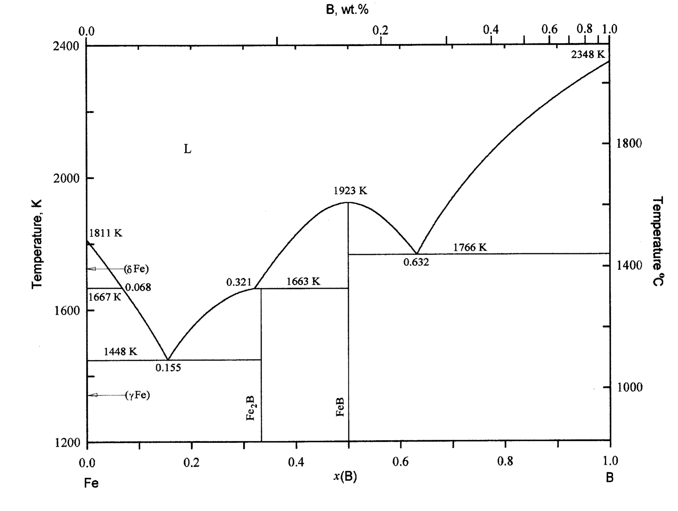

Fig. S3. Calculated phase diagram of the Fe-B system.
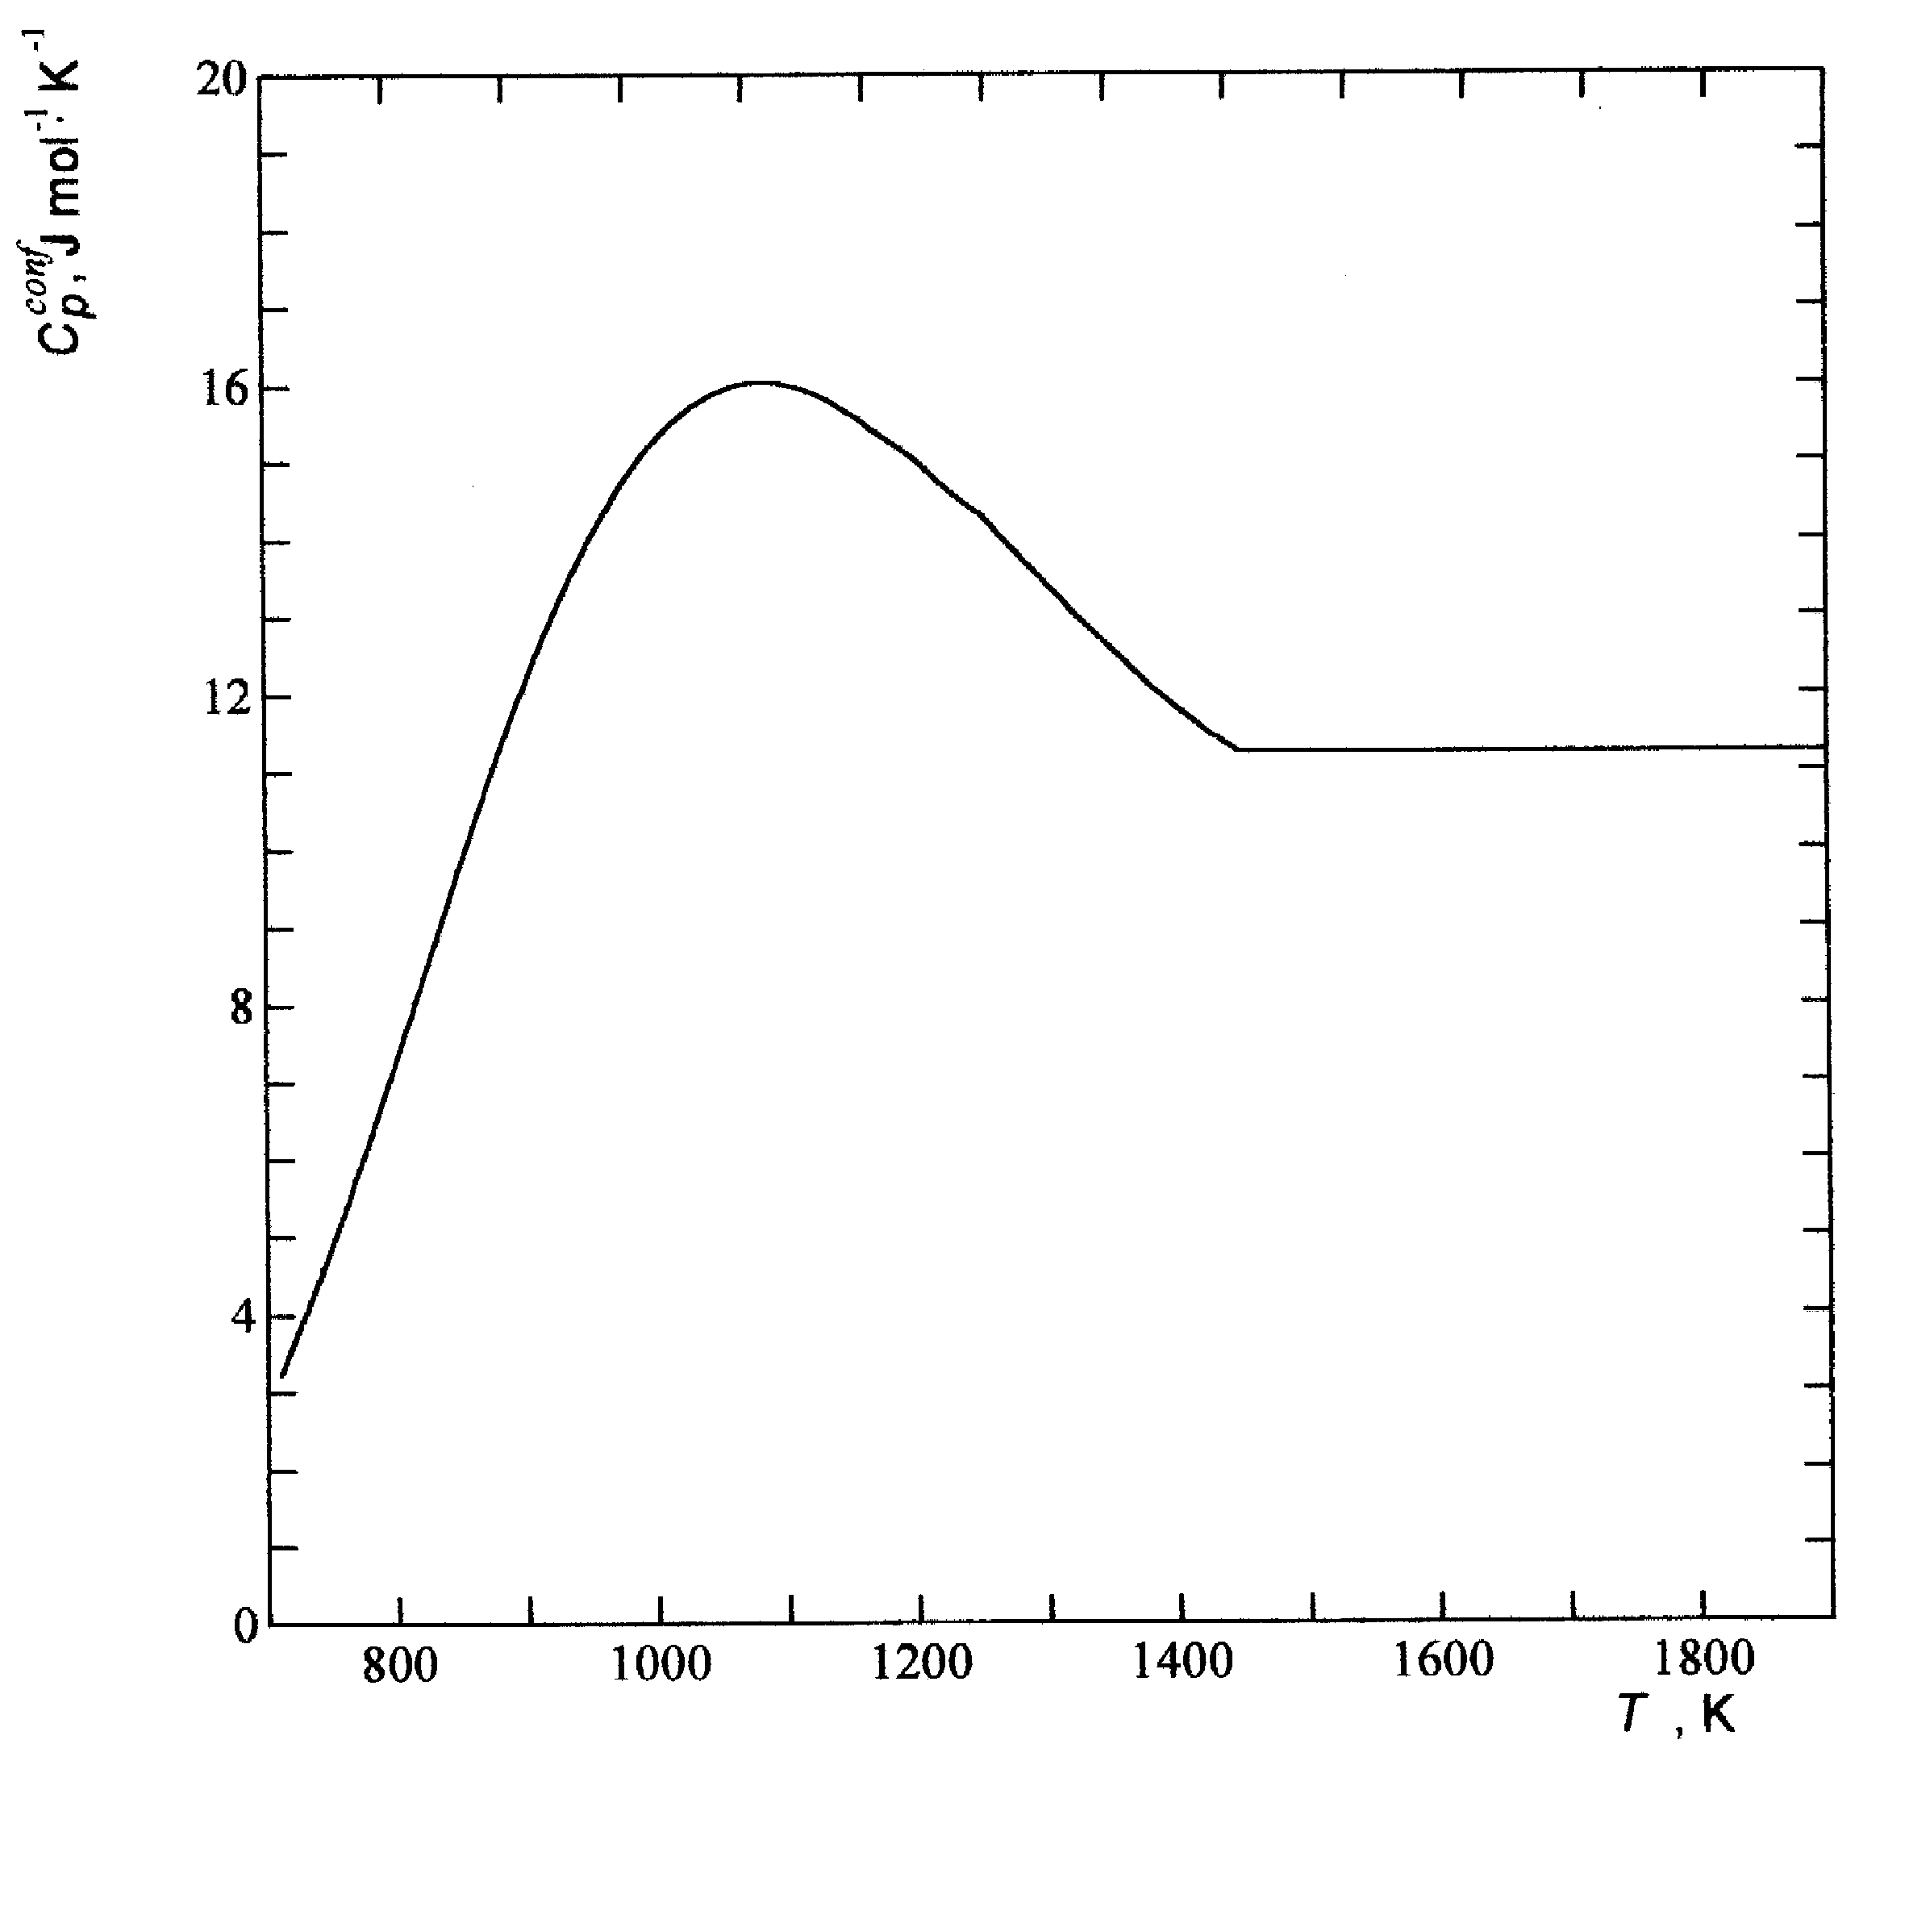

Fig. S4. Temperature dependence of configuration heat capacity C_{p}^{conf} of the Fe-B melt with x(B) = 0.18.

