Supporting informations

S1. X-Ray photoelectron spectra in the W (4f) regions for multilayer films containing Ag₃PW₁₂O₄₀ nanoparticles with n=1 and 3.

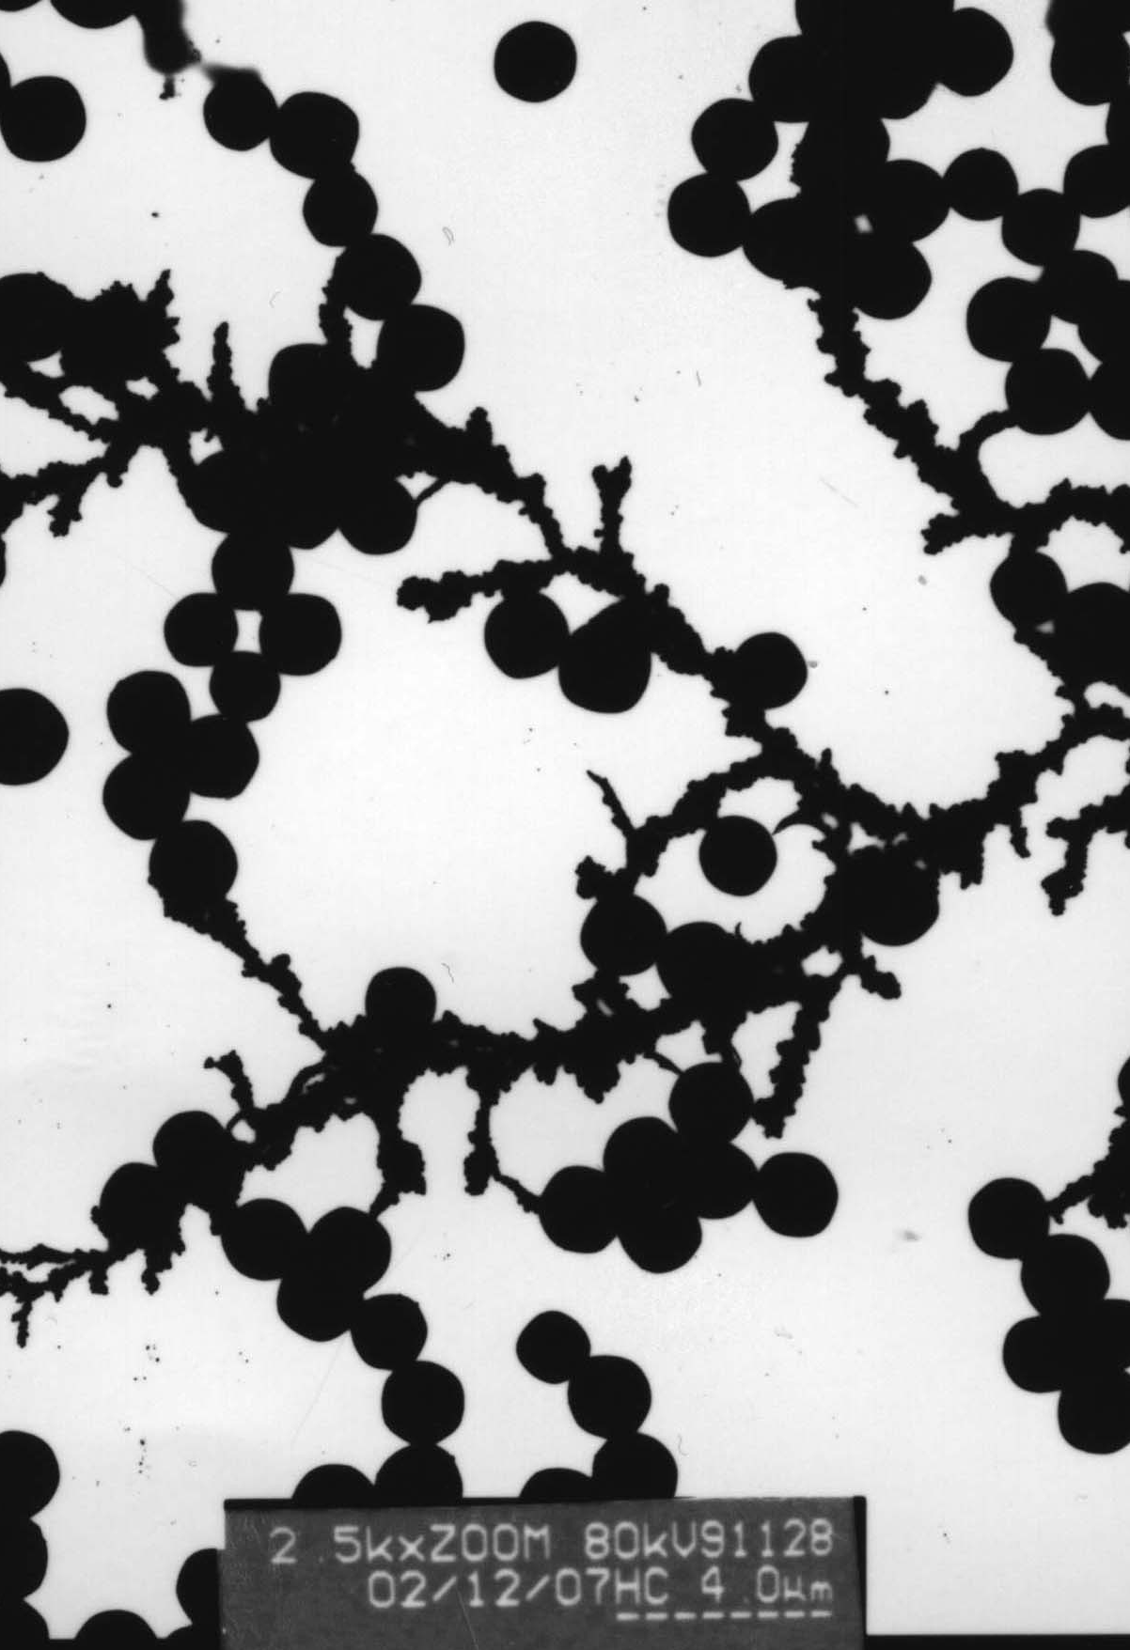

S2. Formation of Ag₃PW₁₂O₄₀ particles attached to the chain of PAA when drops of PW₁₂ solution be added into the PAA-Ag⁺ solution.

