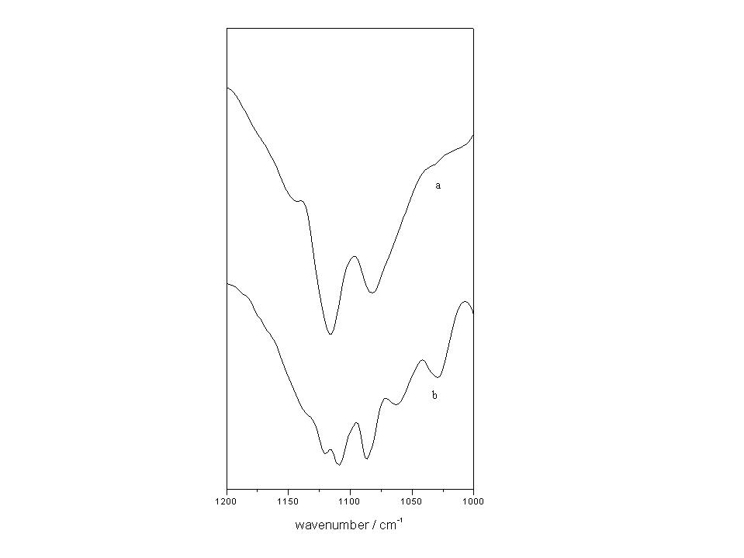

Fig. S1. FT-IR spectra of (a) [Cd(dimb)₂(MeOH)₂](ClO₄)₂ and (b) anion exchanged product in the solid state (KBr disk).

