Supplementary Figure Captions :

Fig. S1 Partial energy level diagram of [Os(HLª)(Lª)Br]. For pictorial
representation of MOs see Fig. S4.

Fig. S2 Partial energy level diagram of [Os(Lª)(pap)Br]. For pictorial
representation of MOs see Fig. S5.

Fig. S3 Partial energy level diagram of [Os(HLª)(pap)Br₂]. For pictorial representation of MOs see Fig. S6.

Fig. S4 Pictorial representation of MOs of [Os(HLª)(Lª)Br] : (a) LUMO+1, (b) LUMO, (c) HOMO, (d) HOMO-1 and (e) HOMO-2.

Fig. S5 Pictorial representation of MOs of [Os(Lª)(pap)Br] : (a) LUMO+1, (b) LUMO, (c) HOMO, (d) HOMO-1 and (e) HOMO-2.

Fig. S6 Pictorial representation of MO’s of [Os(HLª)(pap)Br₂] : (a) LUMO+1, (b) LUMO, (c) HOMO, (d) HOMO-1 and (e) HOMO-2.

Fig. S7 Solution spectra (1200 nm – 350 nm) of [Os(HLª)(Lª)Br] (–––––), [Os(Lª)(pap)Br] (• • •), cc-[Os(HLª)(pap)Br₂] (–•–•–) and cc-[Os(pap)₂Br₂] (- - -).

Fig. S8 Segmented cyclic voltammograms (scan rate 50 mVs⁻¹, solvent CH₂Cl₂, 0.1M TBAP) of (a) [Os(HL^{b})(L^{b})Br], (b) [Os(L^{b})(pap)Br] and (c) [Os(HL^{b})(pap)Br₂].

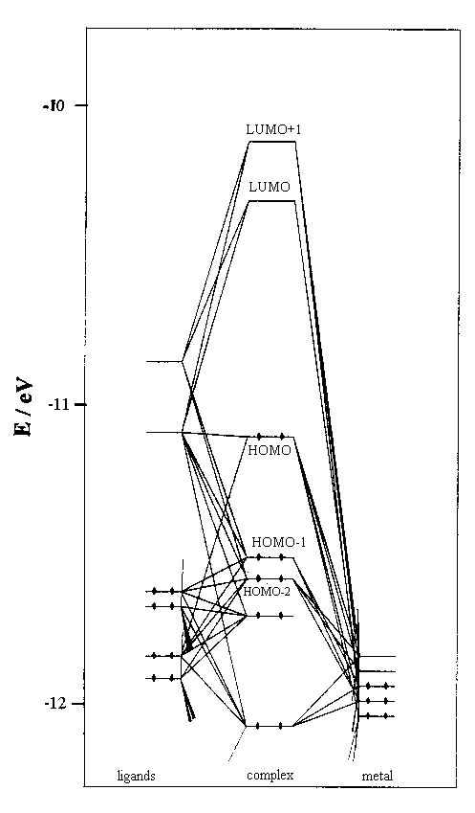

Fig. S1

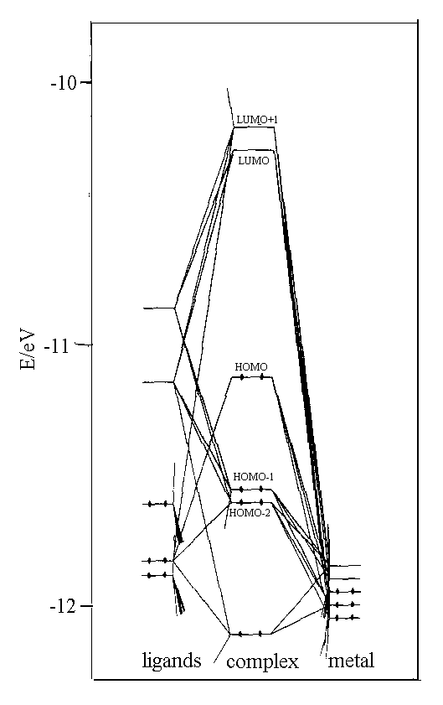

Fig. S2

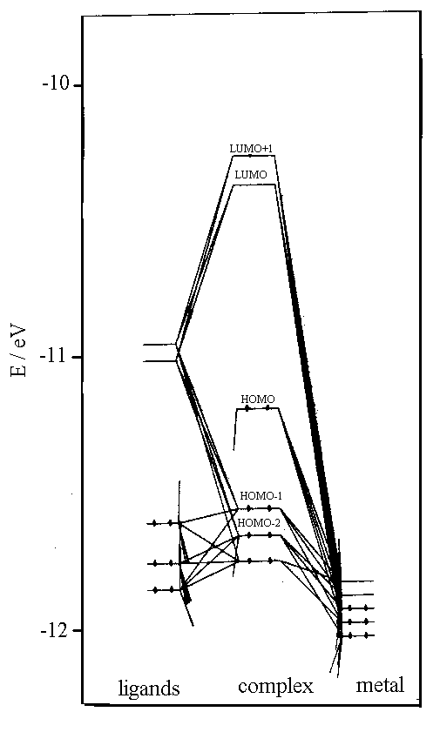

Fig. S3

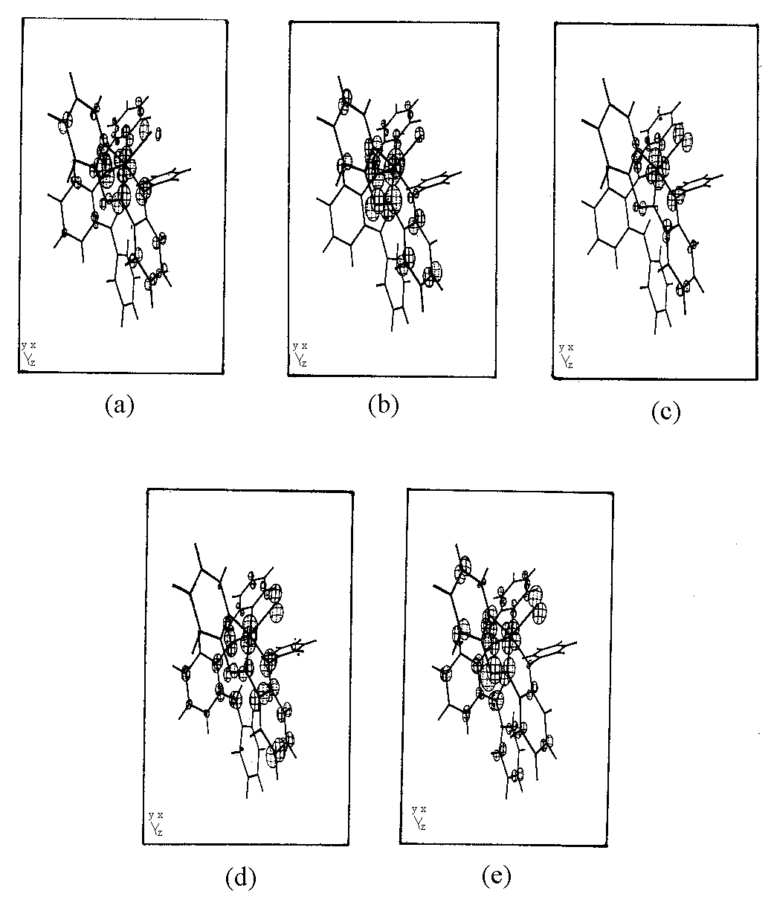

Fig. S4

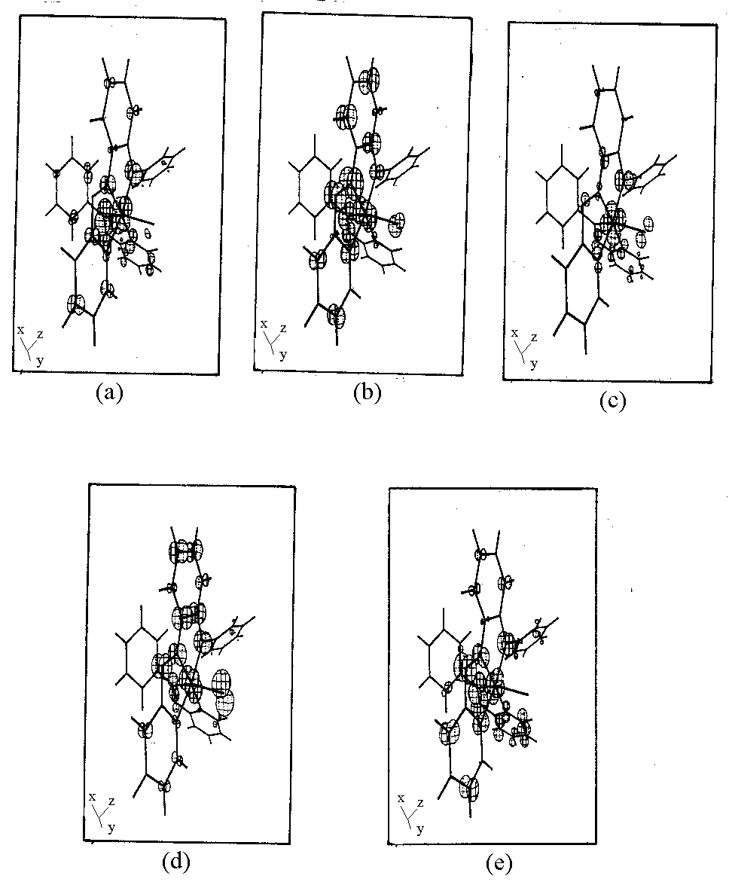

Fig. S5

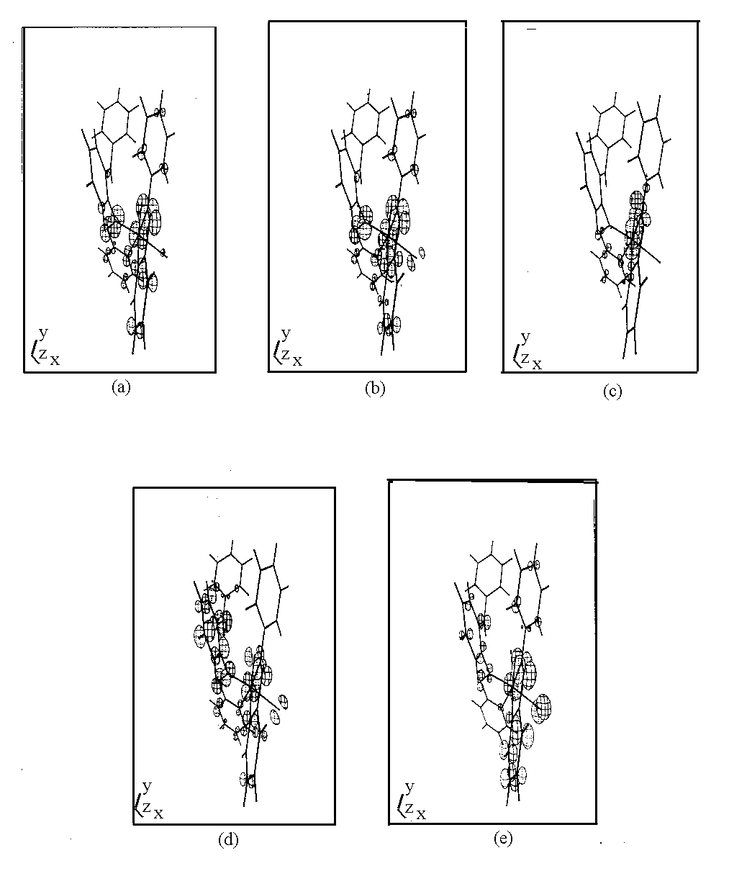

Fig. S6

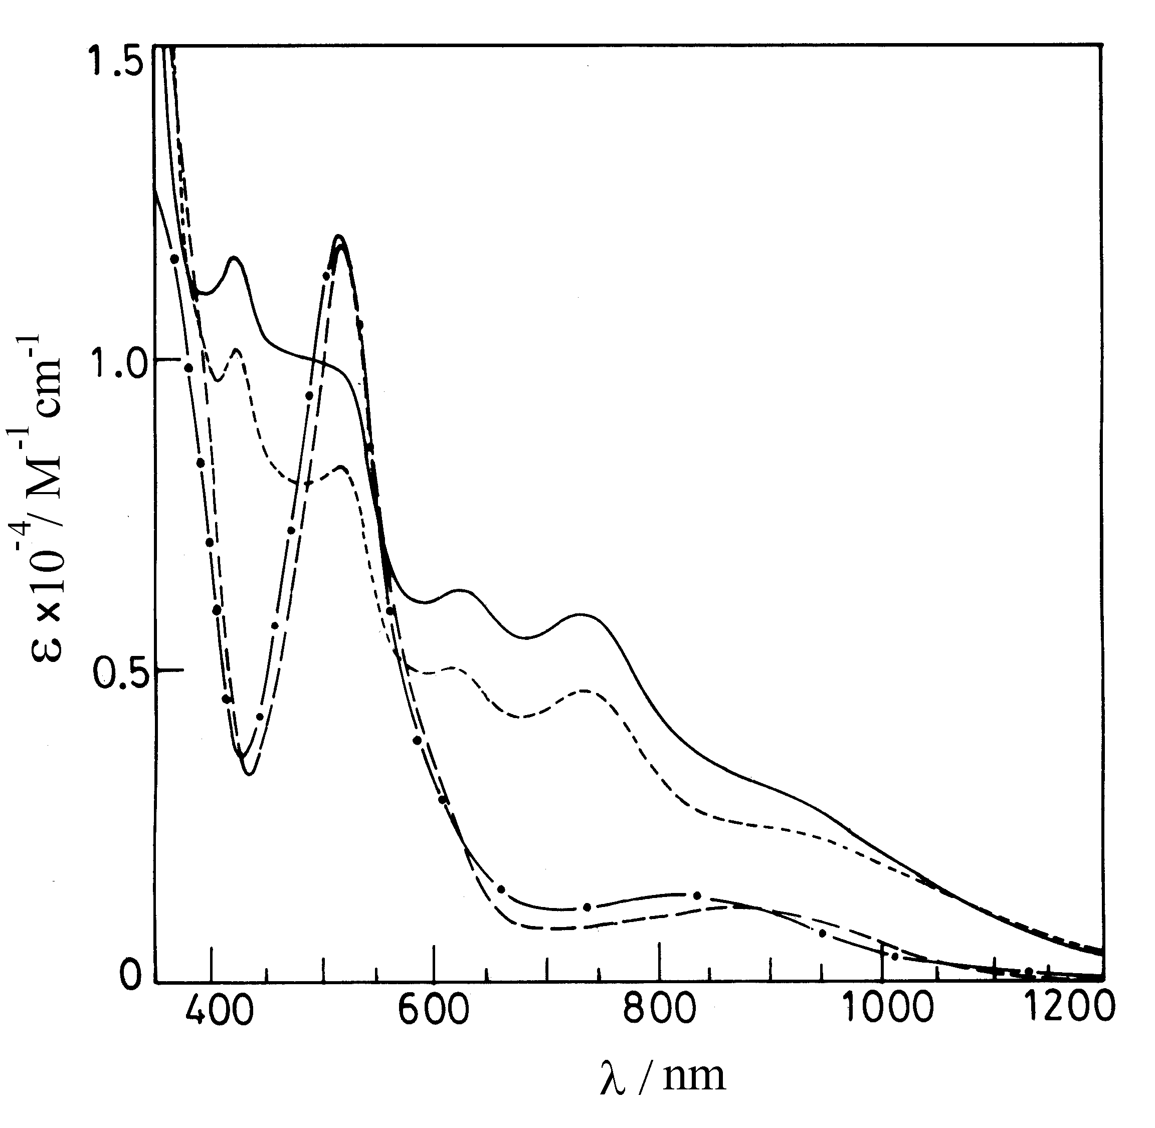
Fig. S7

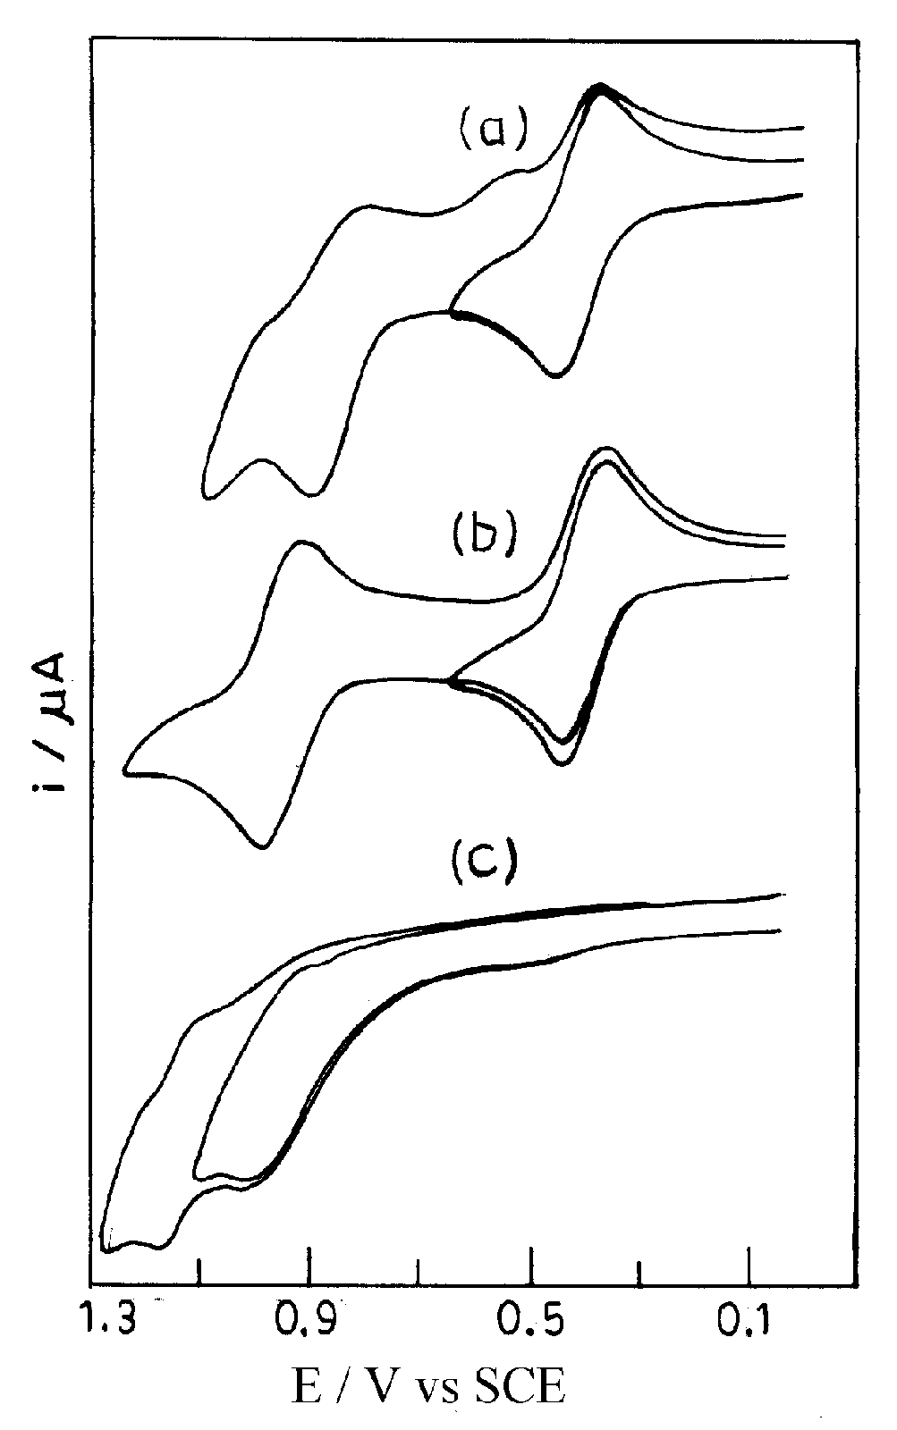

Fig. S8

