Supplementary information
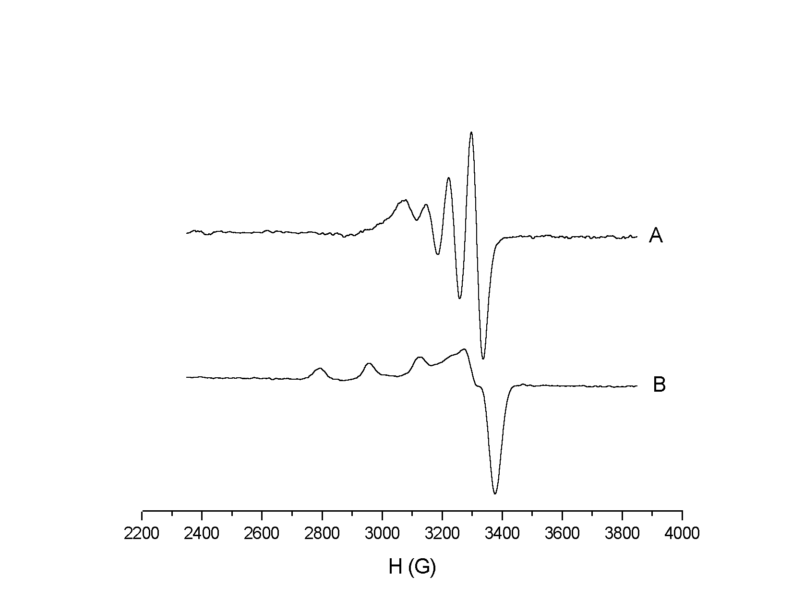

Fig. S1. EPR spectra of 1 in DMF
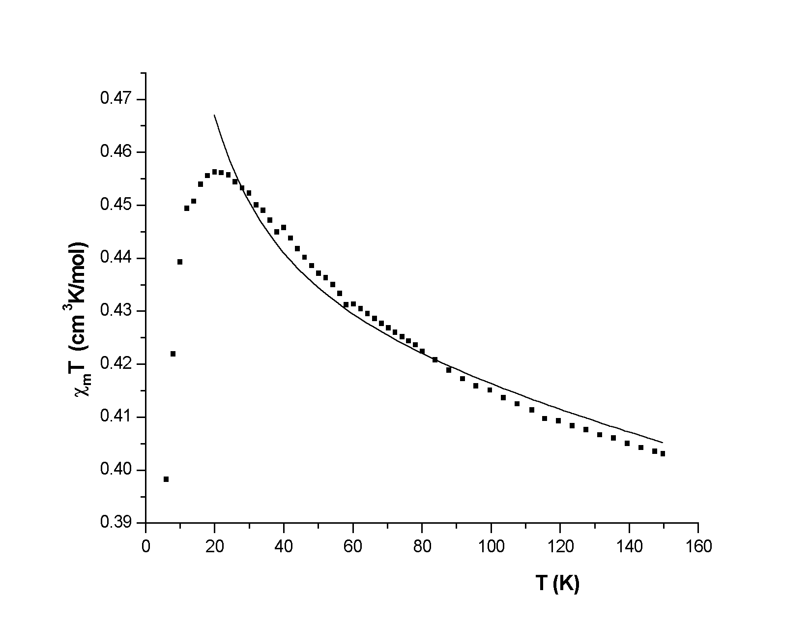
(a) 298 K; (b) 100 K

Fig. S2. Plot of the products χ_{m}T vs temperature for 1; the solid line represents the best calculated fit of the data according to the binuclear model.

