Supplementary Materials

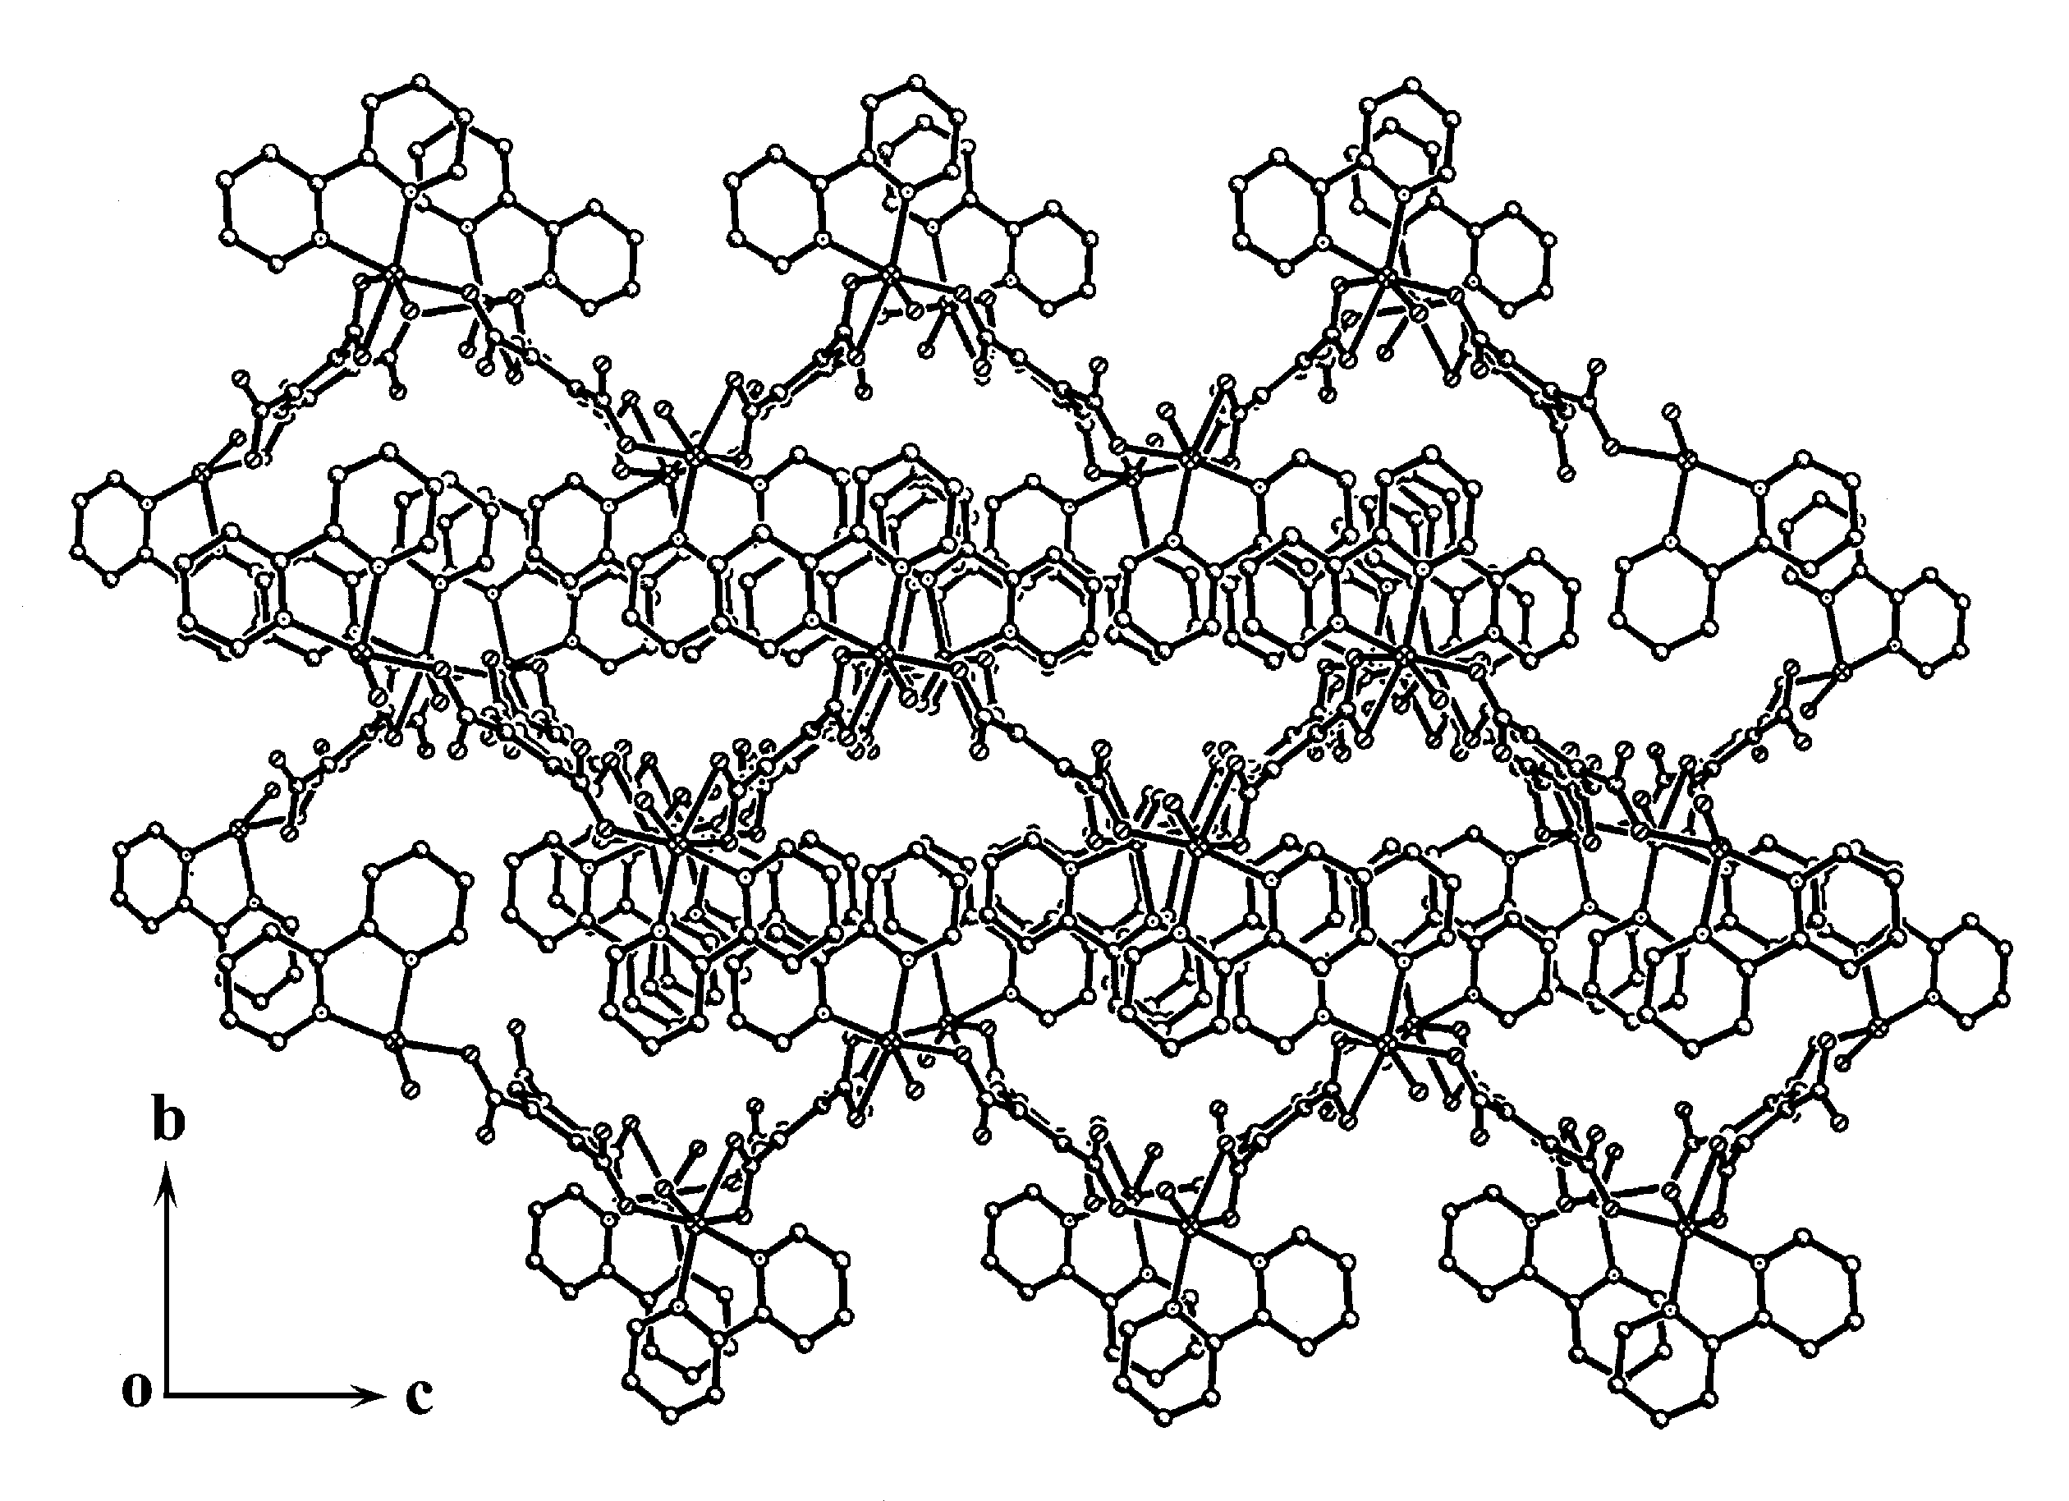

Fig. S1 The packing arrangement of 1 along a axis.

Fig. S2 XPS spectrum of 1

Fig. S3 IR spectrum of 1

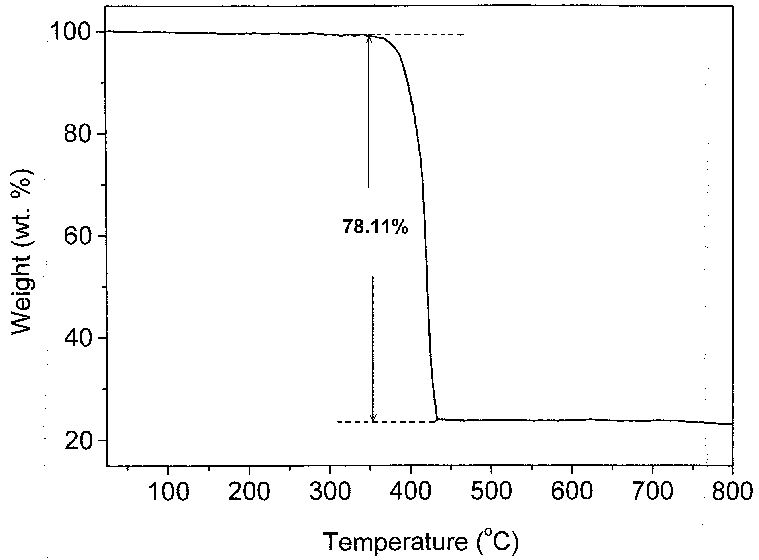

Fig. S4 The TG curve of 1.

