²P-Hδ tt, ⁴P-Hδ tt, ⁴P-Hδ ct

⁴P-Hδ' tt, ⁴P-Hδ' ct
³F-Hβ' tt, ¹Y-Hβ' cc
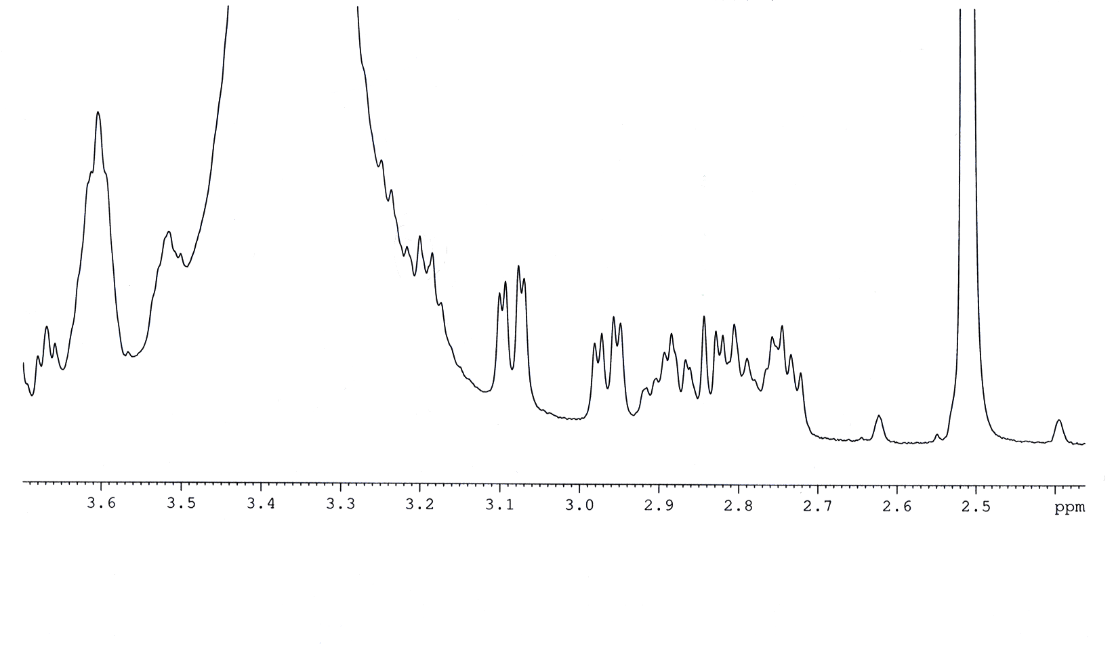
²P-Hδ' ct
²P-Hδ tc
²P-Hδ' cc
²P-Hδ' tt, tc
³F-Hβ ct,
³F-Hβ tt
¹Y-Hβ tc,
¹Y-Hβ tt
³F-Hβ,β' cc
¹Y-Hβ cc
³F-Hβ,β' tc
³F-Hβ' ct
¹Y-Hβ,β' ct
¹Y-Hβ' tc

