Supplementary data

Table S1 Distribution coefficients D=E/(100-E) of lanthanides and an actinide for ligands 1b - 3b. Aqueous phase: cM = 1·10-4 M in 1M HNO3, organic phase: solution of 1b - 3b in chloroform.

Cation | CL | 1b | 2b | 3b
La3+  Eu3+  Yb3+  Th4+ | 1.10-3  1.10-3  1.10-3  4.10-4 | 0.38  1.9  7.6  >1800 | 0.064  0.079  1.0  240 | <0.01  <0.01  2.4  360
Table S2 Selected distances (Å) and angles (°) in molecules 1a, 3a, 3b

 |  | 1a |  | 3a | 3b
 | Molecule A | Molecule B | Molecule C
Angle I-III | 10.0(2) | 3.0(3) | 8.2(2) | 53.4(2) | 43.9(2)
Angle II-IV | 84.1(1) | 80.7(1) | 85.5(1) | 65.7(2) | 68.3(1)
Distance C5-C17 | 5.751(6) | 5.499(6) | 5.666(5) | 7.894(9) | 7.579(6)
Distance C26-C28 | 5.263(5) | 5.375(5) | 5.282(5) | 5.403(7) | 5.515(5)
Distance C11-C23 | 9.557(6) | 9.618(6) | 9.525(6) | 8.300(9) | 8.336(6)
Distance C25-C27 | 5.375(6) | 5.375(5) | 5.282(5) | 5.262(8) | 5.169(6)
Distance O1-O2 | 3.084(4) | 3.372(4) | 2.992(4) | 2.707(6) | 2.723(4)
Distance O2-O3 | 2.931(4) | 2.863(4) | 3.079(5) | 3.036(6) | 3.022(4)
Distance O3-O4 | 3.020(4) | 3.114(4) | 3.163(4) | 2.692(5) | 2.731(4)
Distance O4-O1 | 2.954(4) | 3.164(4) | 2.931(4) | 2.991(6) | 3.067(4)

Table S3 Comparision of extraction efficiencies of 1b - 3b and published systems.

Extractant | Composition of organic phase | Composition of aqueous phase | %E for
 |  |  | La3+ | Eu3+ |  | Yb3+
Phosphonates  1b  2b  3b | CHCl3,  cl=1·10-4M | c(Ln3+)=1·10-4 M  HNO3 (pH=1) | 27±3  8±4  =1 | 65±4  7.3±3  1 |  | 88±4  50±3  71±4
CMPO derivatives  4a20  4b20  4c 20  520 | CH2Cl2, extr. of  Ln3+: cl=1·10-3M;  Ext. of Th4+: cl=1·10-4M | c(Ln3+)=1·10-4 M  c(Th4+)=1·10-4 M  1M HNO3 | 19  13  70  98 | 16  12.5  68  58 |  | 2.6  =2  37  3
Carboxylate  621 | CHCl3 + 4%  octan-1-ol  cl=3·10-3M | 1·10-3M  Nd,Eu,Tb,Dy,Yb,Er, pH=1.5-3.0 (HclO4) | 9.9-91
Phosphineoxide  722 | 1,2-dichlorethan  cl=2·10-3M | 1·10-3M  La,Pr,Nd,Sm,Eu,Gd Ho,Er,Yb,Y  0.9M Al(NO3)3 | E about
 |  |  | 10 |  | 10 | 1
Hydroxamate  823 | CHCl3,  cl=0.9·10-3M | c(Th4+)=0.18·10-3M  c(Al3+)=0.17·10-3M  0.1M NaCl, pH=2 | %E for Th4+  94.6
Iminocarboxylate  924 | CHCl3,  5 equiv. of the ligand | 0.1M NaCl  pH 1 |  |  | =2
CMPO  1025 | CH2Cl2, extr. of  Eu3+: cl=1·10-2M;  extr. of Th4+: cl=0.25M | c(Eu3+)=1·10-4M  c(Th4+)=1·10-4M  1M HNO3 |  |  | 12.2

References: 20 S. Barboso, A. G. Carrera, S. E. Matthews, F. Arnaud-Neu, V. Böhmer, J.- F. Dozol, H. Rouquette and M.-J. Schwing-Weill, J. Chem. Soc., Perkin Trans. 2, 1999, 719-723; 21 R. Ludwig, K. Kunogi, N. Dung and S. Tachimori, Chem. Commun., 1997, 1985-1986; 22M. R. Yaftian, M. Burgard, D. Matt, C.B. Dieleman and F. Rastegar, Solvent Extr. Ion Exch., 6, 15, 1997, 975-989; 23 L. Dasaradhi, P. C. Stark, V. J. Huber, P. H. Smith, G. D. Jarvien and A. S. Gopalan, J. Chem. Soc., Perkin Trans. 2, 1997, 1187-1192; 24 T. N. Lambert, G. D. Jarvinen and A. S.Gopalan, Tetrahedron Lett., 40, 1999, 1613-1616; 25F. Arnaud-Neu, V. Böhmer, J.-F. Dozol, C. Grüttner, R. A. Jakobi, D. Kraft, O. Mauprivez, H. Rouquette, M.-J. Schwing-Weill, N. Simon and W. Vogt, J. Chem. Soc., Perkin Trans. 2, 1996, 1175-1182

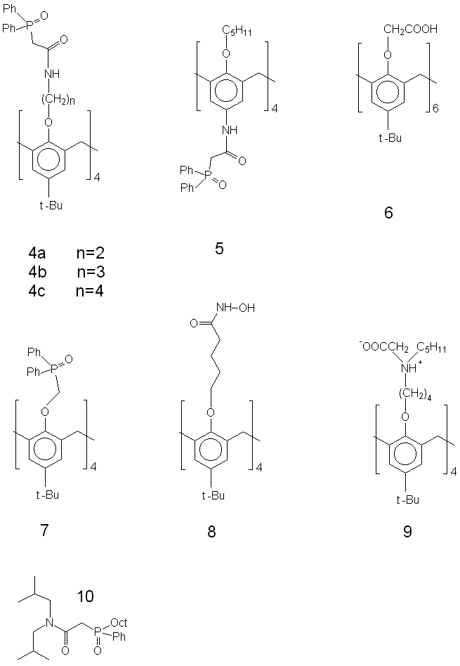Fig. S1 Formulae of the compounds tested

CMPO derivatives of calixarenes (entries 4a, 4b, 4c and 5, Fig. S1) are the most studied extractants due to exploitation of CMPO in the TRUEX process. Compounds 1b, 2b, 3b reach comparable extraction efficiencies at a HNO3 concentration 1 mol dm-3 like the CMPO-based extractants 4a, 4b, 4c, 5 at ten times lower concentrations and using less polar solvent. Thus, the compounds 1b, 2b, 3b are more efficient extractants than 4a, 4b, 4c, 5. This corresponds with the fact that the anionic form of phosphonate group is more suitable for coordination of highly charged lanthanide or actinide cations than the phosphoryl group of phosphineoxides.
Derivatives of calixarenes bearing carboxylic groups (compound 6, Fig. S1) give the D value ~ 1 at pH 2 - 2.5. Compounds 1b, 2b, 3b reach this D value already at pH 1. The extraction ability correlate with the basicity of the donatig group, and thus, the phosphonate derivatives of calixarene are more efficient at low pH than carboxylates.
Phosphineoxide derivative of calixarene 7, Fig. S1), hydroxamate 8 and iminocarboxylate are less efficient than CMPO-based extractants 4a, 4b, 4c. CMPO itself is a far less efficient extractant than the macrocyclic compound due to absence of the chelate efect and electroneutrality of CMPO.

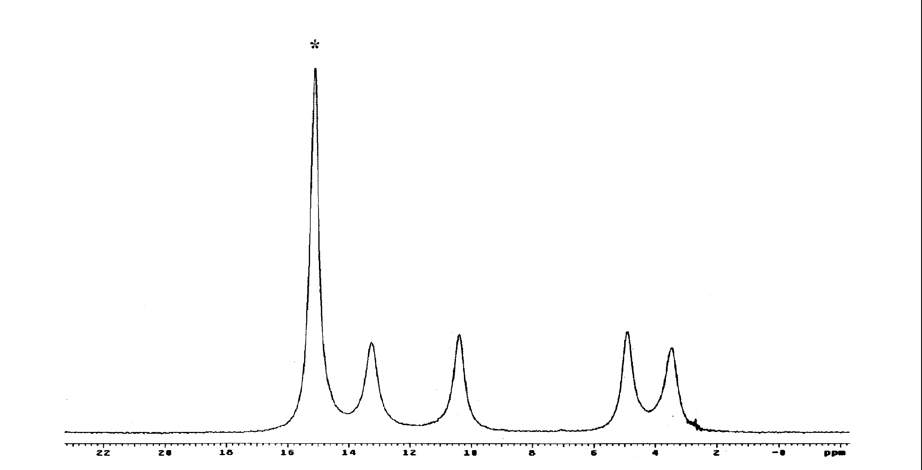

Fig. S2

